Moomoo / Tauros / Miltank

Lineage’s Lore

Inspiration:

In Keltios, Tauros and Miltank are part of the same lineage, fulfilling a fan theory implied in the official games. Sacred Phoenix goes one step further by offering a pre-evolution to these two bovine Pokémon. Thus, Moomoo, the Fakemon Calf, is born!

Since Tauros and Miltank differ significantly, their pre-evolution had to be subdivided into two different forms: the male will be predominantly beige with 3 spots on his head, while the female will have pink skin with a large black spot on her forehead. That said, only the aesthetics differ: the type, stats, abilities and movepool are identical for both forms. This implies that Miltank and Tauros have a common movepool inherited from the time when they were just a Moomoo: quite a challenge when you know that they have few common attacks in the official games. Therefore, it’s by evolving that they unlock their own species movepool.
It gets more complicated with the three Iberian forms of Tauros (called “Paldean” in the official canon), also present in Keltios. They unlock some additional moves compared to the common Tauros.

Etymology:

The etymology of Moomoo comes from the name of Moomoo Milk.
The etymology of Tauros comes from bull in ancient Greek.
The etymology of Miltank comes from “milk” and “tank”.

Habitat:

Because it is one of the best draft Pokémons (not to mention the meat and Moomoo Milk supply), few representatives of this line are found in the wild. The majority will indeed be in the hands of farmers, breeders or herdsmen, although a few herds may be found roaming free.
The juvenile stage is found in the agricultural plains between Tintignac and Eldania, while Tauros and Miltank can also be found in the highlands of Alienor, Nereid, Argonite or Selenia Shire. The Shire where the evolution took place will determine the form of Tauros that the male Moomoo will take.

Note also that the mass of the adult forms has been adjusted upwards to reflect something more realistic: a Miltank will weigh around 120 kg and a Tauros around 150 kg. (A draft animal that does not even weigh 100 kg is not very realistic, even with 1.4 m from head to toe)

Type:

Like its evolutions in their common form, Moomoo is pure Normal-type. Only the Iberian forms of Tauros change type: Fighting for the combat breed, Fighting/Fire for the blaze breed and Fighting/Water for the aqua breed. This is caused by the Mediterranean climate of Selenia, the influence of Groudon which radiates in Argonite and the aura of Kyogre which pulses in Nereid respectively.
In terms of secondary affinities, all forms have the Psychic and Ground-types, to which are added the Fighting and Rock-types when Moomoo evolves, proof of a certain physical strength and a link with the earth. To compensate for the pure Normal-type, the common form of Tauros also gets a partial mastery of the Dark-type and Miltank that of the Fairy-type: enough to have an almost complete coverage without penalty.
The Iberian forms of Tauros are more interesting offensively because of their Fighting-type plus a possible second type. But let’s not forget that the Normal-type species has certain defensive advantages: a unique Fighting weakness and immunity from the vast majority of spectral attacks. The Iberian forms will require more caution defensively, especially those with a double type that have five weaknesses.

Stats:

Its primitive form has pretty decent and balanced stats for a baby Pokémon. Relatively bulky physically, it is a little less so in special because of its weak Special Defense. Its Special Attack is not usable (and will remain so as it evolves), but this is almost without impact because most of its offensive movepool is physical.
As they evolve, Tauros will gain primarily in Attack while Miltank will gain primarily in HP. The Iberian forms are slightly stronger physically but slightly slower. In any case, all evolutions have good Speed and fairly good to good Defense, but no stat is particularly high... although the base Tauros’ Speed, which climbs to 110, can help it strike first in the vast majority of cases.

Movepool:

Being a juvenile species, Moomoo has a movepool limited to around twenty attacks mainly based on charges and tackles and which is learned quite quickly (Tackle, Take Down, Stomp, Headbutt, Giga Impact …). This does not prevent it from taking advantage of a good range of moves from its first levels to impact the stats on itself or a target (Growl, Tail Whip, Work Up), then a coverage offered by its secondary affinities at a higher level (Zen Headbutt, Rest, High Horsepower). A handful of Rock, Steel and Ground attacks can also be learned by teaching and allow extra coverage, even if only Zen Headbutt, Rest and Ground attacks will be really exploitable.

As the species evolves, it diverges by gender, granting different moves. Miltank unlocks the Rollout/Defense Curl combo, then Milk Drink around level 30 to finish on Play Rough thanks to its Fairy-type secondary affinity. It can also get some Fighting-type attacks like Mega Punch, Dynamic Punch or Seismic Toss by learning.
As for Tauros, it’s its signature move Raging Bull that unlocks about ten levels after its evolution, to end up on Thrash and then Head Charge – a more efficient variant of Double-Edge – once it’s fully matured.
The Tauros breed also have some movepool discrepancies: an Iberian evolution unlocks access to Double Kick as well as Fire or Water attacks if the form is also of that type; whereas it is Rage that unlocks with the evolution into the basic Tauros. The common form also gains a secondary affinity to the Dark-type with its associated array of moves. This allows it to use this coverage without penalty in addition to the Ground, Psychic, Rock and Fighting-types common to all Moomoo evolutions. Enough to compensate for its pure Normal-type!
At the level of the acquired movepool, the evolution unlocks access to certain Rock or Ground-type moves, some of which are very interesting strategically: Earthquake + Stone Edge for all Tauros and Stealth Rock + Rock Smash + Strength (which we remember is Fighting-type) for all evolutions.

The Light or Shadow movepool can also be interesting, especially if the Pokémon only has the Normal-type at the base. If the proper ritual has been performed, the whole line has the possibility of using Shadow Hold (useful for trapping an enemy); or at higher levels, inflict heavy physical damage through Shadow End or Ram of Light. Miltank can even learn Life Dew by Move Tutor and provide a healing less powerful than Milk Drink but which benefits all its allies.

To summarize the strategic use of the Pokémon, Tauros is to be favored offensively as a physical wallbreaker by combining its high speed with a varied coverage of offensive attacks corresponding to its affinities + its hidden ability Sheer Force to maximize raw damage, or Intimidate to increase staying power. Miltank will be played more in the stall with its healing and buff attacks combined with the possibility of counterattacking with Fighting, Rock or Fairy-type moves, or generating a snowball effect (Rollout, Rock Smash). Anyone can set Stealth Rock for support.
Note that almost all elemental attacks (Fire, Electric and Ice + Toxic) have been removed for consistency reasons. That said, these coverages would have been almost unusable in practice, because they are not part of the secondary affinities of the lineage (except the Fire for blaze breed Tauros).

Lineage characteristics:

Experience curve: Normal (1,000,000 XP at level 100)
Breeding group: Mammal
Sex ratio: 50% male, 50% female for Moomoo; 100% male for Tauros, 100% female for Miltank
Pain of evolution: Normal (quite painful)
Species fertility: As soon as it evolves into Tauros or Miltank, i.e. from level 20
Hatching time: Quite slow (30 cycles, or 7,680 steps)

Moomoo

Male form:

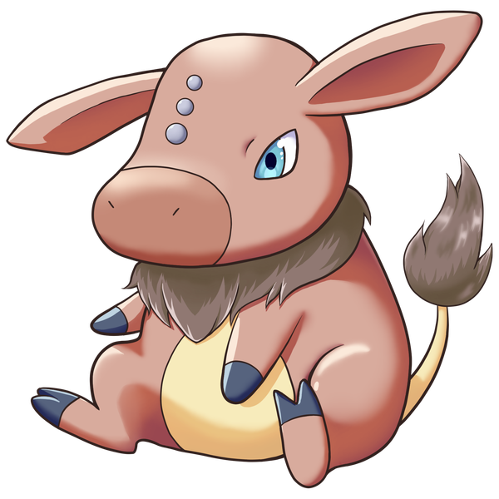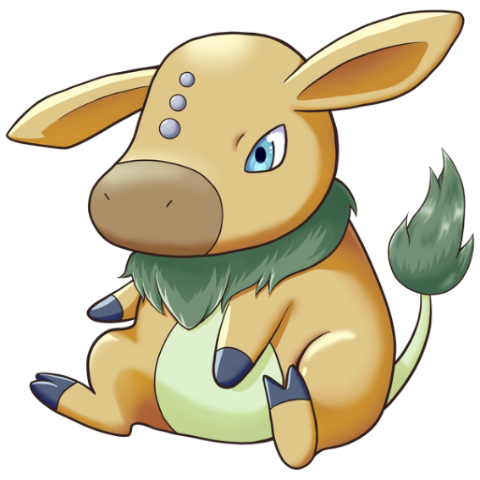

Female form:
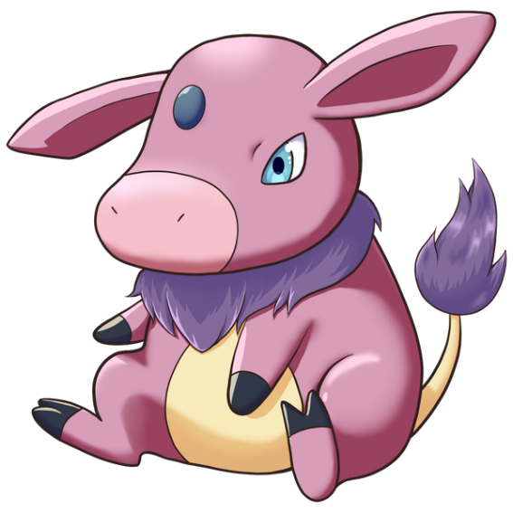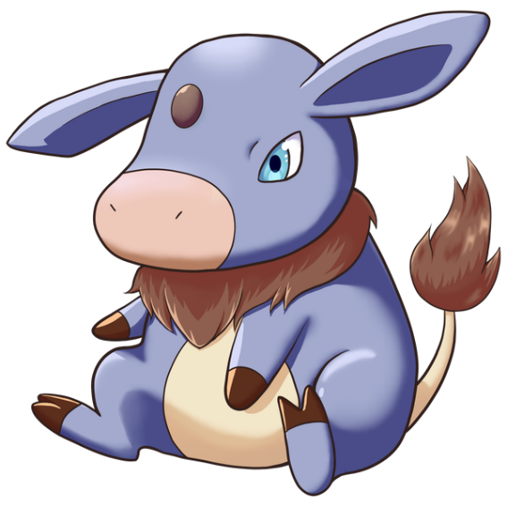

Stats and abilities:

Name: Moomoo
Classification: Calf Pokémon
Evolves into Tauros from level 20 if male ...
… in Iberian aqua breed form if located in the Nereid Shire
… in Iberian blaze breed form if located in the Argonite Shire
… in Iberian fighting breed form if located in the Selenia Shire
… in basic form in all other localities
Evolves into Miltank from level 20 if female

Description (male form): It likes to charge at anything that moves in the hope of increasing its strength. The place where it grows up conditions its future evolution.
Description (female form): It feeds mainly on its mother’s milk but she also likes berries. It thus accumulates fat to prepare its evolution.
Height: 0.6 m (2’00")
Mass: 35.0 kg (77.2 lbs)
Catch rate: 135
Experience yield: 61
Held item in the wild: Oran Berry (25%)
Raw material recovered by hunting: Leather (×1)
Appearance: Biped with a tail
Color: Brown (male) / Pink (female)
Rarity: Uncommon
Tier: Poorly Used – LC
----------

Type: Normal
Secondary types: Ground, Psychic
Immunities: Ghost
Weaknesses: Fighting
----------

Base stats:
HP: 60
Atk: 65
Def: 70
Sp. Atk: 25
Sp. Def: 40
Spd: 60
----------
Total: 320

EV: +1 Def

Abilities:
• Thick Fat: The Pokémon is protected by a layer of thick fat, which halves the affinity from Fire- and Ice-type moves.
• Sap Sipper: Boosts the Attack stat if hit by a Grass-type move instead of taking damage.
• Cud Chew (hidden): When the Pokémon eats a Berry or an Herb, it will regurgitate it at the end of the next turn and can eat it a second time.

Sexual dimorphism:
The male is brown with 3 light grey vertical spots on the forehead, and the hairs on its neck and tail are brown. The female is pink with a big dark grey spot on the forehead, and the hairs on its neck and tail are purple.

Tauros (basic form)

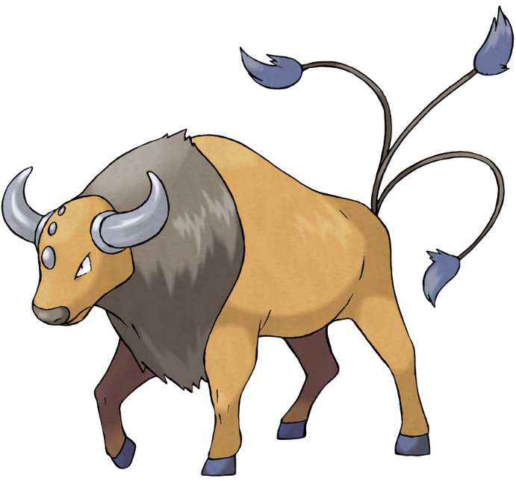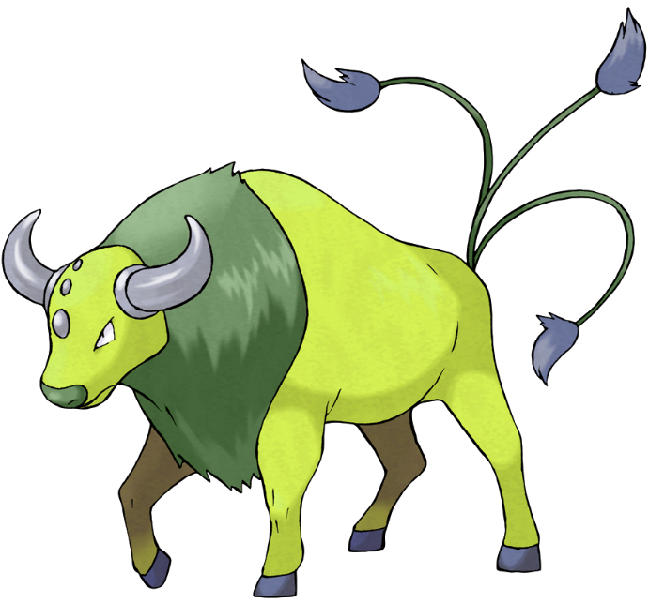

Stats and abilities:

Name: Tauros (basic form)
Classification: Wild Bull Pokémon
Evolution of male Moomoo out of Nereid, Argonite or Selenia Shire from level 20

Description: This Pokémon is not satisfied unless it is rampaging at all times. If there is no opponent for Tauros to battle, it will charge at thick trees and knock them down to calm itself.
Height: 1.4 m (4’07")
Mass: 132.6 kg (292.3 lbs)
Catch rate: 50
Experience yield: 172
Held item in the wild: Chople Berry (6,25%), Mental Herb (18,75%)
Raw material recovered by hunting: Leather (×2)
Appearance: Quadruped
Color: Brown
Rarity: Rare
Tier: Never Used
----------

Type: Normal
Secondary types: Fighting, Ground, Psychic, Rock, Dark
Immunities: Ghost
Weaknesses: Fighting
----------

Base stats:
HP: 75 (+15)
Atk: 100 (+35)
Def: 95 (+25)
Sp. Atk: 40 (+15)
Sp. Def: 70 (+30)
Spd: 110 (+50)
----------
Total: 490 (+170)

EV: +1 Atk, +1 Vit

Abilities:
• Intimidate: The Pokémon intimidates opposing Pokémons upon entering battle, lowering their Attack stat.
• Anger Point: The Pokémon is angered when it takes a critical hit, and that maxes its Attack stat.
• Sheer Force (hidden): Offensive moves that natively have additional beneficial effects lose them, but their power increases.

Sexual dimorphism:
The female is a distinct species (divergent stats, movepool and abilities) more stocky standing on its hind legs, with four large udders on its belly and much less developed horns.

Tauros (Iberian fighting breed form)

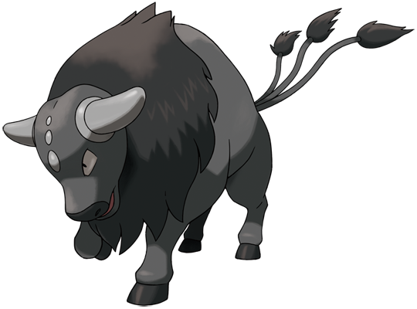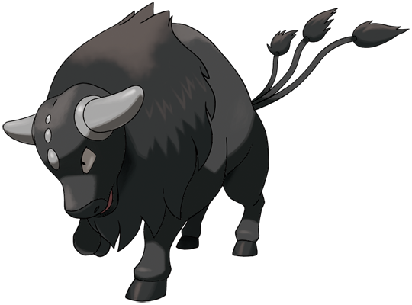

Stats and abilities:

Name: Tauros (Iberian fighting breed form)
Classification: Wild Bull Pokémon
Evolution of male Moomoo in the Selenia Shire from level 20

Description: This Pokémon has a muscular body and excels at close-quarters Fighting. It uses its short horns to strike the opponent’s weak spots.
Height: 1.4 m (4’07")
Mass: 172.5 kg (380.3 lbs)
Catch rate: 50
Experience yield: 172
Held item in the wild: White Herb (6,25%), Mental Herb (18,75%)
Raw material recovered by hunting: Leather (×2)
Appearance: Quadruped
Color: Gray
Rarity: Rare
Tier: Never Used
----------

Type: Fighting
Secondary types: Normal, Ground, Psychic, Rock
Resistances: Rock, Dark, Shadow
Weaknesses: Flying, Psychic, Fairy
----------

Base stats:
HP: 75 (+15)
Atk: 110 (+45)
Def: 105 (+35)
Sp. Atk: 30 (+5)
Sp. Def: 70 (+30)
Spd: 100 (+50)
----------
Total: 490 (+170)

EV: +2 Atk

Abilities:
• Intimidate: The Pokémon intimidates opposing Pokémons upon entering battle, lowering their Attack stat.
• Anger Point: The Pokémon is angered when it takes a critical hit, and that maxes its Attack stat.
• Cud Chew (hidden): When the Pokémon eats a Berry or an Herb, it will regurgitate it at the end of the next turn and can eat it a second time.

Sexual dimorphism:
The female is a distinct species (divergent stats, movepool and abilities) more stocky standing on its hind legs, with four large udders on its belly and much less developed horns.

Tauros (Iberian blaze breed form)

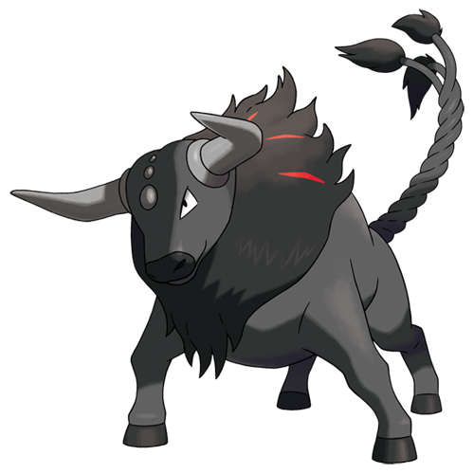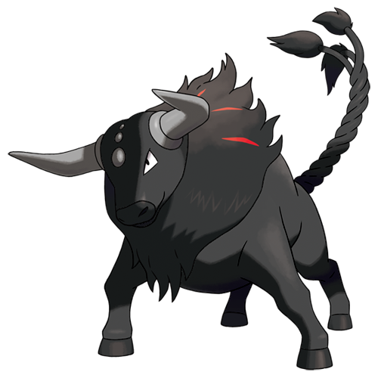

Stats and abilities:

Name: Tauros (Iberian blaze breed form)
Classification: Wild Bull Pokémon
Evolution of male Moomoo in the Argonite Shire from level 20

Description: The influence of Groudon in the dry lands of Iberia has allowed this Tauros to develop an inner fire. It has three braided tails and can heat its horns to red.
Height: 1.4 m (4’07")
Mass: 127.5 kg (280.0 lbs)
Catch rate: 50
Experience yield: 172
Held item in the wild: White Herb (6,25%), Mental Herb (18,75%)
Raw material recovered by hunting: Leather (×2)
Appearance: Quadruped
Color: Gray
Rarity: Rare
Tier: Rarely Used
----------

Type: Fighting / Fire
Secondary types: Normal, Ground, Psychic, Rock
Resistances: Fire, Grass, Ice, Bug, Dark, Steel, Fairy, Shadow
Weaknesses: Water, Ground, Flying, Psychic, Fairy
----------

Base stats:
HP: 75 (+15)
Atk: 110 (+45)
Def: 105 (+35)
Sp. Atk: 30 (+5)
Sp. Def: 70 (+30)
Spd: 100 (+50)
----------
Total: 490 (+170)

EV: +2 Atk

Abilities:
• Intimidate: The Pokémon intimidates opposing Pokémons upon entering battle, lowering their Attack stat.
• Anger Point: The Pokémon is angered when it takes a critical hit, and that maxes its Attack stat.
• Cud Chew (hidden): When the Pokémon eats a Berry or an Herb, it will regurgitate it at the end of the next turn and can eat it a second time.

Sexual dimorphism:
The female is a distinct species (divergent stats, movepool and abilities) more stocky standing on its hind legs, with four large udders on its belly and much less developed horns.

Tauros (Iberian aqua breed form)

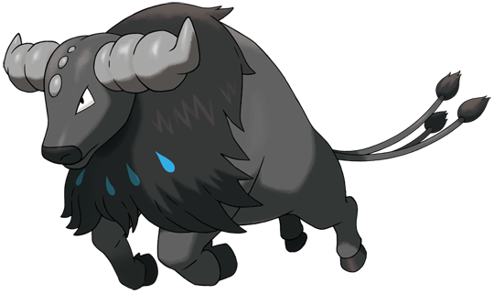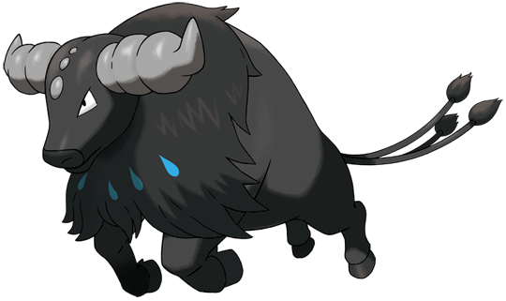

Stats and abilities:

Name: Tauros (Iberian aqua breed form)
Classification: Wild Bull Pokémon
Evolution of male Moomoo in the Nereid Shire from level 20

Description: The influence of Kyogre on the western coasts of Iberia allowed this Tauros to acquire the mastery of water. Its horns can project water at high pressure, which allows it to defend itself or to swim very fast.
Height: 1.4 m (4’07")
Mass: 165.0 kg (363.8 lbs)
Catch rate: 50
Experience yield: 172
Held item in the wild: White Herb (6,25%), Mental Herb (18,75%)
Raw material recovered by hunting: Leather (×2)
Appearance: Quadruped
Color: Gray
Rarity: Rare
Tier: Rarely Used
----------

Type: Fighting / Water
Secondary types: Normal, Ground, Psychic, Rock
Resistances: Fire, Water, Ice, Rock, Dark, Steel, Shadow
Weaknesses: Électrik, Grass, Flying, Psychic, Fairy
----------

Base stats:
HP: 75 (+15)
Atk: 110 (+45)
Def: 105 (+35)
Sp. Atk: 30 (+5)
Sp. Def: 70 (+30)
Spd: 100 (+50)
----------
Total: 490 (+170)

EV: +2 Atk

Abilities:
• Intimidate: The Pokémon intimidates opposing Pokémons upon entering battle, lowering their Attack stat.
• Anger Point: The Pokémon is angered when it takes a critical hit, and that maxes its Attack stat.
• Cud Chew (hidden): When the Pokémon eats a Berry or an Herb, it will regurgitate it at the end of the next turn and can eat it a second time.

Sexual dimorphism:
The female is a distinct species (divergent stats, movepool and abilities) more stocky standing on its hind legs, with four large udders on its belly and much less developed horns.

Miltank

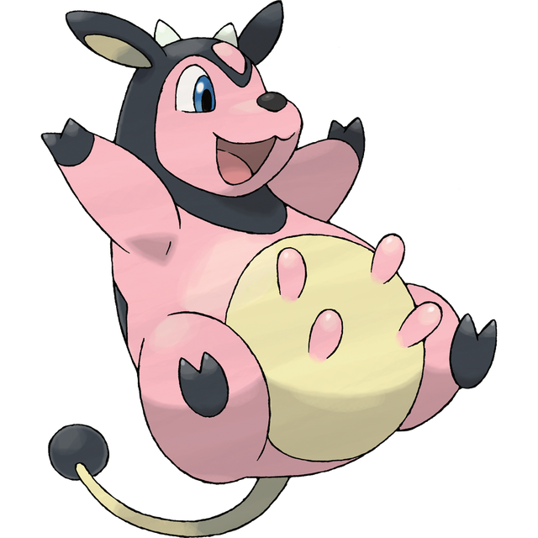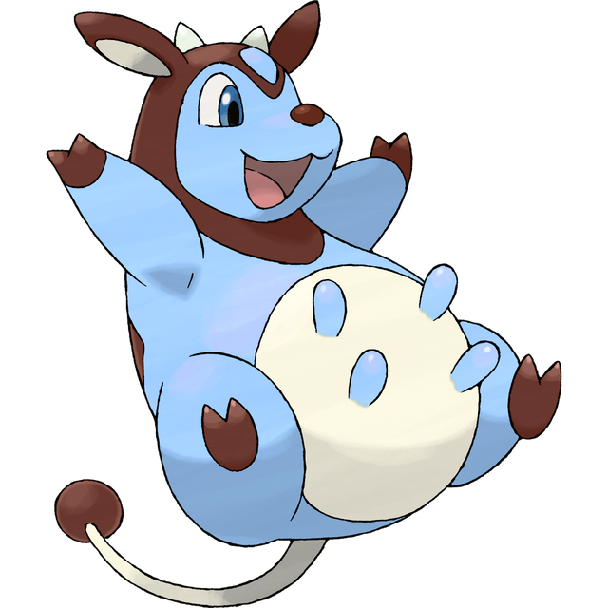

Stats and abilities:

Name: Miltank
Classification: Milk Cow Pokémon
Evolution of female Moomoo from level 20

Description: Miltank gives over five gallons of milk on a daily basis. Its sweet milk is enjoyed by children and grown-ups alike. People who can’t drink milk turn it into yogurt and eat it instead.
Height: 1.4 m (4’07")
Mass: 124.5 kg (274.5 lbs)
Catch rate: 50
Experience yield: 172
Held item in the wild: Moomoo Milk (100%)
Raw material recovered by hunting: Leather (×2)
Appearance: Biped with a tail
Color: Pink
Rarity: Rare
Tier: Never Used
----------

Type: Normal
Secondary types: Fighting, Ground, Psychic, Rock, Fairy
Immunities: Ghost
Weaknesses: Fighting
----------

Base stats:
HP: 95 (+35)
Atk: 80 (+15)
Def: 105 (+35)
Sp. Atk: 40 (+15)
Sp. Def: 70 (+30)
Spd: 100 (+40)
----------
Total: 490 (+170)

EV: +2 Def

Abilities:
• Thick Fat: The Pokémon is protected by a layer of thick fat, which halves the affinity from Fire- and Ice-type moves.
• Sap Sipper: Boosts the Attack stat if hit by a Grass-type move instead of taking damage.
• Scrappy (hidden): The Pokémon can hit Ghost-type Pokémon with Normal- and Fighting-type moves.

Sexual dimorphism:
The male is a distinct species (divergent stats, movepool and abilities) more massive and standing on four legs, with three tails and much more developed horns. The type may also diverge depending on the breed of the male, as there are several breeds.

Innate movepool (by leveling up or Move Reminder)

❌: Attack impossible to learn for this evolutionary stage or this form
💿: Attack not yet innate to this stage of evolution, but can be learned through external teaching.
Bold: Move benefiting from STAB at the time it is learned.
Italics: Move learned at a time when future evolution is required to unlock a STAB or secondary affinity.
Red: Anti-STAB because no secondary affinity on all stages of evolution. This move will consume more energy and have less power.
A learning level of 0 means that the Pokémon learns it when it evolves. Attacks that appear at level 1 after an evolution can be unlocked without a TM thanks to the Move Reminder.

Move | Type | Cat. | Power | Acc. | Learning level
 |  |  |  |  | Moomoo | Tauros |  |  |  | Miltank
Rage |  |  | 20 | 100 | ❌ | 0 | ❌ | ❌ | ❌ | ❌
Double Kick |  |  | 30 | 100 | ❌ | ❌ | 0 | 0 | 0 | ❌
Flame Charge |  |  | 50 | 100 | ❌ | ❌ | ❌ | 0 | ❌ | ❌
Aqua Jet |  |  | 40 | 100 | ❌ | ❌ | ❌ | ❌ | 0 | ❌
Rollout |  |  | 30 | 90 | ❌ | ❌ |  |  |  | 0
Defense Curl |  |  | - | ∞ | ❌ | ❌ |  |  |  | 0
Horn Attack |  |  | 65 | 100 | ❌ | 1 |  |  |  | ❌
Scary Face |  |  | - | 100 | ❌ | 1 |  |  |  | ❌
Pursuit |  |  | 40 | 100 | ❌ | 1 | ❌ | ❌ | ❌ | ❌
Assurance |  |  | 60 | 100 | ❌ | 1 | ❌ | ❌ | ❌ | ❌
Heal Bell |  |  | - | ∞ | ❌ | ❌ |  |  |  | 1
Tackle |  |  | 40 | 100 | 1 | 1 |  |  |  | 1
Growl |  |  | - | 100 | 3 | 3 |  |  |  | 3
Tail Whip |  |  | - | 100 | 6 | 6 |  |  |  | 6
Work Up |  |  | - | ∞ | 11 | 11 |  |  |  | 11
Stomp |  |  | 65 | 100 | 15 | 15 |  |  |  | 15
Take Down |  |  | 90 | 85 | 19 | 19 |  |  |  | 19
Headbutt |  |  | 70 | 100 | 22 | 23 |  |  |  | 23
Body Slam |  |  | 85 | 100 | 26 | 27 |  |  |  | 27
Raging Bull |  |  | 90 | 100 | ❌ | 31 |  |  |  | ❌
Milk Drink |  |  | - | ∞ | ❌ | ❌ |  |  |  | 31
Zen Headbutt |  |  | 80 | 90 | 30 | 35 |  |  |  | 35
Rest |  |  | - | ∞ | 34 | 39 |  |  |  | 39
High Horsepower |  |  | 95 | 95 | 39 | 43 |  |  |  | 43
Thrash |  |  | 120 | 100 | ❌ | 47 |  |  |  | ❌
Charm |  |  | - | 100 | ❌ | ❌ |  |  |  | 47
Head Charge |  |  | 120 | 100 | ❌ | 51 |  |  |  | ❌
Double-Edge |  |  | 120 | 100 | ❌ | ❌ |  |  |  | 51
Flare Blitz |  |  | 120 | 100 | ❌ | ❌ | ❌ | 53 | ❌ | ❌
Wave Crash |  |  | 120 | 100 | ❌ | ❌ | ❌ | ❌ | 53 | ❌
Close Combat |  |  | 120 | 100 | ❌ | 55 |  |  |  | ❌
Play Rough |  |  | 90 | 90 | ❌ | ❌ |  |  |  | 55
Giga Impact |  |  | 150 | 100 | 44 | 59 |  |  |  | 59

Shadow and Light movepool

Moves in blue are not part of the innate movepool and can only be obtained by Move Tutor once the Pokémon has obtained the type in question at least once and reached the minimum level.

Move | Type | Cat. | Power | Acc. | Learned instead of | Learning level
 |  |  |  |  |  | Moomoo | Tauros | Miltank
Shadow Blitz |  |  | 40 | 100 | Tackle | 1 | 1 | 1
Sacred Blitz |  |  | 40 | 100 | Tackle | 1 | 1 | 1
Shadow Rush |  |  | 55 | 100 | Stomp | 15 | 15 | 15
Sacred Rush |  |  | 60 | 100 | Stomp | 15 | 15 | 15
Shadow Hold |  |  | - | 100 | Body Slam | 26 | 27 | 27
Sacred Shield |  |  | - | ∞ | Body Slam | 26 | 27 | 27
Shadow Break |  |  | 75 | 100 | Zen Headbutt | 30 | 35 | 53
Sacred Break |  |  | 80 | 100 | Zen Headbutt | 30 | 35 | 35
Shadow End |  |  | 120 | 90 | Raging Bull / Double-Edge | ❌ | 51 | 51
Ram of Light |  |  | 100 | 95 | Raging Bull / Double-Edge | ❌ | 51 | 51
Life Dew |  |  | - | ∞ | (Nothing) | ❌ | ❌ | 25

Acquired movepool (Technical Parchment, Move Tutor …)

• The attacks listed below or in the innate movepool are all legitimate for this Pokémon because the Mirror Herb – a kind of universal TM – allows you to transfer any move from a Pokémon that already knows it to another.
• Moves that benefit from STAB for at least one of the forms or evolutionary stages are noted in bold.
• If an evolution is required to unlock a STAB or secondary affinity and the attack could already be learned before the evolution in question, they are indicated in italics.
• Those that obtain no secondary affinity for all evolutionary stages (anti-STAB) are marked in red.

Move | Type | Category | Aptitude
Move | Type | Category | Moomoo | Tauros |  |  |  | Miltank
Facade
Frustration
Return
Natural Gift
Secret Power
Hidden Power
Hyper Beam
Sleep Talk
Protect
Substitute
Reversal
Endure
Belch
Bulldoze
Psych Up
Rock Slide
Rock Tomb
Payback
Iron Head
Attract
Wild Charge |  |  | ❌ |  |  |  |  | ❌
Rock Smash |  |  | ❌
Strength |  |  | ❌
Dig |  |  | ❌ |  |  |  |  | ❌
Drill Run |  |  | ❌ |  |  |  |  | ❌
Earthquake |  |  | ❌ |  |  |  |  | ❌
Stomping Tantrum |  |  | ❌ |  |  |  |  | ❌
Stone Edge |  |  | ❌ |  |  |  |  | ❌
Stealth Rock |  |  | ❌
Sandstorm |  |  | ❌
Outrage |  |  | ❌ |  |  |  |  | ❌
Thief |  |  | ❌ |  |  |  |  | ❌
Throat Chop |  |  | ❌ |  |  |  |  | ❌
Retaliate |  |  | ❌ |  |  |  |  | ❌
Body Press |  |  | ❌ | ❌
Bulk Up |  |  | ❌ | ❌ |  |  |  | ❌
Heat Crash |  |  | ❌ | ❌ | ❌ |  | ❌ | ❌
Fire Blast |  |  | ❌ | ❌ | ❌ |  | ❌ | ❌
Fire Spin |  |  | ❌ | ❌ | ❌ |  | ❌ | ❌
Flamethrower |  |  | ❌ | ❌ | ❌ |  | ❌ | ❌
Overheat |  |  | ❌ | ❌ | ❌ |  | ❌ | ❌
Will-O-Wisp |  |  | ❌ | ❌ | ❌ |  | ❌ | ❌
Sunny Day |  |  | ❌ | ❌ | ❌ |  | ❌ | ❌
Liquidation |  |  | ❌ | ❌ | ❌ | ❌ |  | ❌
Hydro Pump |  |  | ❌ | ❌ | ❌ | ❌ |  | ❌
Scald |  |  | ❌ | ❌ | ❌ | ❌ |  | ❌
Surf |  |  | ❌ | ❌ | ❌ | ❌ |  | ❌
Water Pulse |  |  | ❌ | ❌ | ❌ | ❌ |  | ❌
Rain Dance |  |  | ❌ | ❌ | ❌ | ❌ |  | ❌
Brick Break |  |  | ❌ | ❌
Dynamic Punch |  |  | ❌ | ❌
Focus Punch |  |  | ❌ | ❌
Mega Punch |  |  | ❌ | ❌
Seismic Toss |  |  | ❌ | ❌
Focus Blast |  |  | ❌ | ❌
Fling |  |  | ❌ | ❌
Gyro Ball |  |  | ❌ | ❌
Heavy Slam |  |  | ❌ | ❌
Iron Tail |  |  | ❌ | ❌

