Ancient Venipede / Whirlipede / Scolipede

Lineage’s Lore

Inspiration:

Electric-types are rare in the Keltios bestiary. Since the Scolipede lineage is one of the fastest insects with the ability to paralyze opponents with its poison according to its Pokédex descriptions, making it a regional form based on electricity seemed like an excellent idea.
After a first attempt at a concept that was quickly forgotten, Eysselia created the complete lineage with the distinctive mark of coarse fur, predominantly blue and yellow (and slightly radioactive colors for the shiny) and the absence of any venom gland, replaced by electric prods. This regional form, rather common in Keltios, is lighter, a little faster and a little less defensive than the modern Venipede, but has considerable combat assets. This makes it one of the most interesting insects in strategy.

Etymology:

The etymology of Venipede comes from “venom” and “centipede” (even if this regional form is not venomous, the name remains).
The etymology of Whirlipede comes from “whirl” and “centipede”.
The etymology of Scolipede comes from “scolopender” and “centipede”.

Habitat:

Creatures of the woods and swamps, Ancient Venipedes are found in small quantities from Cernos Lake to Elda Forest.
Another breeding area is on the northern shores of the Moon Gulf. Mostly Whirlipedes, with a few sub-evolutions.
The third zone, which includes Scolipedes, is located around the Haedus River, from the southern slopes of Mount Taranus to the mouth in Betulis. The closer you get to Mount Taranus, the more dangerous the specimens.
On the scale of the kingdom, it is therefore a fairly common magical creature with a distribution over three different areas.
Note that the basic form of this Pokémon does not exist in Keltios.

Type:

The line is assigned the double Bug/Electric type. It's a well-balanced combination that compensates well with 5 resistances and 3 weaknesses, all simple. Only the weaknesses to Fire (very common to counter Steel types) and Rock (therefore to Stealth Rock) are considered troublesome.
In terms of secondary affinities, Venipede starts with the Rock- and Dark-types. It unlocks the Steel-type on his first evolution, then the Ground-type by evolving into Scolipede, a very interesting coverage that may surprise some
Note that in official game, the Psychic resistance (provided by the Bug type) and the Dragon weakness (provided by the Electric type) do not exist.

Stats:

Venipede has pretty good Speed and Defense for a baby Pokémon, but its offensive potential is limited and its staying power handicapped by its very low HP.

The intermediate evolved form sees its Speed stagnate, in exchange for very good defense stats... unfortunately handicapped by its still low HP and offensive stats which barely increase. Overall, its bulk is rather weak. Having said that, Whirlipede has a number of trump cards to boost its Speed stat in combat and thus cancel out one of its weak points, notably its Speed Boost ability, which allows it to increase it for sure after each consecutive turn spent in combat.

As for the final evolution, it results in a regression of its defensive stats with a bulk equivalent to that of Inteleon, i.e., low. However, this is the evolutionary stage when the strengths of its species can finally be expressed: its Speed becomes particularly remarkable, placing it among the best Speed tiers, and its fairly good Attack enables it to inflict damage that is finally physically significant, but its Special Attack is too weak to be exploitable …
Stats aren't Scolipede's strong point (a total of 485 points is rather low for a final evolved form), but it's through its movepool and abilities that it has the opportunity to shine. So that makes it an ideal “Glass Cannon”: a bad Bulk but who's almost certain to strike first. It’s up to its trainer to know how to choose the first move carefully.

Movepool:

Compared to its base form, the regional version of Keltios sees the entire Poison-type movepool replaced with Electric moves. Forget poisoning and venom glands, the keys to victory lie in the management of Speed, flinch and paralysis!

Venipede obtains Nuzzle directly from birth. This means it can easily paralyze opponents while inflicting small amounts of damage without the risk of being blocked by Taunt. It also learns the Defense Curl + Rollout combo, which it can use without penalty thanks to its secondary affinity with the Rock-type.
It learns Silk Trap and Electroweb quite quickly, two moves that can lower the Speed of its targets. It's possible to teach Protect instead of Silk Trap if you also want to block status attacks, but the teaching potential lies mainly in Bug-type offensive movepool such as Twineedle, Skitter Smack, Struggle Bug or Infestation. Interestingly, it's also a Pursuit user.

Intermediate evolution unlocks three types of acquired moves: those that allow it to pivot (Volt Switch and U-turn) - attacks inaccessible in its base form; those that allow it to destroy the battlefield (Steel Roller, which in Sacred Phoenix will always inflict damage even if the terrain is not altered); and those that allow it to flinch its enemies (Steamroller, Rock Climb). As for attacks learned naturally, we find Iron Defense and Bug Bite.

The final evolved form unlocks the “gruff” offensive movepool that suits its Attack stat so well: Megahorn to inflict large Bug-type damage (with Pin Missile or X-Scissor as alternatives), Volt Tackle for the Electric type, and Zing Zap if you want to combine a chance to flinch an already paralyzed enemy.
On the teachable attacks side, we find Swords Dance, which, if it can place it, will allow it to wallbreaker. (A Focus Sash can help.) Added to this arsenal is a Ground-type secondary affinity and the unlocking of the Earthquake attack, a coverage that can help it deal with Fire-types. Speaking of coverage, the Light and Shadow movepool is not exceptional and is purely offensive, even if it can bring a few surprises.

Note that the Pokémon can learn Spikes and thus hinder its opponents. But unlike its Poison counterpart, this is the only Entry Hazard it can learn. In the same vein, there's also Endeavor, which can be taught from the first evolutionary stage, enabling it to inflict major damage as a suicide lead after taking a blow that should have been fatal.
On the other hand, forget Baton Pass which is banned in Keltios, because it is subject to too many imbalances and exploits. The lineage will therefore not be able to use it to transmit Speed boosts to a teammate.

In conclusion, this is a fragile but very fast Pokémon that can become impossible to outspeed if it has the Speed Boost ability, unless the opponent has a priority to counter it.
Its two most appropriate roles are hyper offense and suicide lead. Scolipede can also capitalize on the hax by paralyzing its opponent, followed by a series of flinching attacks. It has excellent coverage with its Ground and Rock movepools, as well as its Bug and Electric STABs. Finally, it can do residual damage by pivoting, using its remarkable Speed to let a bolder Pokémon take the blow.
Its Speed also allows it to revenge kill. A Focus Sash is recommended so that he can hold out for at least one turn, a turn that will allow it to ensure a boost of Speed after placing spikes, setting up with Swords Dance or preparing a counter-attack with Endeavor.

Lineage characteristics:

Experience curve: Normal (1,000,000 XP at level 100)
Breeding group: Insectoid
Sex ratio: 50% male, 50% female
Pain of evolution: High (painful)
Species fertility: As soon as it evolves into Whirlipede, i.e., from level 22
Hatching time: Quite fast (15 cycles, or 3,780 steps)
Possible reincarnation after death: Calafoal

Ancient Venipede

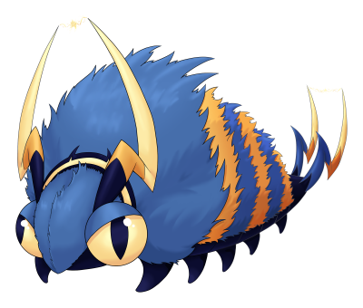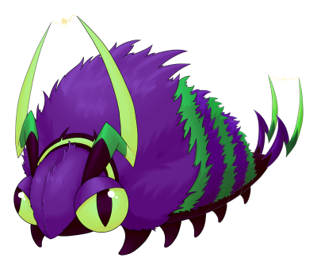

Stats and abilities:

Name: Ancient Venipede
Classification: Centipede Pokémon
Evolves into Ancient Whirlipede from level 22

Description: This Pokémon generates electricity with its fur. Any magical creature that brushes against its antennae risks paralysis, which has saved it from predators on more than one occasion.
Height: 0.4 m (1’04")
Mass: 4.7 kg (10.4 lbs)
Catch rate: 240
Experience yield: 52
Held item in the wild: Cheri Berry (6.25%), Oran Berry (18.75 %)
Raw material recovered by hunting: Raw Silk (×0.5)
Appearance: Bug like
Color: Blue
Rarity: Common
Tier: Zero Used – LC
----------

Type: Bug / Electric
Secondary affinities: Normal, Rock, Dark
Resistances: Electric, Grass, Fighting, Psychic, Steel
Weaknesses: Fire, Rock, Dragon
----------

Base stats:
HP: 30
Atk: 45
Def: 59
Sp. Atk: 30
Sp. Def: 39
Spd: 67
----------
Total: 270

EV: +1 Spd

Abilities:
• Static: The Pokémon is charged with static electricity, so contact with it may cause paralysis.
• Swarm: Powers up Bug-type moves a little when the Pokémon is injured, and significantly if badly.
• Speed Boost (hidden): Its Speed stat is boosted every turn.

Sexual dimorphism:
None

Ancient Whirlipede

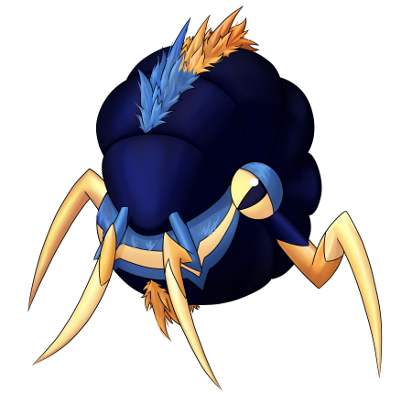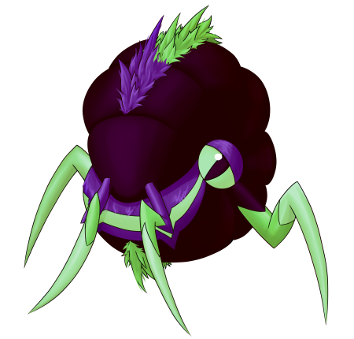

Stats and abilities:

Name: Ancient Whirlipede
Classification: Curlipede Pokémon
Evolution of Ancient Venipede from level 22
Evolves into Ancient Scolipede to level 30

Description: This insect curls into a ball to attack. As it swirls, it generates even more electricity, making its blows faster and more powerful.
Height: 1.2 m (3’11")
Mass: 42.3 kg (93.3 lbs)
Catch rate: 120
Experience yield: 126
Held item in the wild: Wacan Berry (6.25%), Oran Berry (18.75 %), Cheri Berry (50 %)
Raw material recovered by hunting: Raw Silk (×1)
Appearance: Only a head
Color: Blue
Rarity: Uncommon
Tier: Zero Used – NFE (Poorly Used – NFE with Speed Boost ability)
----------

Type: Bug / Electric
Secondary affinities: Normal, Rock, Dark, Steel
Resistances: Electric, Grass, Fighting, Psychic, Steel
Weaknesses: Fire, Rock, Dragon
----------

Base stats:
HP: 40 (+10)
Atk: 55 (+10)
Def: 99 (+40)
Sp. Atk: 40 (+10)
Sp. Def: 79 (+40)
Spd: 67 (+0)
----------
Total: 380 (+110)

EV: +2 Def

Abilities:
• Static: The Pokémon is charged with static electricity, so contact with it may cause paralysis.
• Swarm: Powers up Bug-type moves a little when the Pokémon is injured, and significantly if badly.
• Speed Boost (hidden): Its Speed stat is boosted every turn.

Sexual dimorphism:
None

Ancient Scolipede

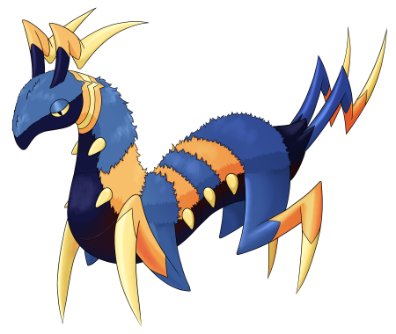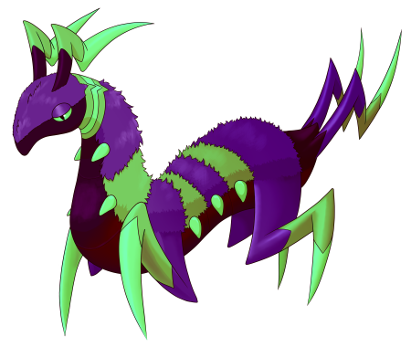

Stats and abilities:

Name: Ancient Scolipede
Classification: Megapede Pokémon
Evolution of Ancient Whirlipede from level 30
Mega Stone: (none)

Description: This Pokémon's agility is remarkable. It uses its speed to surprise and flinch its targets, before paralyzing them with its electrically-charged appendages.
Height: 2.5 m (8’02")
Mass: 148.8 kg (328,0 lbs)
Catch rate: 60
Experience yield: 214
Held item in the wild: Magnet (6.25%), Wacan Berry (18.75 %), Cheri Berry (50 %)
Raw material recovered by hunting: Raw Silk (×2)
Appearance: Bug like
Color: Blue
Rarity: Rare
Tier: Never Used (Over Used with Speed Boost ability)
----------

Type: Bug / Electric
Secondary affinities: Normal, Ground, Rock, Dark, Steel
Resistances: Electric, Grass, Fighting, Psychic, Steel
Weaknesses: Fire, Rock, Dragon
----------

Base stats:
HP: 60 (+20)
Atk: 100 (+45)
Def: 79 (-20)
Sp. Atk: 55 (+15)
Sp. Def: 69 (-10)
Spd: 122 (+55)
----------
Total: 485 (+105)

EV: +3 Spd

Abilities:
• Static: The Pokémon is charged with static electricity, so contact with it may cause paralysis.
• Swarm: Powers up Bug-type moves a little when the Pokémon is injured, and significantly if badly.
• Speed Boost (hidden): Its Speed stat is boosted every turn.

Sexual dimorphism:
None

Final evolution, no Mega-Evolution

Innate movepool (by leveling up or Move Reminder)

❌: Attack impossible to learn for this evolutionary stage or this form
💿: Attack not yet innate to this stage of evolution, but can be learned through external teaching.
Bold: Move benefiting from STAB at the time it is learned.
Italics: Move learned at a time when future evolution is required to unlock a STAB or secondary affinity.
Red: Anti-STAB because no secondary affinity on all stages of evolution. This move will consume more energy and have less power.
A learning level of 0 means that the Pokémon learns it when it evolves. Attacks that appear at level 1 after an evolution can be unlocked without a TM thanks to the Move Reminder.

Move | Type | Cat. | Power | Acc. | Learning level
 |  |  |  |  | Ancient Venipede | Ancient Whirlipede | Ancient Scolipede
Iron Defense |  |  | - | ∞ | 💿 | 0 | 22
Rock Climb |  |  | 90 | 85 | ❌ | 1 | 1
Fury Cutter |  |  | 40 | 95 | ❌ | ❌ | 1
Leech Life |  |  | 80 | 100 | ❌ | ❌ | 1
Pin Missile |  |  | 25 | 95 | 💿 | 💿 | 1
Wild Charge |  |  | 90 | 100 | 💿 | 💿 | 1
Nuzzle |  |  | 20 | 100 | 1 | 1 | 1
Defense Curl |  |  | - | ∞ | 1 | 1 | 1
Rollout |  |  | 30 | 90 | 4 | 4 | 4
Silk Trap |  |  | - | ∞ | 8 | 8 | 8
Screech |  |  | - | 85 | 12 | 12 | 12
Electroweb |  |  | 55 | 95 | 16 | 16 | 16
Pursuit |  |  | 40 | 100 | 20 | 20 | 20
Bug Bite |  |  | 60 | 100 | 24 | 26 | 26
Spark |  |  | 65 | 100 | 28 | 32 | 34
Agility |  |  | - | ∞ | 32 | 40 | 38
Charge |  |  | - | ∞ | 36 | 44 | 46
Zing Zap |  |  | 80 | 100 | 40 | 50 | 52
Megahorn |  |  | 120 | 85 | ❌ | ❌ | 58
Volt Tackle |  |  | 120 | 100 | 44 | 56 | 66

Shadow and Light movepool

Moves in blue are not part of the innate movepool and can only be obtained by Move Tutor once the Pokémon has obtained the type in question at least once and reached the minimum level.

Move | Type | Cat. | Power | Acc. | Learned instead of | Learning level
 |  |  |  |  |  | Ancient Venipede | Ancient Whirlipede | Ancient Scolipede
Shadow Blitz |  |  | 40 | 100 | Rollout | 4 | 4 | 4
Sacred Tackle |  |  | 40 | 100 | Rollout | 4 | 4 | 4
Shadow Rush |  |  | 55 | 100 | Electroweb | 16 | 16 | 16
Sacred Rush |  |  | 60 | 100 | Electroweb | 16 | 16 | 16
Shadow Bolt |  |  | 75 | 100 | Charge | 36 | 44 | 46
Celestial Bolt |  |  | 75 | 100 | Charge | 36 | 44 | 46
Shadow End |  |  | 120 | 90 | Volt Tackle | 44 | 56 | 66
Ram of Light |  |  | 100 | 95 | Volt Tackle | 44 | 56 | 66
Shadow Break |  |  | 75 | 100 | (Nothing) | 25 | 25 | 25

Acquired movepool (Technical Parchment, Move Tutor …)

• The attacks listed below or in the innate movepool are all legitimate for this Pokémon because the Mirror Herb – a kind of universal TM – allows you to transfer any move from a Pokémon that already knows it to another.
• Moves that benefit from STAB for at least one of the forms or evolutionary stages are noted in bold.
• If an evolution is required to unlock a STAB or secondary affinity and the attack could already be learned before the evolution in question, they are indicated in italics.
• Those that obtain no secondary affinity for all evolutionary stages (anti-STAB) are marked in red.

Move | Type | Category | Aptitude
Move | Type | Category | Ancient Venipede | Ancient Whirlipede | Ancient Scolipede
Facade |  |  | ✔️ | ✔️ | ✔️
Secret Power |  |  | ✔️ | ✔️ | ✔️
Frustration |  |  | ✔️ | ✔️ | ✔️
Return |  |  | ✔️ | ✔️ | ✔️
Double-Edge |  |  | ✔️ | ✔️ | ✔️
Hidden Power |  |  | ✔️ | ✔️ | ✔️
Protect |  |  | ✔️ | ✔️ | ✔️
Sleep Talk |  |  | ✔️ | ✔️ | ✔️
Substitute |  |  | ✔️ | ✔️ | ✔️
Wild Charge |  |  | ✔️ | ✔️ | Innate
Thunder Shock |  |  | ✔️ | ✔️ | ✔️
Thunderbolt |  |  | ✔️ | ✔️ | ✔️
Shock Wave |  |  | ✔️ | ✔️ | ✔️
Thunder Wave |  |  | ✔️ | ✔️ | ✔️
Eerie Impulse |  |  | ✔️ | ✔️ | ✔️
Endure |  |  | ✔️ | ✔️ | ✔️
Spikes |  |  | ✔️ | ✔️ | ✔️
Rest |  |  | ✔️ | ✔️ | ✔️
Pin Missile |  |  | ✔️ | ✔️ | Innate
Twineedle |  |  | ✔️ | ✔️ | ✔️
Skitter Smack |  |  | ✔️ | ✔️ | ✔️
Struggle Bug |  |  | ✔️ | ✔️ | ✔️
Infestation |  |  | ✔️ | ✔️ | ✔️
Signal Beam |  |  | ✔️ | ✔️ | ✔️
Payback |  |  | ✔️ | ✔️ | ✔️
Iron Defense |  |  | ✔️ | Innate | Innate
Attract |  |  | ✔️ | ✔️ | ✔️
Headbutt |  |  | ❌ | ✔️ | ✔️
Giga Impact |  |  | ❌ | ✔️ | ✔️
Snore |  |  | ❌ | ✔️ | ✔️
Double Team |  |  | ❌ | ✔️ | ✔️
Thunder |  |  | ❌ | ✔️ | ✔️
Volt Switch |  |  | ❌ | ✔️ | ✔️
Rock Smash |  |  | ❌ | ✔️ | ✔️
U-turn |  |  | ❌ | ✔️ | ✔️
Steamroller |  |  | ❌ | ✔️ | ✔️
First Impression |  |  | ❌ | ✔️ | ✔️
Bite |  |  | ❌ | ✔️ | ✔️
Gyro Ball |  |  | ❌ | ✔️ | ✔️
Steel Roller |  |  | ❌ | ✔️ | ✔️
Cut |  |  | ❌ | ❌ | ✔️
False Swipe |  |  | ❌ | ❌ | ✔️
Endeavor |  |  | ❌ | ❌ | ✔️
Swords Dance |  |  | ❌ | ❌ | ✔️
Rising Voltage |  |  | ❌ | ❌ | ✔️
Strength |  |  | ❌ | ❌ | ✔️
Dig |  |  | ❌ | ❌ | ✔️
Earthquake |  |  | ❌ | ❌ | ✔️
Bulldoze |  |  | ❌ | ❌ | ✔️
Stomping Tantrum |  |  | ❌ | ❌ | ✔️
X-Scissor |  |  | ❌ | ❌ | ✔️
Rock Slide |  |  | ❌ | ❌ | ✔️
Rock Tomb |  |  | ❌ | ❌ | ✔️
Assurance |  |  | ❌ | ❌ | ✔️
Throat Chop |  |  | ❌ | ❌ | ✔️
Snatch |  |  | ❌ | ❌ | ✔️
Iron Tail |  |  | ❌ | ❌ | ✔️
Smart Strike |  |  | ❌ | ❌ | ✔️

