Ourobud / Thornud / Scincophyl

Lineage’s Lore

Inspiration:

The lizard theme was chosen to create the Keltios’ Grass-type elemental starter. A creature that lives mainly in Iberia, Australian lizards were the main source of inspiration.

Biologically, it’s a neighbor of Heliolisk and Jungko. In terms of ideas, the emphasis on spines gave this Grass Pokémon an electric edge, in the sense that electricity is emitted by its spines. The concept was taken a step further with the tail, which takes the form of a flower acting as a lightning rod on the final evolved form, whereas it is a bud in its juvenile phase.

Etymology:

The etymology of Ourobud comes from “Ouroboros” and “bud”
The etymology of Thornud comes from “thorn” and “bud”. Its name also comes from the Australian lizard thorny devil (Moloch horridus).
The etymology of Scincophyl comes from the Australian lizard Tiliqua scincoides and “phýllon” (leaf, in ancient Greek).

Habitat:

This Pokémon is adapted to warm climates and lives in south-western Iberia, an area renowned for its thunderstorms. It is also found in the western part of the Iberian desert, but its range does not extend beyond the kingdom of Keltios.

Type:

To respect the affinity triangle between the double types of the three elemental starters, it was decided that this plant lizard would be of Electric-type, a very rare combination, as only possessed by Mow Rotom (then by Hisui’s Voltorb when Legends Arceus was released).
The second type is obtained during the first evolution: it is a pure Grass- type in its infantile stage.
Although the Flying and Ground weaknesses are compensated for, this double type has 5 remaining simple weaknesses inherited mainly from the Grass-type, against 5 resistances (including a double).
Offensively, all Grass- and Dragon-types resist this combination. In terms of coverage, the Dragon-, Steel- and Fighting-types can be found, but nothing to beat the Grass-type. For this reason, territorial battles between Scincophyls have a reputation for lasting a long time.

Stats:

Fakemon’s baby form is rather slow, but rather bulky.
As it evolves, its strengths and weaknesses are reversed. Speed increases significantly, physical strength appreciably, bulk little.
The final evolving form is very fast and specialized in Physical, even if it is fragile in Defense. Its distribution makes it ideally suited to the role of Glass Cannon and physical wallbreaker, which combines perfectly with its Lightning Eater and Overvoltage abilities.

Movepool:

In Little Cup, Ourobud is weak and has a limited movepool. Its Electric-type moves are not yet all accessible, and its only coverages (the first of which suffers from anti-STAB at this stage of evolution) are Steel and Dragon.
It can, however, set up itself with Hone Claws, Growth or Dragon Dance, cripple opponents with Thunder Wave, slow them down with Breaking Swipe, or be taught some fairly powerful Grass-type moves.

Its evolution into Thornud unlocks its true potential, a potential that can be accelerated by prematurely teaching it its innately learned attacks.
The first advantage gained is the acquisition of its Electric-type and secondary affinities Fighting and Steel, synonymous with exploitable coverages.
The second advantage is the possibility of learning Swords Dance, an alternative to Dragon Dance which is innate and which will become particularly useful when evolving into Scincophyl. (Thornud doesn’t have high Speed ​​yet, but Scincophyl is natively very fast.)
The third asset is the Hone Claws + Hustle ability combo. Of limited interest with Ourobud due to its low, unspecialized stats, Thornud needs only one placement to turn into a wallbreaker (+125% Attack) while having its accuracy penalty turned into a bonus.
If it has obtained the signature ability Overvoltage instead, Thornud will get the same boost as Hustle as soon as the terrain is electrified, especially if it uses Electric moves. If it has had time to place a Swords Dance or Dragon Dance beforehand (by delegating the invocation of a storm or electric terrain to a teammate in double battle, for example - even if it can do it itself), it will turn into a wallbreaker that’s almost impossible to stop, unless it’s walled by a Ground-type.

Its final evolution replaces its Hustle ability with Lightning Eater, an equivalent of Lightning Rod, but which boosts Attack. The potential of this ability is optimal in multi-battle; if this Pokémon absorbs an Electric attack, it switches to wallbreaker mode without needing to consume a turn.
At the same time, its Speed becomes considerable (123 of base stat). With a Dragon Dance, virtually no Pokémon will be able to overtake it. However, due to its low bulk, it remains vulnerable to revenge killers, but Scincophyl also has priorities: Quick Attack natively, Extreme Speed and Grassy Glide through teaching... and Pursuit if an opponent intends to switch (although the latter will do little damage due to the anti-STAB).
At the same time, its high speed works well with flinching attacks such as Zing Zap. Combined with paralysis, Scincophyl can prevent opponents from attacking for several turns if the Hax is on its side.

In terms of coverages, the Steel-type allows it to pass Ice-types, the Combat-type allows it to pass Steel-types, and the Dragon-type allows it to pass Dragon-types... and Electric! (This weakness has been added to my type chart so that each type has at least two vulnerabilities). In the latter case, Outrage can be chosen to inflict heavy damage once placed, and Dragon Tail to eject an unwanted or set up target.
Despite this, don’t forget that Scincophyl will be walled off by almost all Grass-type Pokémons. Teaching it U-turn will enable it to strategically withdraw from this disadvantageous situation, even if the damage inflicted will be reduced by the anti-STAB (Bug-type is not one of its secondary affinities).
Thornud and its evolution can also learn a few Dark-type attacks to surprise or annoy the opponent, notably Knock Off and Pursuit. But here too, the anti-STAB will be present and damage will remain limited.

It should also be noted that Scincophyl’s low Special Attack will prevent it from exploiting its special movepool, even if it can learn Volt Switch (U-turn will generally be preferred for the coverage it provides).

Finally, the Pokémon has the option of healing itself with Synthesis, Leech Seed and Aromatherapy. In practice, it’s difficult to exploit these Cleric’s moves unless you have a totally safe turn (e.g.: an opponent who stalls and has no offensive moves).

Lineage characteristics:

Experience curve: Quite slow (1,100,000 XP at level 100)
Breeding group: Floral (Juvenile for Ourobud)
Sex ratio: 50% male, 50% female
Pain of evolution: Average (quite painful)
Species fertility: From evolution into Thornud
Hatching time: Medium (20 cycles, or 5,120 steps)
Possible reincarnation after death: Calafoal

Ourobud

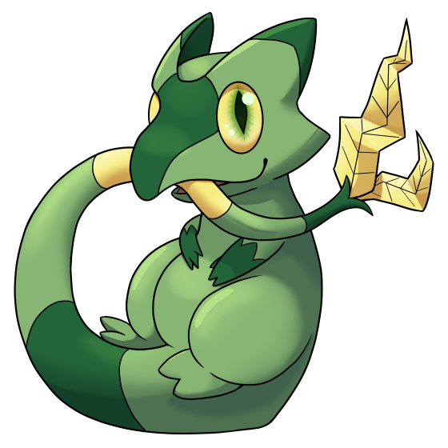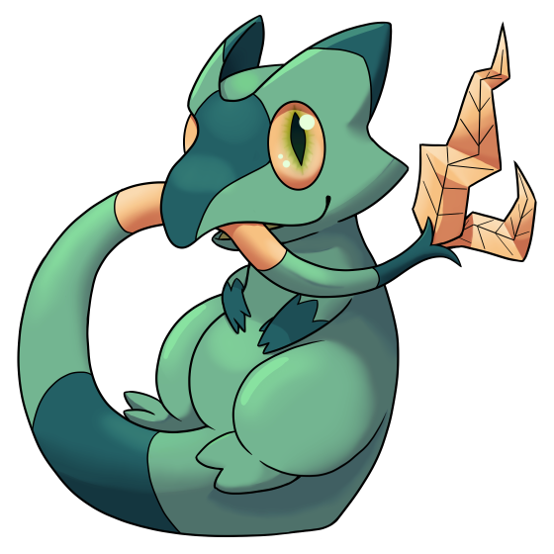

Name: Ourobud
Classification: Lizard Pokémon
Evolves into Thornud from level 16

Description: Native to the hot, stormy areas of Iberia, this lizard likes to curl up in a ball to chew its tail, hoping this will speed up the growth of its bud.
Height: 0.6 m (2’00")
Mass: 2.1 kg (4.6 lbs)
Catch rate: 140
Experience yield: 60
Held item in the wild: None
Raw material recovered by hunting: Seed (×0.5)
Appearance: Bipedal with tail
Color: Green
Rarity: Rare
Tier: Poorly Used – LC
----------

Type: Grass
Secondary affinities: Normal, Electric, Dragon
Resistances: Water, Grass, Ground, Light
Weaknesses: Fire, Ice, Poison, Flying, Bug
----------

Base stats:
HP: 55
Atk: 46
Def: 67
Sp. Atk: 42
Sp. Def: 58
Spd: 40
----------
Total: 308

EV: +1 Def

Abilities:
• Overgrow: Powers up Grass-type moves a little when the Pokémon is injured, and significantly if badly.
• Hustle: Boosts the Pokémon’s Attack stat but lowers its accuracy.
• Limber (hidden): Its limber body protects the Pokémon from paralysis.

Sexual dimorphism:
None at this stage of development

Thornud

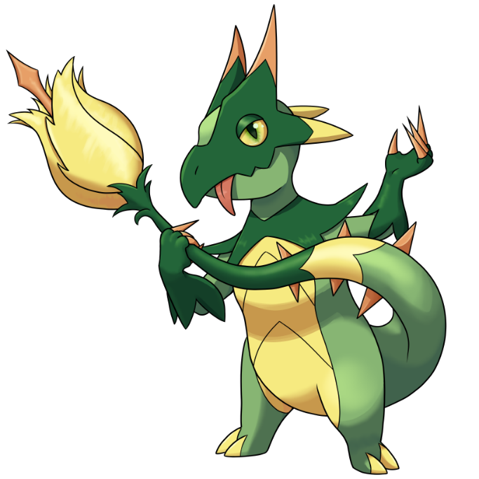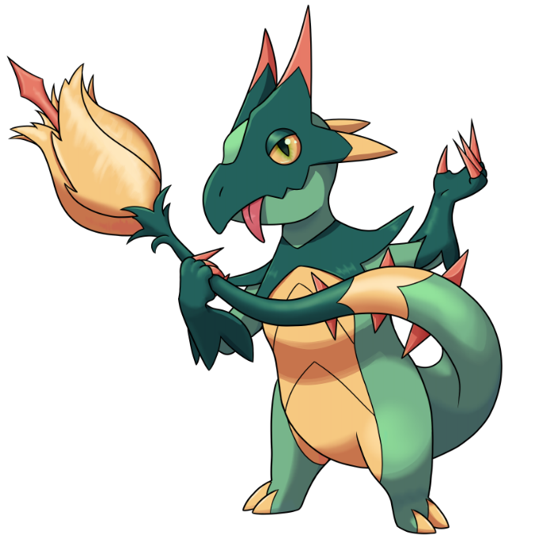

Name: Thornud
Classification: Thorn Pokémon
Evolves from Ourobud at level 16
Evolves into Scincophyl at level 35

Description: Their flower stores a lot of electrical power, but is difficult to control until it has fully bloomed. As a result, they often destroy things by accident.
Height: 1.1 m (3’07")
Mass: 17.3 kg (38.1 lbs)
Catch rate: 70
Experience yield: 122
Held item in the wild: Salac Berry (6.25 %)
Raw material recovered by hunting: Seed (×1)
Appearance: Bipedal with tail
Color: Green
Rarity: Rare
Tier: Poorly Used – NFE
----------

Type: Grass / Electric
Secondary affinities: Normal, Fighting, Dragon, Steel
Critical resistances: Electric
Resistances: Water, Grass, Steel, Light
Weaknesses: Fire, Ice, Poison, Bug, Dragon
----------

Base stats:
HP: 67 (+12)
Atk: 79 (+33)
Def: 69 (+2)
Sp. Atk: 52 (+10)
Sp. Def: 69 (+11)
Spd: 80 (+40)
----------
Total: 416 (+108)

EV: +2 Spd

Abilities:
• Overgrow: Powers up Grass-type moves a little when the Pokémon is injured, and significantly if badly.
• Hustle: Boosts the Pokémon’s Attack stat but lowers its accuracy.
• Overvoltage (hidden): Increases Attack by 50% on magnetic field or in thunderstorms, but doubles the energy consumption of all its moves.

Sexual dimorphism:
None at this stage of development

Scincophyl

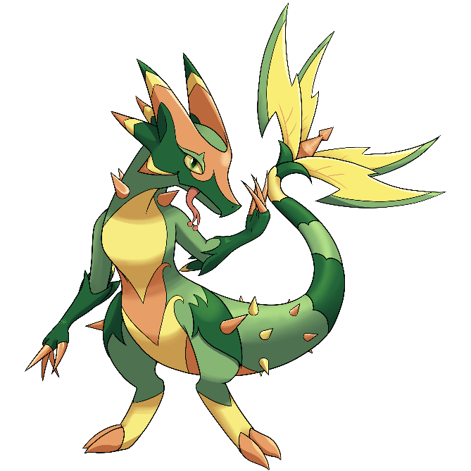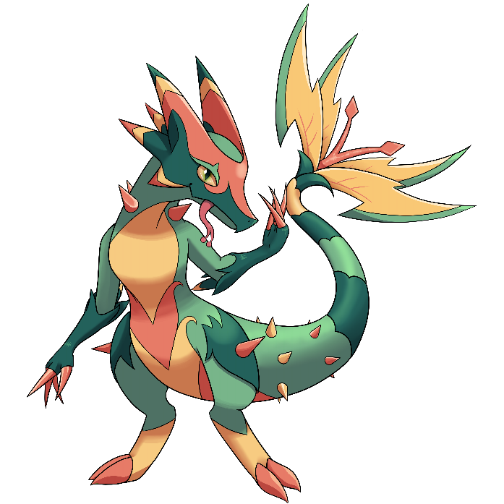
(Female / shiny male)

Name: Scincophyl
Classification: Lightning Rod Pokémon
Evolves from Thornud at level 35
Mega Stone: none

Description: Its floral tail acts as a lightning rod. When it absorbs electricity, it goes into a frenzied state and lacerates its enemies with lightning speed.
Height: 2.1 m (6’11")
Mass: 61.8 kg (136.2 lbs)
Catch rate: 35
Experience yield: 237
Held item in the wild: Bright Power (6.25 %), Salac Berry (18.75 %)
Raw material recovered by hunting: Seed (×2)
Appearance: Bipedal with tail
Color: Green
Rarity: Very rare
Tier: Under Used
----------

Type: Grass / Electric
Secondary affinities: Normal, Fighting, Dragon, Steel
Absorbed: Electric (if Lighting Eater ability)
Critical resistances: Electric (unless Lighting Eater ability)
Resistances: Water, Grass, Steel, Light
Weaknesses: Fire, Ice, Poison, Bug, Dragon
----------

Base stats:
HP: 78 (+11)
Atk: 118 (+39)
Def: 71 (+2)
Sp. Atk: 62 (+10)
Sp. Def: 81 (+12)
Spd: 123 (+43)
----------
Total: 533 (+117)

EV: +3 Spd

Abilities:
• Overgrow: Powers up Grass-type moves a little when the Pokémon is injured, and significantly if badly.
• Lightning Eater: Draws in all Electric-type moves to absorb them and boost its Atk stat.
• Overvoltage (hidden): Increases Attack by 50% on magnetic field or in thunderstorms, but doubles the energy consumption of all its moves.

Sexual dimorphism:
The center of the female’s flower has a single pistil, while the male has two large stamens.

Innate movepool (by leveling up or Move Reminder)

❌: Attack impossible to learn for this evolutionary stage or this form
💿: Attack not yet innate to this stage of evolution, but can be learned through external teaching.
Bold: Move benefiting from STAB at the time it is learned.
Italics: Move learned at a time when future evolution is required to unlock a STAB or secondary affinity.
Red: Anti-STAB because no secondary affinity on all stages of evolution. This move will consume more energy and have less power.
A learning level of 0 means that the Pokémon learns it when it evolves. Attacks that appear at level 1 after an evolution can be unlocked without a TM thanks to the Move Reminder.

Move | Type | Cat. | Power | Acc. | Learning level
 |  |  |  |  | Ourobud | Thornud | Scincophyl
Spark |  |  | 95 | 65 | 💿 | 0 | 16
Slash |  |  | 70 | 100 | 💿 | 1 | 1
Noble Roar |  |  | - | 100 | ❌ | 1 | 1
Hone Claws |  |  | - | ∞ | 💿 | 1 | 1
Swords Dance |  |  | - | ∞ | ❌ | 💿 | 0
Dragon Dance |  |  | - | ∞ | 💿 | 💿 | 1
Breaking Swipe |  |  | 60 | 100 | 💿 | 💿 | 1
Iron Tail |  |  | 100 | 75 | 💿 | 💿 | 1
Scratch |  |  | 40 | 100 | 1 | 1 | 1
Growl |  |  | - | 100 | 1 | 1 | 1
Leafage |  |  | 40 | 100 | 6 | 6 | 6
Quick Attack |  |  | 40 | 100 | 10 | 10 | 10
Growth |  |  | - | ∞ | 13 | 13 | 13
Trailblaze |  |  | 50 | 100 | 17 | 18 | 18
Leech Seed |  |  | - | 90 | ❌ | 22 | 22
Zing Zap |  |  | 80 | 100 | 23 | 26 | 26
Synthesis |  |  | - | ∞ | 27 | 30 | 30
Leaf Blade |  |  | 90 | 100 | 31 | 34 | 34
Screech |  |  | - | 90 | 35 | 38 | 39
Wild Charge |  |  | 90 | 100 | 39 | 42 | 44
Spiky Shield |  |  | - | ∞ | ❌ | 46 | 49
Supercell Slam |  |  | 100 | 95 | ❌ | 50 | 54
Thunderstorm |  |  | - | ∞ | ❌ | 54 | 59
Power Whip |  |  | 120 | 85 | 44 | 58 | 64
Volt Tackle |  |  | 120 | 100 | ❌ | 62 | 69

Shadow and Light movepool

Moves in blue are not part of the innate movepool and can only be obtained by Move Tutor once the Pokémon has obtained the type in question at least once and reached the minimum level.

Move | Type | Cat. | Power | Acc. | Learned instead of | Learning level
 |  |  |  |  |  | Ourobud | Thornud | Scincophyl
Shadow Blitz |  |  | 40 | 100 | Quick Attack | 10 | 10 | 10
Sacred Blitz |  |  | 40 | 100 | Quick Attack | 10 | 10 | 10
Shadow Bolt |  |  | 75 | 100 | Zing Zap | 23 | 26 | 26
Celestial Bolt |  |  | 75 | 100 | Zing Zap | 23 | 26 | 26
Life Dew |  |  | - | ∞ | Synthesis | 27 | 30 | 30
Shadow Down |  |  | - | 100 | Screech | 35 | 38 | 39
Shadow Break |  |  | 80 | 100 | Wild Charge | 39 | 42 | 44
Sacred Break |  |  | 80 | 100 | Wild Charge | 39 | 42 | 44
Shadow Sky |  |  | - | ∞ | Thunderstorm | ❌ | 54 | 59
Sigil of Light |  |  | - | ∞ | Thunderstorm | ❌ | 54 | 59
Shadow End |  |  | 120 | 90 | Volt Tackle | ❌ | 62 | 69
Ram of Light |  |  | 100 | 95 | Volt Tackle | ❌ | 62 | 69
Shadow Rend |  |  | 65 | 100 | (Nothing) | 15 | 15 | 15
Sacred Claw |  |  | 65 | 100 | (Nothing) | 15 | 15 | 15

Acquired movepool (Technical Parchment, Move Tutor …)

• The attacks listed below or in the innate movepool are all legitimate for this Pokémon because the Mirror Herb – a kind of universal TM – allows you to transfer any move from a Pokémon that already knows it to another.
• Moves that benefit from STAB for at least one of the forms or evolutionary stages are noted in bold.
• If an evolution is required to unlock a STAB or secondary affinity and the attack could already be learned before the evolution in question, they are indicated in italics.
• Those that obtain no secondary affinity for all evolutionary stages (anti-STAB) are marked in red.

Move | Type | Category | Aptitude
Move | Type | Category | Ourobud | Thornud | Scincophyl
Facade |  |  | ✔️ | ✔️ | ✔️
Secret Power |  |  | ✔️ | ✔️ | ✔️
Frustration |  |  | ✔️ | ✔️ | ✔️
Return |  |  | ✔️ | ✔️ | ✔️
Endeavor |  |  | ✔️ | ✔️ | ✔️
Take Down |  |  | ✔️ | ✔️ | ✔️
False Swipe |  |  | ✔️ | ✔️ | ✔️
Covet |  |  | ✔️ | ✔️ | ✔️
Natural Gift |  |  | ✔️ | ✔️ | ✔️
Slash |  |  | ✔️ | Innate | Innate
Hidden Power |  |  | ✔️ | ✔️ | ✔️
Nature Power |  |  | ✔️ | ✔️ | ✔️
Double Team |  |  | ✔️ | ✔️ | ✔️
Protect |  |  | ✔️ | ✔️ | ✔️
Sleep Talk |  |  | ✔️ | ✔️ | ✔️
Substitute |  |  | ✔️ | ✔️ | ✔️
Spark |  |  | ✔️ | Innate | Innate
Thunder Shock |  |  | ✔️ | ✔️ | ✔️
Thunderbolt |  |  | ✔️ | ✔️ | ✔️
Shock Wave |  |  | ✔️ | ✔️ | ✔️
Charge |  |  | ✔️ | ✔️ | ✔️
Thunder Wave |  |  | ✔️ | ✔️ | ✔️
Bullet Seed |  |  | ✔️ | ✔️ | ✔️
Seed Bomb |  |  | ✔️ | ✔️ | ✔️
Grassy Glide |  |  | ✔️ | ✔️ | ✔️
Giga Drain |  |  | ✔️ | ✔️ | ✔️
Energy Ball |  |  | ✔️ | ✔️ | ✔️
Leaf Storm |  |  | ✔️ | ✔️ | ✔️
Grass Pledge |  |  | ✔️ | ✔️ | ✔️
Aromatherapy |  |  | ✔️ | ✔️ | ✔️
Sweet Scent |  |  | ✔️ | ✔️ | ✔️
Grassy Terrain |  |  | ✔️ | ✔️ | ✔️
Endure |  |  | ✔️ | ✔️ | ✔️
Belch |  |  | ✔️ | ✔️ | ✔️
Rest |  |  | ✔️ | ✔️ | ✔️
Agility |  |  | ✔️ | ✔️ | ✔️
Breaking Swipe |  |  | ✔️ | ✔️ | Innate
Dragon Dance |  |  | ✔️ | ✔️ | Innate
Hone Claws |  |  | ✔️ | Innate | Innate
Metal Claw |  |  | ✔️ | ✔️ | ✔️
Iron Tail |  |  | ✔️ | ✔️ | Innate
Iron Head |  |  | ✔️ | ✔️ | ✔️
Attract |  |  | ✔️ | ✔️ | ✔️
Rage |  |  | ❌ | ✔️ | ✔️
Cut |  |  | ❌ | ✔️ | ✔️
Headbutt |  |  | ❌ | ✔️ | ✔️
Extreme Speed |  |  | ❌ | ✔️ | ✔️
Swords Dance |  |  | ❌ | ✔️ | Innate
Focus Energy |  |  | ❌ | ✔️ | ✔️
Flash |  |  | ❌ | ✔️ | ✔️
Thunder Punch |  |  | ❌ | ✔️ | ✔️
Thunder |  |  | ❌ | ✔️ | ✔️
Volt Switch |  |  | ❌ | ✔️ | ✔️
Rising Voltage |  |  | ❌ | ✔️ | ✔️
Electric Terrain |  |  | ❌ | ✔️ | ✔️
Needle Arm |  |  | ❌ | ✔️ | ✔️
Petal Blizzard |  |  | ❌ | ✔️ | ✔️
Solar Blade |  |  | ❌ | ✔️ | ✔️
Solar Beam |  |  | ❌ | ✔️ | ✔️
Petal Dance |  |  | ❌ | ✔️ | ✔️
Grass Knot |  |  | ❌ | ✔️ | ✔️
Rock Smash |  |  | ❌ | ✔️ | ✔️
Counter |  |  | ❌ | ✔️ | ✔️
Brick Break |  |  | ❌ | ✔️ | ✔️
Dynamic Punch |  |  | ❌ | ✔️ | ✔️
Focus Punch |  |  | ❌ | ✔️ | ✔️
Dig |  |  | ❌ | ✔️ | ✔️
Fury Cutter |  |  | ❌ | ✔️ | ✔️
U-turn |  |  | ❌ | ✔️ | ✔️
Outrage |  |  | ❌ | ✔️ | ✔️
Pursuit |  |  | ❌ | ✔️ | ✔️
Thief |  |  | ❌ | ✔️ | ✔️
Knock Off |  |  | ❌ | ✔️ | ✔️
Throat Chop |  |  | ❌ | ✔️ | ✔️
Giga Impact |  |  | ❌ | ❌ | ✔️
Hyper Beam |  |  | ❌ | ❌ | ✔️
Sunny Day |  |  | ❌ | ❌ | ✔️
Frenzy Plant |  |  | ❌ | ❌ | ✔️
Strength |  |  | ❌ | ❌ | ✔️
Rock Climb |  |  | ❌ | ❌ | ✔️
Dragon Tail |  |  | ❌ | ❌ | ✔️
Dragon Rush |  |  | ❌ | ❌ | ✔️

