Nocy / Nosmound / Nostra

Lineage’s Lore

Inspiration:

Originally a simple regional form of Pidgeot from an abandoned fangame that remained in embryonic form, the decision to make it something totally original was soon felt. The theme was the bird of the underworld, and Arnik, its original creator outlined its four main characteristics:
– Ghost/Flying-type (a very rare dual type: at Keltios, this will be the only lineage to have it.)
– The eyes are its face are empty...
–... because its real eyes (three in all) are located on each end of its three long tail feathers.
– Its sub-evolutions (never drawn) have respectively only one and two tail feathers with an eye at their ends.

Hræsvelg was the perfect inspiration and it became a bird of prey with two pairs of wings and a spectral appearance from which emanates an evil aura.
I also had to create the two pre-evolved forms that didn’t exist. I wanted to start from the raven of the underworld with Celtic motifs, but the artist of our project finally went another way by being inspired more by Natu.

Knowing that it was overpowered in its original game (last trainer’s Pokémon with Shadow Tag as an ability), it naturally became the pseudo-legendary of Keltios and will join the closed circle of Ubers.

Etymology:

The etymology of Nocy comes from “nocturnal” and “baby”.
The etymology of Nosmound comes from “nocturnal” and “mound” (burial mound for the dead).
The etymology of Nostra comes from “nocturnal” and the word “Astra” (stars in Latin).

Habitat:

Like all Ghost Pokémons, the lineage is perpetuated by the death of non-spectral magical creatures: in this case, most Flying Pokémons. If such a Pokémon should feel the desire to remain in the world of the living, it will reincarnate as Nocy.
This first evolutionary stage can be found in the last floors of the Yveltal’s Tower in Sambucus, but it remains difficult to find since it is a pseudo legendary. Some of them can also be seen in the company of Nosmounds on the slopes of the Odinic Mountains or the Distortion Massif, inaccessible without Rock Climb or Waterfall.
Nostra is a Pokémon too powerful to take up residence in the world of the living. At this point, the call of the realm of the dead is stronger and they will only be found in the wild in the Distortion World... although there may be alpha Nostras hiding in the deepest caves of the Distortion Massif.

Type:

The lineage inherits the dual Ghost/Flying-type. At Keltios, this combination offers 3 immunities, 1 critical resistance against the Bug-type, 3 simple resistances (including one against the Psychic-type) and 6 weaknesses (including one against the new Light-type). It is therefore quite heterogeneous and average defensively, but its numerous immunities will make it a dangerous Pokémon. (Don’t forget that Ghost-types are immune to their own status moves: death does not affect them, even if they remain very sensitive to their offensive magic).
Since they have a natural ability to fly, granting them Light or Shadow-type will not remove their immunity to Ground-type attacks, even though this new type replaces the Flying-type.
Offensively, the dual type Ghost/Flying offers excellent coverage, so few magical creatures will be able to withstand its onslaught.

Stats:

Its primitive form has fragile stats, except for Speed and Special Attack where it’s a bit more drinkable. As it evolves, its Attack tends to balance on its Special Attack while retaining its good Speed, which makes it offensively balanced, but at the cost of mediocre bulk.
Its final evolved form results in a big increase in its stats. The first stat to benefit from this is its HP, which gives it a fairly good bulk, making it viable for short-term stall strategies. Its two offensive stats are over 110, which gives it a very good potential in mixed, even if we will tend to favor the Special. Finally, its fairly good Speed will allow it to strike first in most situations, except among Ubers where Nostra will be considered a fairly slow Pokémon, and therefore vulnerable to a pre-emptive attack.

Movepool:

At the beginning, the Pokémon has access to basic Flying and Ghost-type moves. It is around level 20 that some interesting attacks appear: the priority brought by Shadow Sneak, Ominous Wind to randomly increase a stat with each use and Roost to regenerate and ensure a minimum of Staying Power.

Its first evolution unlocks a secondary affinity with the Ice-type, access to Icy Wind, as well as a few abilities exclusive to the Move Reminder: Tailwind and Hone Claws to boost itself, Pursuit to surprise the opponent, and Brave Bird to hit hard (at its own risk due to the recoil). Naturally learned attacks also gain in power and highlight its mixed potential. These include Shadow Claw and Drill Peck on the physical side; and on the special side, Air Cutter (which can flinch, which goes very well with its fairly high Speed) and Bitter Malice. The latter is as powerful as Shadow Ball, but instead of having a 20% chance of lowering Special Defense, it has a 100% base chance of lowering Attack. This makes it a master card for a Stall strategy if combined with Roost. Nasty Plot, which unlocks at a fairly high level, will reveal a Sweeper potential, but keep in mind that this requires placement turns (and is not compatible with “choice” items, but a Life Orb can be a good strategy).

As it evolves, Nostra becomes as dangerous as a Legendary because of its Shadow Tag ability and the Perish Song attack that it learns at the same time. Knowing that Nostra itself is immune to this attack (because it is a Ghost-type), this will only leave four turns for its opponents to take it down before Yveltal’s wings strike them, unless they have a way to force a switch or are themselves immune to Perish Song.
Nostra unlocks Phantom Force shortly before its very late final evolution (perfect for gaining a turn after a Perish Song) and Hurricane some levels after (a Flying STAB that will pair nicely with its Special Attack stat).
This semi-legendary also acquires the possibility to learn Blizzard by the Move Reminder and thus have one of the best coverages (even if the attack remains not very accurate). Some Dark-type attacks (like Dark Pulse) can also be learned by external means and constitute a fourth type of coverage for it.
Finally, it should be noted that the lineage has a secondary affinity with the Shadow-type. Even if its natural attacks remain the most powerful, it offers an additional coverage.

Lineage characteristics:

Experience curve: Slow (1,250,000 XP at level 100)
Breeding group: Undead
Sex ratio: 50% male, 50% female
Pain of evolution: Maximum (very painful)
Species fertility: None. This Ghost Pokémon is the fruit of the reincarnation of a Pokémon of Flying-type whose soul remained in the world of the living.
Hatching time: None (15,360 steps if an egg is generated, only possible by cheating)

Nocy

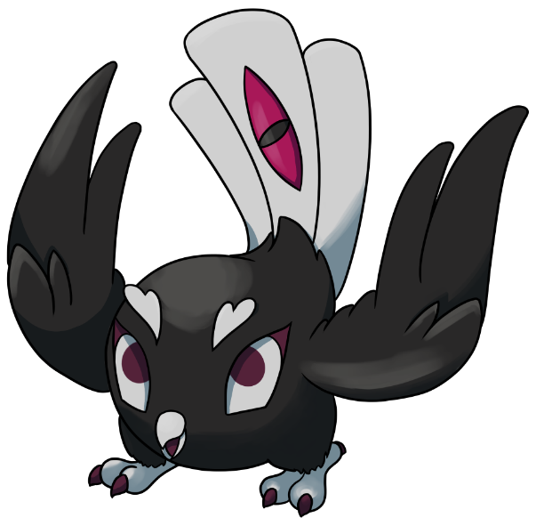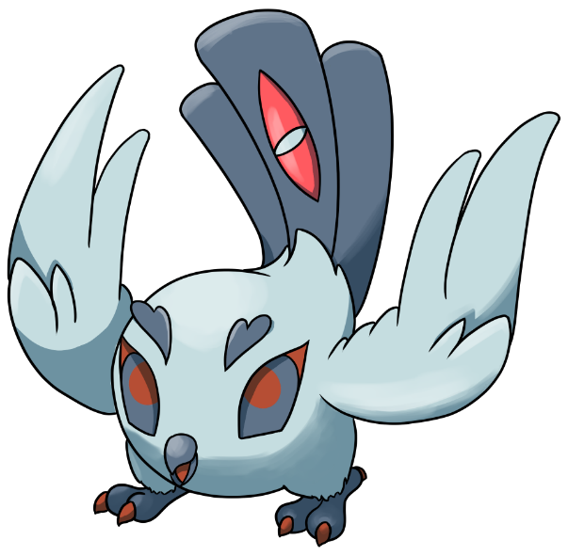

Stats and abilities:

Name: Nocy
Classification: Spectral fledgling Pokémon
Evolves into Nosmound from level 32

Description: They appear in flocks after a bloody battle, calling souls for their final journey. Once peace returns, few remain in the world of the living.
Height: 0.4 m (1’04")
Mass: 0.9 kg (2.0 lbs)
Catch rate: 45
Experience yield: 92
Held item in the wild: None
Raw material recovered by hunting: Nil (intangible Pokémon)
Appearance: A pair of wings
Color: Black
Rarity: Very rare (pseudo-legendary)
Tier: Zero Used – LC
----------

Type: Ghost / Flying
Secondary types: Normal, Dark, Shadow
Immunities: Normal, Fighting, Ground
Critical Resistances: Bug
Resistances: Grass, Poison, Psychic
Weaknesses: Electric, Ice, Rock, Ghost, Dark, Light
----------

Base stats:
HP: 40
Atk: 50
Def: 42
Sp. Atk: 62
Sp. Def: 45
Spd: 61
----------
Total: 300

EV: +1 Sp. Atk

Abilities:
• No Guard: The Pokémon employs no-guard tactics to ensure incoming and outgoing attacks always land.
• Infiltrator: The Pokémon’s moves are unaffected by the target’s barriers, substitutes, and the like.

Sexual dimorphism:
None

Nosmound

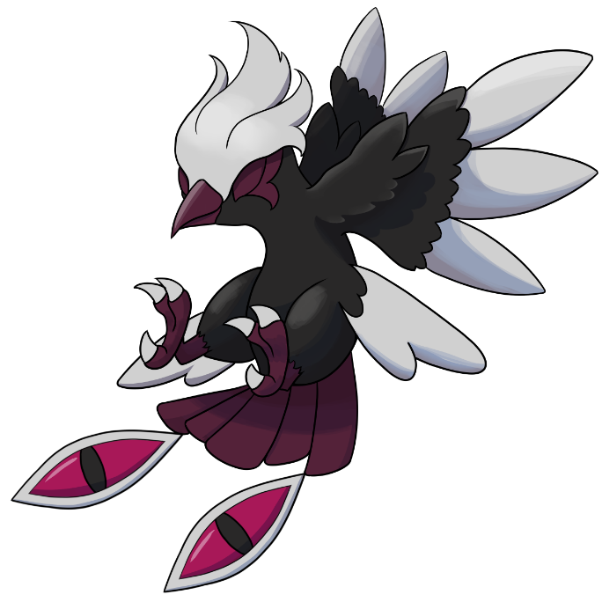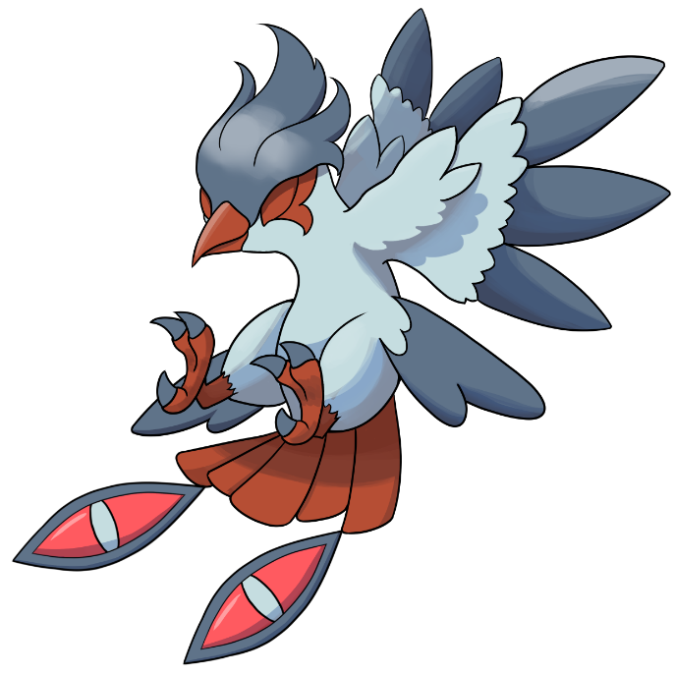

Stats and abilities:

Name: Nosmound
Classification: Spectral Bird Pokémon
Evolution of Nocy from level 32
Evolves into Nostra from level 58

Description: It flies over the graves and guides the souls to the afterlife. Its wingbeats are capable of generating a sinister and icy wind.
Height: 0.9 m (2’11")
Mass: 2.7 kg (6.0 lbs)
Catch rate: 25
Experience yield: 191
Held item in the wild: Bright Powder (6.25%)
Raw material recovered by hunting: Nil (intangible Pokémon)
Appearance: A pair of wings
Color: Black
Rarity: Very rare (pseudo-legendary)
Tier: Poorly Used - NFE
----------

Type: Ghost / Flying
Secondary types: Normal, Ice, Dark, Shadow
Immunities: Normal, Fighting, Ground
Critical Resistances: Bug
Resistances: Grass, Poison, Psychic
Weaknesses: Electric, Ice, Rock, Ghost, Dark, Light
----------

Base stats:
HP: 65 (+25)
Atk: 75 (+25)
Def: 57 (+17)
Sp. Atk: 80 (+18)
Sp. Def: 65 (+15)
Spd: 78 (+17)
----------
Total: 420 (+120)

EV: +2 Sp. Atk

Abilities:
• No Guard: The Pokémon employs no-guard tactics to ensure incoming and outgoing attacks always land.
• Infiltrator: The Pokémon’s moves are unaffected by the target’s barriers, substitutes, and the like.

Sexual dimorphism:
None

Nostra

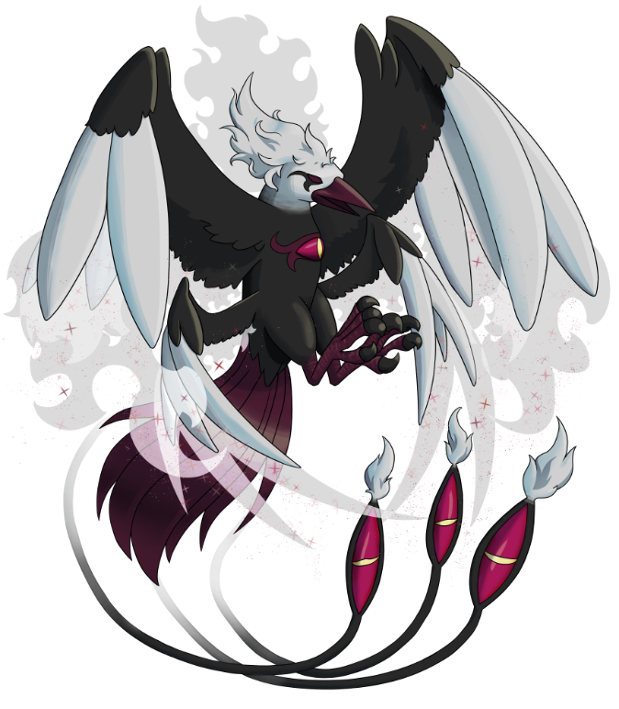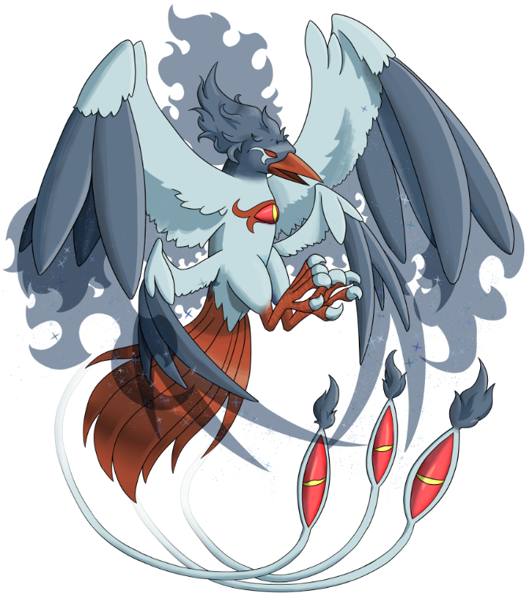

Stats and abilities:

Name: Nostra
Classification: Underworld Eagle Pokémon
Evolution of Nosmound from level 58
Mega Stone: (none)

Description: It is known as the Corpse Swallower. Guardian of the kingdoms of Yveltal and Giratina, its song attracts souls to the other world.
Height: 2.2 m (7’03")
Mass: 28.8 kg (61.7 lbs)
Catch rate: 12
Experience yield: 357
Held item in the wild: Spell Tag (6.25%), Bright Powder (18.75%)
Raw material recovered by hunting: Nil (intangible Pokémon)
Appearance: Many wings
Color: Black
Rarity: Very rare (pseudo-legendary)
Tier: Uber
----------

Type: Ghost / Flying
Secondary types: Normal, Dark, Shadow
Immunities: Normal, Ice, Fighting, Ground
Critical Resistances: Bug
Resistances: Grass, Poison, Psychic
Weaknesses: Electric, Ice, Rock, Ghost, Dark, Light
----------

Base stats:
HP: 110 (+45)
Atk: 116 (+41)
Def: 80 (+23)
Sp. Atk: 120 (+40)
Sp. Def: 82 (+17)
Spd: 92 (+14)

EV: +3 Sp. Atk

Abilities:
• Shadow Tag: This Pokémon steps on the opposing Pokémon’s shadow to prevent it from escaping.

Sexual dimorphism:
None

Final evolution, no Mega-Evolution

Innate movepool (by leveling up or Move Reminder)

❌: Attack impossible to learn for this evolutionary stage or this form
💿: Attack not yet innate to this stage of evolution, but can be learned through external teaching.
Bold: Move benefiting from STAB at the time it is learned.
Italics: Move learned at a time when future evolution is required to unlock a STAB or secondary affinity.
Red: Anti-STAB because no secondary affinity on all stages of evolution. This move will consume more energy and have less power.
A learning level of 0 means that the Pokémon learns it when it evolves. Attacks that appear at level 1 after an evolution can be unlocked without a TM thanks to the Move Reminder.

Move | Type | Cat. | Power | Acc. | Learning level
 |  |  |  |  | Nocy | Nosmound | Nostra
Icy Wind |  |  | 55 | 95 | ❌ | 0 | 32
Hone Claws |  |  | - | ∞ | ❌ | 1 | 1
Pursuit |  |  | 40 | 100 | ❌ | 1 | 1
Tailwind |  |  | - | ∞ | ❌ | 1 | 1
Brave Bird |  |  | 120 | 100 | ❌ | 1 | 1
Perish Song |  |  | - | ∞ | ❌ | ❌ | 0
Blizzard |  |  | 120 | 70 | ❌ | ❌ | 1
Astonish |  |  | 30 | 100 | 1 | 1 | 1
Leer |  |  | - | 100 | 3 | 3 | 3
Peck |  |  | 35 | 100 | 6 | 6 | 6
Confuse Ray |  |  | - | 100 | 10 | 10 | 10
Shadow Sneak |  |  | 40 | 100 | 15 | 15 | 15
Wing Attack |  |  |  |  | 20 | 20 | 20
Ominous Wind |  |  | 60 | 100 | 24 | 24 | 24
Roost |  |  | - | ∞ | 28 | 28 | 28
Shadow Claw |  |  | 70 | 100 | 34 | 36 | 36
Air Slash |  |  | 75 | 95 | 37 | 40 | 40
Bitter Malice |  |  | 80 | 100 | 41 | 45 | 45
Drill Peck |  |  | 80 | 10 | 45 | 49 | 49
Nasty Plot |  |  | - | ∞ | 48 | 53 | 53
Phantom Force |  |  | 90 | 100 | 53 | 59 | 63
Hurricane |  |  | 120 |  | 58 | 66 | 71
Destiny Bond |  |  | - | ∞ | 63 | 71 | 79

Shadow and Light movepool

Moves in blue are not part of the innate movepool and can only be obtained by Move Tutor once the Pokémon has obtained the type in question at least once and reached the minimum level.
Note that this lineage has a natural secondary affinity with the Shadow-type. These moves will therefore not be subject to anti-STAB if the Pokémon has lost this type.

Move | Type | Cat. | Power | Acc. | Learned instead of | Learning level
 |  |  |  |  |  | Nocy | Nosmound | Nostra
Shadow Blitz |  |  | 40 | 100 | Peck | 6 | 6 | 6
Sacred Tackle |  |  | 40 | 100 | Peck | 6 | 6 | 6
Shadow Panic |  |  | - | 90 | Confuse Ray | 10 | 10 | 10
Celestial Torment |  |  | - | 100 | Confuse Ray | 10 | 10 | 10
Shadow Rend |  |  | 65 | 100 | Shadow Claw | 34 | 36 | 36
Sacred Claw |  |  | 65 | 100 | Shadow Claw | 34 | 36 | 36
Shadow Chill |  |  | 75 | 100 | Air Slash | 37 | 40 | 40
Celestial Chill |  |  | 75 | 100 | Air Slash | 37 | 40 | 40
Shadow Storm |  |  | 95 | 100 | (Nothing) | ❌ | 40 | 40
Shadow Sky |  |  | - | ∞ | (Nothing) | ❌ | ❌ | 35
Shadow End |  |  | 120 | 90 | (Nothing) | ❌ | ❌ | 45
Light of Ruin |  |  | 140 | 90 | (Nothing) | ❌ | ❌ | 50

Acquired movepool (Technical Parchment, Move Tutor …)

• The attacks listed below or in the innate movepool are all legitimate for this Pokémon because the Mirror Herb – a kind of universal TM – allows you to transfer any move from a Pokémon that already knows it to another.
• Moves that benefit from STAB for at least one of the forms or evolutionary stages are noted in bold.
• If an evolution is required to unlock a STAB or secondary affinity and the attack could already be learned before the evolution in question, they are indicated in italics.
• Those that obtain no secondary affinity for all evolutionary stages (anti-STAB) are marked in red.

Move | Type | Category | Aptitude
Move | Type | Category | Nocy | Nosmound | Nostra
Facade |  |  | ✔️ | ✔️ | ✔️
Secret Power |  |  | ✔️ | ✔️ | ✔️
Frustration |  |  | ✔️ | ✔️ | ✔️
Return |  |  | ✔️ | ✔️ | ✔️
Endeavor |  |  | ✔️ | ✔️ | ✔️
Hidden Power |  |  | ✔️ | ✔️ | ✔️
Double Team |  |  | ✔️ | ✔️ | ✔️
Protect |  |  | ✔️ | ✔️ | ✔️
Sleep Talk |  |  | ✔️ | ✔️ | ✔️
Substitute |  |  | ✔️ | ✔️ | ✔️
Endure |  |  | ✔️ | ✔️ | ✔️
Aerial Ace |  |  | ✔️ | ✔️ | ✔️
Pluck |  |  | ✔️ | ✔️ | ✔️
Dual Wingbeat |  |  | ✔️ | ✔️ | ✔️
Rest |  |  | ✔️ | ✔️ | ✔️
Agility |  |  | ✔️ | ✔️ | ✔️
Hex |  |  | ✔️ | ✔️ | ✔️
Shadow Ball |  |  | ✔️ | ✔️ | ✔️
Night Shade |  |  | ✔️ | ✔️ | ✔️
Grudge |  |  | ✔️ | ✔️ | ✔️
Spite |  |  | ✔️ | ✔️ | ✔️
Mean Look |  |  | ✔️ | ✔️ | ✔️
Spectral Curse |  |  | ✔️ | ✔️ | ✔️
Steel Wing |  |  | ✔️ | ✔️ | ✔️
Attract |  |  | ✔️ | ✔️ | ✔️
Hyper Beam |  |  | ❌ | ✔️ | ✔️
Ice Beam |  |  | ❌ | ✔️ | ✔️
Mist |  |  | ❌ | ✔️ | ✔️
Haze |  |  | ❌ | ✔️ | ✔️
Fly |  |  | ❌ | ✔️ | ✔️
Razor Wind |  |  | ❌ | ✔️ | ✔️
Whirlwind |  |  | ❌ | ✔️ | ✔️
Lash Out |  |  | ❌ | ✔️ | ✔️
Night Slash |  |  | ❌ | ✔️ | ✔️
Dark Pulse |  |  | ❌ | ✔️ | ✔️
Double-Edge |  |  | ❌ | ❌ | ✔️
Giga Impact |  |  | ❌ | ❌ | ✔️
Snowscape |  |  | ❌ | ❌ | ✔️
Sky Attack |  |  | ❌ | ❌ | ✔️

