Cubone / Marowak / Kangasbone / Kangaskhan

Lineage’s Lore

Inspiration:

With Tauros and Miltank, here’s another another lineage that fulfills an old Pokéfans theory. Kangaskhan becomes the final evolution of Marowak, offering interest to a Pokémon stuck in the weakest tier in the official games.
However, only females can reach this final stage. It was therefore necessary to create a male Pokémon of equivalent power: Kangasbone, which uses a large bone as a club to deliver shattering blows.

The death of a Pokémon from this lineage will produce a tropical Marowak, which has no evolution. If a Cubone dies and is reincarnated shortly after birth, it can acquire this form as early as level 5 (minimum reincarnation level). A Cubone can also acquire this spectral form if it reaches its evolution level in a cursed and dark place (indoors or outdoors at night). This is said to be due to a curse placed on the skull worn from a deceased sibling.

The species is only fertile after evolution into (non-spectral) Marowak, which makes it rare and vulnerable to hunting due to its slow breeding rate. We can also understand why Kangaskhan are very protective of their offspring.

Last but not least, Kangaskhan’s weight has been revised upwards: a corpulent creature 2 meters tall can hardly weigh less than 100 kg.

Etymology:

The etymology of Cubone comes from “cub” and “bone”
The etymology of Marowak comes from “marrow” and “whack”
The etymology of Kangasbone comes from “kangaroo” and “bone”
The etymology of Kangaskhan comes from “kangaroo” and “khan” (leader, in Mongolian and Turkish).

Habitat:

In terms of lineage distribution, it tends to be found in deserts and bone-strewn areas such as the caves of southern Iberia, the Huath Desert, the Tower of Yveltal and the southern slopes of the Odinic Mountains. The spectral form is naturally found in these last two grim areas of northern Keltios, though it is ironically referred to as "Tropical Form" (due to what Pokémon was first seen in the Selestia Archipelago and the sailors who traveled report many legends about them). As for Kangasbone and Kangaskhan, they can only be found in remote areas of the Huath desert, and often as Alpha Pokémons, as this stage of evolution is only reached at high levels.

Type:

The types of this lineage have been converged in order to link each species: Cubone and Marowak gain the Normal-type in second position, while Kangaskhan sees the Ground-type appear in this slot, but her Mega Evolution remains pure Normal type so as not to add powercreep to an already Uber Pokémon. Kangasbone, on the other hand, becomes Ground / Combat. This shows that the female is increasingly prioritizing the Normal-type, while the male is strengthening his brute-force, ground-related side. Don’t forget that the order of types is important, as it’s the second type that will be replaced when the Pokémon becomes Light or Shadow.

Strategically, the addition of Normal-type to Cubone and Marowak gives them two advantages: immunity to Ghost-type (in exchange for a Fighting weakness) and a STAB on the many moves of this type that them learn naturally. As for Kangaskhan (not Mega), this allows her to deliver fairly powerful Earthquakes (or Bonemerangs), and to manage two of her natural counters in vanilla gameplay: Steel and Rock-types. However, you’ll have to be careful with the weaknesses common to all Ground types: Grass, Water and Ice, types often used offensively.
Kangasbone, on the other hand, inherits the unique Ground / Fighting double type. This combination is defensively fragile (6 weaknesses for 3 resistances, 1 double resistance and 1 immunity), but dangerous from an offensive point of view (they are the only two types to strike effectively on 5 defensive types).

On the tropical Marowak side, we have a very heterogeneous result defensively, but rather advantageous: 10 resisted types (including 2 immunities and 1 critical resistance) against 6 simple weaknesses. Offensive level, Ghost and Fire give very good coverage.

Stats:

Its primitive form is very slow with low stats everywhere, except on its Defense which is quite high. By evolving into Marowak (or by reincarnating into its spectral version), its Attack and Special Defense climb to the average, while his Defense and Speed increase substantially. Despite this, its HP and Speed remain low, weakening its bulk and making it vulnerable to ripostes.

Evolution into Kangaskhan results in a decrease in Defense, but a significant increase in HP and Speed, while her Attack becomes quite good. This makes her quite versatile, although an offensive role will be preferred.
Kangasbone, on the other hand, sees his HP and Attack increase significantly. Its Moxie and Defiant abilities will help him become a terrifying physical wallbreaker, but he remains a slow Pokémon (though not slow enough for a Trick Room to counterbalance it). As a result, he will often have to take an attack before he can deliver his terrifying sledgehammer blow ... Nevertheless, his staying power (105/100/80 on defensive stats) should enable him to hold out for a blow or two despite his many elemental vulnerabilities.

A word about the Thick Club: this item doubles the Attack of Cubone and Marowak. Perfect for a wallbreaker role, the species nevertheless remains vulnerable to Revenge Killers due to its Speed (unless you play Trick Room and minimize IVs on this stat) and to the alteration of its held item (Knock Off, Trick ...). The Eviolite for the basic Marowak (+50% on both defensive stats) could be discussed, but the Pokémon doesn’t have enough bulk to be played in stall strategies.
At Kangasbone, the Thick Club boost is 50%. In other words, a Choice Band without its drawbacks. It gives him a very slight increase in Attack compared to the Marowak stage (i.e., an offensive monster that hits as hard as a Rampardos or Mega Garchomp), while benefiting from a significantly better bulk compared to his pre-evolution (even if it’s not exceptional).
For her part, Kangaskhan does not benefit from this boost, so as not to amplify the powercreep generated by the addition of the Ground-type and the legacy of moves inherited when she was just a Cubone or a Marowak. Her strength lies in her Mega Evolution: as (over)powerful as a Legendary, her ability to strike twice with Parental Bond and double the damage of Seismic Toss will shatter many an opponent’s tenacity, especially those based on friendship.

Movepool:

Cubone is born with Mud-Slap and Growl, followed by Tail Whip and False Swipe. It quickly learns Bone Club (which is not dexited at Keltios), which will be its best offensive asset if it holds the eponymous item, before Bone Rush and Bonemerang are learned a little later. Don’t overlook its Normal attacks, which take advantage of the STAB: Rage then Headbutt; and at high level, Retaliate, Thrash and Double-Edge. It also learns Fling and Bite at a relatively modest level, Dark-type being its first secondary affinity (Fighting and Rock will come second with its first evolution).
If it evolves (or reincarnates) into a tropical Marowak, a whole tree of Fire and Ghost-type moves will be revealed (Fire Spin, Will-O-Wisp, Flare Blitz, Shadow Bone, Hex, etc.), while the Normal, Combat, Ground, and Dark-types are relegated to secondary affinities.
By evolving into Kangaskhan or Kangasbone, these Pokémons unlock a common movepool. Some of these moves will reveal themselves through a Move Reminder: Double Hit, Fake Out, Seismic Toss, Dizzy Punch, Chip Away, Sucker Punch, Endure, and Crunch. At high level will be learned Reversal, Last Resort, Double-Edge and Earthquake. Fighting-type ones will particularly benefit Kangasbone, while Kangaskhan will make the most of Normal-type ones.
In terms of teachable moves, there are those of the Dark, Rock and Fighting-type from the Marowak stage. Swords Dance remains the major asset and will sublimate the wallbreaker potential of the whole line, but Stealth Rock should not be overlooked for annoying opponents and of course Earthquake, a more precise alternative to Bonemerang. Ditto for Drain Punch which will greatly increase the stall ability of Kangasbone.

It should be noted that, as Kangaskhan is a final evolution of the Cubone lineage, she inherits all innate or acquired attacks from previous evolutionary stages, such as Bonemerang or Swords Dance. On the other hand, illogical attacks (such as Toxic, Aerial Ace, Surf or elemental fists) are no longer available to her.

On the side of the spectral Marowak, it can learn Poltergeist, enough to inflict heavy physical damage. Sunny Day can be used to reinforce its Fire offensive power. On the other hand, special moves such as Shadow Ball and Flamethrower are of little use, given Marowak’s low Special Attack stat.

Lineage characteristics:

Experience curve: Quite slow (1,100,000 XP at level 100)
Breeding group: Mammal (Undead for tropical Marowak)
Sex ratio: 50% male, 50% female for Cubone and Marowak; 100% male for Kangasbone, 100% female for Kangaskhan
Pain of evolution: high (painful)
Species fertility: From Marowak non-ghost evolution, i.e., from level 28 onwards
Hatching time: Rather slow (25 cycles, or 6,400 steps)
Possible reincarnation after death: Tropical Marowak

Cubone

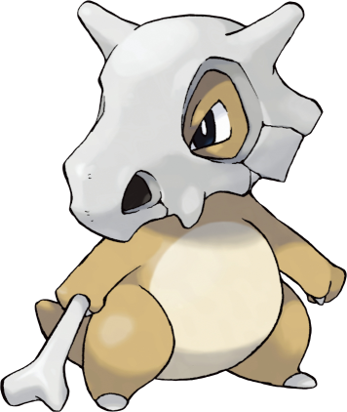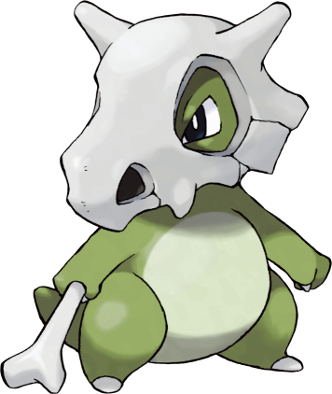

Stats and abilities:

Name: Cubone
Classification: Lonely Pokémon
Evolves into tropical Marowak from level 28 in a dark and cursed place
Evolves into Marowak (basic form) from level 28 in all other localities

Description: Cubone pines for the mother it will never see again. Seeing a likeness of its mother in the full moon, it cries. The stains on the skull the Pokémon wears are made by the tears it sheds.
Height: 0.4 m (1’04")
Mass: 6.5 kg (14.3 lbs)
Catch rate: 190
Experience yield: 64
Held item in the wild: Thick Club (25%)
Raw material recovered by hunting: Leather (×0,5)
Appearance: Biped with a tail
Color: Brown
Rarity: Uncommon
Tier: Poorly Used – LC
----------

Type: Ground / Normal
Secondary types: Dark
Immunities: Ghost
Resistances: Poison, Rock
Weaknesses: Water, Grass, Ice, Fighting
----------

Base stats:
HP: 50
Atk: 50
Def: 95
Sp. Atk: 40
Sp. Def: 50
Spd: 35
----------
Total: 320

EV: +1 Def

Abilities:
• Rock Head: Protects the Pokémon from recoil damage.
• Lightning Rod: The Pokémon draws in all Electric-type moves. Instead of being hit by Electric-type moves, it boosts its Sp. Atk.
• Battle Armor (hidden): Hard armor protects the Pokémon from critical hits.

Sexual dimorphism:
None

Marowak (basic form)

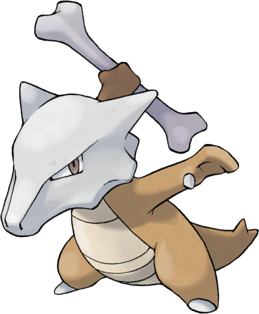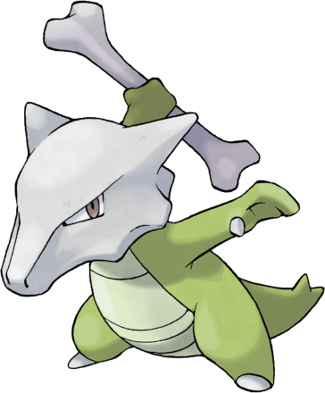

Stats and abilities:

Name: Marowak (basic form)
Classification: Bone Keeper Pokémon
Evolution of Cubone out of dark and cursed place from level 28
Evolves into Kangasbone from level 48 if male
Evolves into Kangaskhan from level 48 if female

Description: Marowak is the evolved form of a Cubone that has overcome its sadness at the loss of its mother and grown tough. This Pokémon’s tempered and hardened spirit is not easily broken.
Height: 1.0 m (3’03")
Mass: 45.0 kg (99.2 lbs)
Catch rate: 90
Experience yield: 124
Held item in the wild: Thick Club (25%)
Raw material recovered by hunting: Leather (×1)
Appearance: Biped with a tail
Color: Brown
Rarity: Rare
Tier: Poorly Used - NFE
----------

Type: Ground / Normal
Secondary types: Fighting, Rock, Dark
Immunities: Ghost
Resistances: Poison, Rock
Weaknesses: Water, Grass, Ice, Fighting
----------

Base stats:
HP: 60 (+10)
Atk: 80 (+30)
Def: 100 (+5)
Sp. Atk: 50 (+10)
Sp. Def: 80 (+30)
Spd: 55 (+20)
----------
Total: 425 (+105)

EV: +2 Def

Abilities:
• Rock Head: Protects the Pokémon from recoil damage.
• Lightning Rod: The Pokémon draws in all Electric-type moves. Instead of being hit by Electric-type moves, it boosts its Sp. Atk.
• Battle Armor (hidden): Hard armor protects the Pokémon from critical hits.

Sexual dimorphism:
None

Marowak (tropical form)

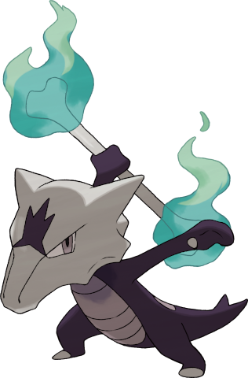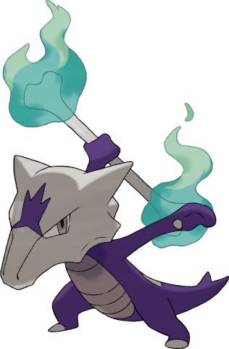

Stats and abilities:

Name: Marowak (tropical form)
Classification: Bone Keeper Pokémon
Evolution of Cubone in a dark and cursed place from level 28

Description: When it beats opponents with its bone, the cursed flames spread to them. No amount of water will stop those flames from burning.
Height: 1.0 m (3’03")
Mass: 34.0 kg (75,0 lbs)
Catch rate: 75
Experience yield: 149
Held item in the wild: Thick Club (25%)
Raw material recovered by hunting: None
Appearance: Biped with a tail
Color: Violet
Rarity: Rare
Tier: Rarely Used
----------

Type: Fire / Ghost
Secondary types: Normal, Fighting, Ground, Dark
Immunities: Normal, Fighting
Critical resistances: Bug
Resistances: Fire, Grass, Ice, Poison, Psychic, Steel, Fairy
Weaknesses: Water, Ground, Rock, Ghost, Dark, Light
----------

Base stats:
HP: 60 (+10)
Atk: 80 (+30)
Def: 100 (+5)
Sp. Atk: 50 (+10)
Sp. Def: 80 (+30)
Spd: 55 (+20)
----------
Total: 425 (+105)

EV: +2 Def

Abilities:
• Cursed Body: May disable a move used on the Pokémon.
• Lightning Rod: The Pokémon draws in all Electric-type moves. Instead of being hit by Electric-type moves, it boosts its Sp. Atk.
• Rock Head (hidden): Protects the Pokémon from recoil damage.

Sexual dimorphism:
None

Kangasbone

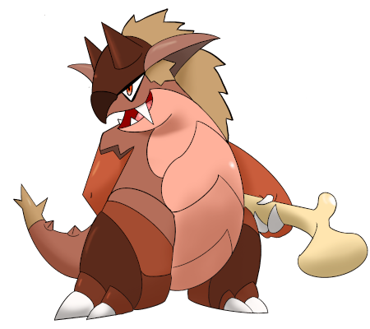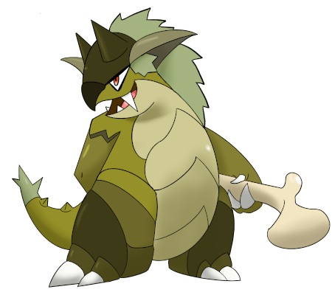

Stats and abilities:

Name: Kangasbone
Classification: Bone Mass Pokémon
Evolution of male Marowak (basic form) from level 48

Description: Proud of the strength he’s acquired from handling his bone, he’ll do anything to defend his herd. The longer he fights, the more devastating his mace blows.
Height: 2.2 m (7’03")
Mass: 247.0 kg (544.6 lbs)
Catch rate: 45
Experience yield: 221
Held item in the wild: Thick Club (50%)
Raw material recovered by hunting: Leather (×2)
Appearance: Biped with a tail
Color: Brown
Rarity: Very rare
Tier: Rarely Used
----------

Type: Ground / Fighting
Secondary types: Normal, Rock, Dark
Immunities: Electric
Critical resistances: Rock
Resistances: Poison, Dark, Shadow
Weaknesses: Water, Grass, Ice, Flying, Psychic, Fairy
----------

Base stats:
HP: 105 (+45)
Atk: 110 (+30)
Def: 100 (+0)
Sp. Atk: 50 (+0)
Sp. Def: 80 (+0)
Spd: 65 (+10)
----------
Total: 510 (+85)

EV: +1 HP, +2 Atk

Abilities:
• Defiant: Boosts the Pokémon’s Attack stat sharply when its stats are lowered.
• Scrappy: The Pokémon can hit Ghost-type Pokémons with Normal- and Fighting-type moves.
• Moxie (hidden): The Pokémon shows moxie, and that boosts the Attack stat after knocking out any Pokémon.

Sexual dimorphism:
The female is a distinct species (divergent stats, types and abilities) with a ventral pouch capable of carrying a baby. However, she has no horns on her head and has abandoned the bone she used as a club.

Kangaskhan

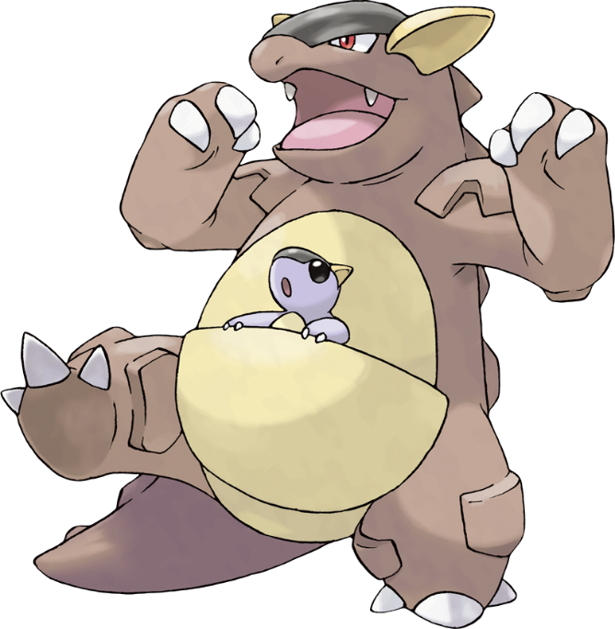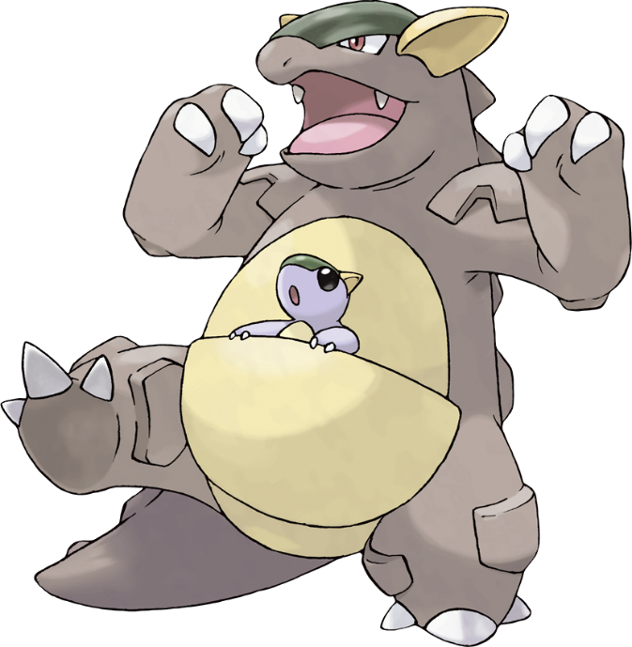

Stats and abilities:

Name: Kangaskhan
Classification: Parent Pokémon
Evolution of female Marowak (basic form) from level 48
Mega Stone: (Sacred) Kangaskhanite

Description: If you come across a young Kangaskhan playing by itself, you must never disturb it or attempt to catch it. The baby Pokémon’s parent is sure to be in the area, and it will become violently enraged at you.
Height: 2.2 m (7’03")
Mass: 164.0 kg (361.6 lbs)
Catch rate: 45
Experience yield: 221
Held item in the wild: Thick Club (25%)
Raw material recovered by hunting: Leather (×2)
Appearance: Biped with a tail
Color: Brown
Rarity: Very rare
Tier: Rarely Used
----------

Type: Normal / Ground
Secondary types: Fighting, Rock, Dark
Immunities: Ghost
Resistances: Poison, Rock
Weaknesses: Water, Grass, Ice, Fighting
----------

Base stats:
HP: 105 (+45)
Atk: 95 (+15)
Def: 80 (-20)
Sp. Atk: 50 (+0)
Sp. Def: 80 (+0)
Spd: 90 (+35)
----------
Total: 500 (+75)

EV: +2 HP, +1 Atk

Abilities:
• Early Bird: The Pokémon always wakes up after one turn of sleep.
• Scrappy: The Pokémon can hit Ghost-type Pokémons with Normal- and Fighting-type moves.
• Inner Focus (hidden): The Pokémon’s intensely focused, and that protects the Pokémon from flinching.

Sexual dimorphism:
The male is a distinct species (divergent stats, types and abilities) who doesn’t have a baby on his belly, but holds a huge bone that serves as a club. He also has horns on his head.

Mega Kangaskhan

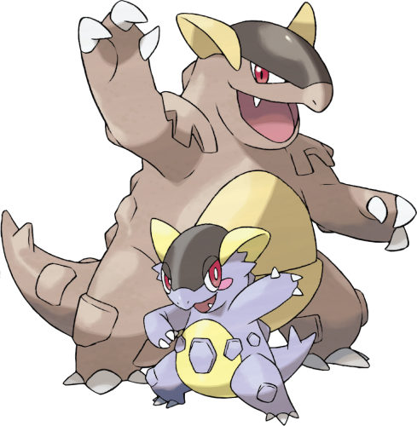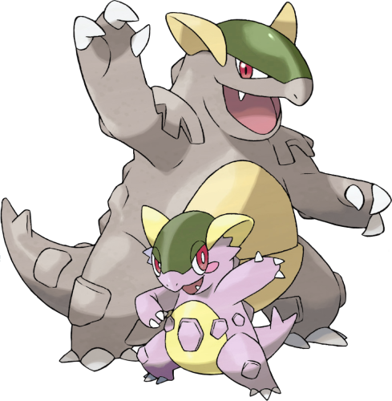

Stats and abilities:

Name: Mega Kangaskhan
Classification: Parent Pokémon
Mega Stone: (Sacred) Kangaskhanite

Description: Its child has grown rapidly, thanks to the energy of Mega Evolution. Mother and child show their harmonious teamwork in battle.
Height: 2.2 m (7’03")
Mass: 184.0 kg (405.7 lbs)
Catch rate: 10
Experience yield: 345
Held item in the wild: Thick Club (25%)
Raw material recovered by hunting: Leather (×2)
Appearance: Biped with a tail
Color: Brown
Rarity: Legendary
Tier: Uber
----------

Type: Normal
Secondary types: Fighting, Ground, Rock, Dark
Immunities: Ghost
Weaknesses: Fighting
----------

Base stats:
HP: 105 (+0)
Atk: 125 (+30)
Def: 100 (+20)
Sp. Atk: 70 (+20)
Sp. Def: 100 (+20)
Spd: 100 (+10)
----------
Total: 600 (+100)

EV: +2 HP, +2 Atk

Abilities:
• Parental Bond: The parent and child attack one after the other.

Innate movepool (by leveling up or Move Reminder)

❌: Attack impossible to learn for this evolutionary stage or this form
💿: Attack not yet innate to this stage of evolution, but can be learned through external teaching.
Bold: Move benefiting from STAB at the time it is learned.
Italics: Move learned at a time when future evolution is required to unlock a STAB or secondary affinity.
Red: Anti-STAB because no secondary affinity on all stages of evolution. This move will consume more energy and have less power.
A learning level of 0 means that the Pokémon learns it when it evolves. Attacks that appear at level 1 after an evolution can be unlocked without a TM thanks to the Move Reminder.
Note: Thanks to reincarnation, it is possible to have a Tropical Marowak as early as level 5. That’s why the two columns between levels 5 and 28 are already differentiated.

Move | Type | Cat. | Power | Acc. | Learning level
 |  |  |  |  | Cubone | Marowak |  | Kangasbone and Kangaskhan
Swords Dance |  |  | - | ∞ | ❌ | 0 | 1 | 1
Shadow Bone |  |  | 85 | 100 | ❌ | ❌ | 0 | ❌
Fire Fang |  |  | 65 | 95 | ❌ | ❌ | 1 | ❌
Fire Spin |  |  | 35 | 85 | ❌ | ❌ | 1 | ❌
Endure |  |  | - | ∞ | 💿 | 💿 |  | 0
Dizzy Punch |  |  | 70 | 100 | ❌ | ❌ |  | 1
Chip Away |  |  | 70 | 100 | ❌ | ❌ |  | 1
Fake Out |  |  | 40 | 100 | ❌ | ❌ |  | 1
Double Hit |  |  | 35 | 90 | ❌ | ❌ |  | 1
Seismic Toss |  |  | 0 | 100 | ❌ | ❌ |  | 1
Crunch |  |  | 80 | 100 | ❌ | ❌ |  | 1
Sucker Punch |  |  | 70 | 100 | ❌ | ❌ |  | 1
Outrage |  |  | 120 | 100 | ❌ | ❌ |  | 1
Mud-Slap |  |  | 20 | 100 | 1 | 1 |  | 1
Growl |  |  | - | 100 | 1 | 1 |  | 1
Tail Whip |  |  | - | 100 | 3 | 3 |  | 3
False Swipe |  |  | 40 | 100 | 6 | 6 | 6 | 6
Rage |  |  | 20 | 100 | 10 | 10 | 10 | 10
Hex |  |  | 65 | 100 | ❌ | ❌ | 10 | ❌
Bone Club |  |  | 65 | 90 | 13 | 13 | 13 | 13
Headbutt |  |  | 70 | 100 | 16 | 16 | 16 | 16
Flame Wheel |  |  | 60 | 100 | ❌ | ❌ | 19 | ❌
Bite |  |  | 60 | 100 | 20 | 20 | 22 | 20
Fling |  |  | 10-130 | 100 | 23 | 23 | 24 | 23
Bone Rush |  |  | 25 | 90 | 26 | 26 | 27 | 26
Retaliate |  |  | 70 | 100 | 30 | 31 | 30 | 31
Will-O-Wisp |  |  | - | 80 | ❌ | ❌ | 33 | ❌
Bonemerang |  |  | 50 | 90 | 33 | 35 | 36 | 35
Focus Energy |  |  | - | ∞ | 36 | 39 | 40 | 39
Thrash |  |  | 120 | 100 | 40 | 44 | 44 | 44
Endeavor |  |  | 0 | 100 | 44 | 49 | 49 | 50
Flare Blitz |  |  | 120 | 100 | ❌ | ❌ | 54 | ❌
Double-Edge |  |  | 120 | 100 | 49 | 54 | 60 | 56
Reversal |  |  | 20-200 | 100 | ❌ | ❌ |  | 60
Earthquake |  |  | 100 | 100 | ❌ | 💿 |  | 65
Last Resort |  |  | 60-140 | 100 | ❌ | ❌ |  | 70

Shadow and Light movepool

Moves in blue are not part of the innate movepool and can only be obtained by Move Tutor once the Pokémon has obtained the type in question at least once and reached the minimum level.

Move | Type | Cat. | Power | Acc. | Learned instead of | Learning level
 |  |  |  |  |  | Cubone | Marowak |  | Kangasbone and Kangaskhan
Shadow Blitz |  |  | 40 | 100 | False Swipe | 6 | 6 | 6 | 6
Sacred Blitz |  |  | 40 | 100 | False Swipe | 6 | 6 | 6 | 6
Shadow Fang |  |  | 70 | 95 | Bite | 20 | 20 | 22 | 20
Sacred Fang |  |  | 70 | 95 | Bite | 20 | 20 | 22 | 20
Shadow Shed |  |  | - | ∞ | Focus Energy | 36 | 39 | 40 | 39
Sacred Shield |  |  | - | ∞ | Focus Energy | 36 | 39 | 40 | 39
Shadow End |  |  | 120 | 90 | Double-Edge | 49 | 54 | 60 | 56
Ram of Light |  |  | 100 | 95 | Double-Edge | 49 | 54 | 60 | 56
Shadow Fire |  |  | 75 | 100 | (Nothing) | ❌ | ❌ | 25 | ❌
Celestial Fire |  |  | 75 | 100 | (Nothing) | ❌ | ❌ | 25 | ❌
Shadow Break |  |  | 75 | 100 | (Nothing) | ❌ | ❌ | ❌ | 25
Sacred Break |  |  | 80 | 100 | (Nothing) | ❌ | ❌ | ❌ | 25

Acquired movepool (Technical Parchment, Move Tutor …)

• The attacks listed below or in the innate movepool are all legitimate for this Pokémon because the Mirror Herb – a kind of universal TM – allows you to transfer any move from a Pokémon that already knows it to another.
• Moves that benefit from STAB for at least one of the forms or evolutionary stages are noted in bold.
• If an evolution is required to unlock a STAB or secondary affinity and the attack could already be learned before the evolution in question, they are indicated in italics.
• Those that obtain no secondary affinity for all evolutionary stages (anti-STAB) are marked in red.

Move | Type | Category | Aptitude
Move | Type | Category | Cubone | Marowak |  | Kangasbone and Kangaskhan
Facade |  |  | ✔️ | ✔️ |  | ✔️
Frustration |  |  | ✔️ | ✔️ |  | ✔️
Return |  |  | ✔️ | ✔️ |  | ✔️
Secret Power |  |  | ✔️ | ✔️ |  | ✔️
Body Slam |  |  | ✔️ | ✔️ |  | ✔️
Hidden Power |  |  | ✔️ | ✔️ |  | ✔️
Protect |  |  | ✔️ | ✔️ |  | ✔️
Sleep Talk |  |  | ✔️ | ✔️ |  | ✔️
Substitute |  |  | ✔️ | ✔️ |  | ✔️
Brick Break |  |  | ✔️ | ✔️ |  | ✔️
Endure |  |  | ✔️ | ✔️ |  | Innate
Dig |  |  | ✔️ | ✔️ |  | ✔️
Bulldoze |  |  | ✔️ | ✔️ |  | ✔️
Earth Power |  |  | ✔️ | ✔️ |  | ✔️
Rest |  |  | ✔️ | ✔️ |  | ✔️
Stealth Rock |  |  | ✔️ | ✔️ |  | ✔️
Sandstorm |  |  | ✔️ | ✔️ |  | ✔️
Thief |  |  | ✔️ | ✔️ |  | ✔️
Attract |  |  | ✔️ | ✔️ |  | ✔️
Mega Punch |  |  | ❌ | ✔️ |  | ✔️
Strength |  |  | ❌ | ✔️ |  | ✔️
Rock Smash |  |  | ❌ | ✔️ |  | ✔️
Focus Blast |  |  | ❌ | ✔️ |  | ✔️
Earthquake |  |  | ❌ | ✔️ |  | Innate
Stomping Tantrum |  |  | ❌ | ✔️ |  | ✔️
Scorching Sands |  |  | ❌ | ✔️ |  | ✔️
Rock Slide |  |  | ❌ | ✔️ |  | ✔️
Rock Tomb |  |  | ❌ | ✔️ |  | ✔️
Rock Climb |  |  | ❌ | ✔️ |  | ✔️
Stone Edge |  |  | ❌ | ✔️ |  | ✔️
Throat Chop |  |  | ❌ | ✔️ |  | ✔️
Iron Tail |  |  | ❌ | ✔️ |  | ✔️
Iron Head |  |  | ❌ | ✔️ |  | ✔️
Fire Punch |  |  | ❌ | ❌ | ✔️ | ❌
Flamethrower |  |  | ❌ | ❌ | ✔️ | ❌
Fire Blast |  |  | ❌ | ❌ | ✔️ | ❌
Heat Wave |  |  | ❌ | ❌ | ✔️ | ❌
Burning Jealousy |  |  | ❌ | ❌ | ✔️ | ❌
Sunny Day |  |  | ❌ | ❌ | ✔️ | ❌
Drain Punch |  |  | ❌ | ❌ | ✔️ | ✔️
Fissure |  |  | ❌ | ❌ | ✔️ | ✔️
Shadow Claw |  |  | ❌ | ❌ | ✔️ | ✔️
Poltergeist |  |  | ❌ | ❌ | ✔️ | ❌
Shadow Ball |  |  | ❌ | ❌ | ✔️ | ❌
Spite |  |  | ❌ | ❌ | ✔️ | ❌
Cut |  |  | ❌ | ❌ |  | ✔️
Giga Impact |  |  | ❌ | ❌ |  | ✔️
Hyper Beam |  |  | ❌ | ❌ |  | ✔️
Snore |  |  | ❌ | ❌ |  | ✔️
Safeguard |  |  | ❌ | ❌ |  | ✔️
Work Up |  |  | ❌ | ❌ |  | ✔️
Roar |  |  | ❌ | ❌ |  | ✔️
Low Kick |  |  | ❌ | ❌ |  | ✔️
Hammer Arm |  |  | ❌ | ❌ |  | ✔️

