Slugaqua / Flabaqua / Glautilus

Lineage’s Lore

Inspiration:

This Fakemon is inspired by various marine slugs, notably the nudibranchs, an order of gastropod mollusks. More specifically, Slugaqua is a pokemonization of Chromodoris lochi, Flabaqua of Flabellina affinis and Glautilus of Glaucus atlanticus.
Initially, this Fakemon was intended to be a starter (hence the distribution of its stats and its tier corresponding to such a Pokémon). But since it wasn't adopted by the person who asked me to draw it, it naturally joins the Keltios universe with an adapted lore.

Etymology:

The etymology of Slugaqua comes from “Slug” and “aqua”
The etymology of Flabaqua comes from Flabellina affinis and “aqua”
The etymology of Glautilus comes from Glaucus atlanticus and “Nautilus”.

Habitat:

Native to the warm waters of the Selene Ocean, these peaceful mollusks roam the seabed between the southern coast of Keltios and the Selestia Archipelago. They like to be carried to the surface by sea currents as they migrate.
Their psychic energy is stored on the ball they carry on their back, an organ that migrates and crystallizes on the top of their head when they become adults. When they use their Infinity Energy, the Slugaquas’ and Flabaquas’ dorsal protuberance begins to glow. In the case of Glautilus, this phenomenon manifests itself on their crystals and the bright spots on their starry backs. When they use their powers in schools, the sea waters light up like the vault of heaven. It’s a beautiful sight to see.

Their wisdom and innate aptitude for telepathy has earned them the nickname of Emissaries of Lugia. They indeed share the marine habitat and the Psychic-type with the Goddess of the Ocean. As soon as danger arises in their habitat, they send out a distress signal via telepathic sonar, which when picked up by their fellow creatures, rebroadcast the wave in turn. Such a message can reach the coastline. This is how coastal towns have been warned of an impending tidal wave, or shipwrecked people rescued at sea: thanks to Glautiluses relaying the alert.

Type:

Slugaqua is still too immature to use its mental powers effectively, and has only the Water-type. But as soon as it evolves, it definitively acquires the Water/Psychic dual-type, giving it quite a few resistances but also six weaknesses.

Stats:

Don't be fooled by their sea-slug-like appearance: endowed with superior intelligence, Glautiluses know how to be formidable thanks to their psychic powers, which has earned them a place in the tier Under Used by the Ardrasil University Council. This is confirmed by their honorable position in the oceanic food chain at the same level as Milotic or Gyarados.
However, the juvenile stages Slugaqua and Flabaqua have not yet developed the full potential of their powers. To escape predators such as Crawdaunts or Sharpedos, they rely on their teleporting abilities, provided they can react quickly enough.
Regarding the stats distribution, this is clearly a special-oriented Pokémon. Its physical strength is almost nil, and its Defense and Speed are below average. On the other hand, it has incredible Special Attack combined with Special Defense and high HP.
Thanks to its access to Calm Mind and good coverage, its preferred strategic niche will be that of Wallbreaker, provided you take care with its fairly low speed and slightly below-average physical bulk. This can be compensated for with Trick Room and the minimal Speed stat, its hidden Swift Swim ability + Rain, or by setting screens to ensure a minimum of Staying power. Its ability to tank is enhanced by its access to healing attacks and screens.

Movepool:

The movepool of the lineage is naturally based on Water and Psychic attacks, but also on Poison attacks. (In my type table, Psychic resists Poison.) The toxins of its prey are absorbed and stored in special pockets (hence its Hydration ability, which makes it immune to poison in its natural environment), giving it coverage that can surprise opponents. Glautilus also possesses certain Flying-type moves, inherited from its mastery of the psyche and the power of the oceans. Glautilus can also master Dazzling Gleam, giving it a chance to stand up to its Dark-type predators.
Via an Move Reminder or Technical Scroll, it can learn a few Electric- and Ice-type attacks, as well as Giga Drain, but these types are not part of its secondary affinities and will suffer from an anti-STAB.
As this Pokémon is physically frail, its offensive moves are clearly focused on the special.

Lineage characteristics:

Experience curve: Quite slow (1,100,000 XP at level 100)
Breeding group: Mollusk (Juvenile for Slugaqua)
Sex ratio: 100 % hermaphrodite
Pain of evolution: Average (quite painful)
Species fertility: From evolution into Flabaqua
Hatching time: Medium (20 cycles, or 5,120 steps)
Possible reincarnation after death: Frillish

Slugaqua

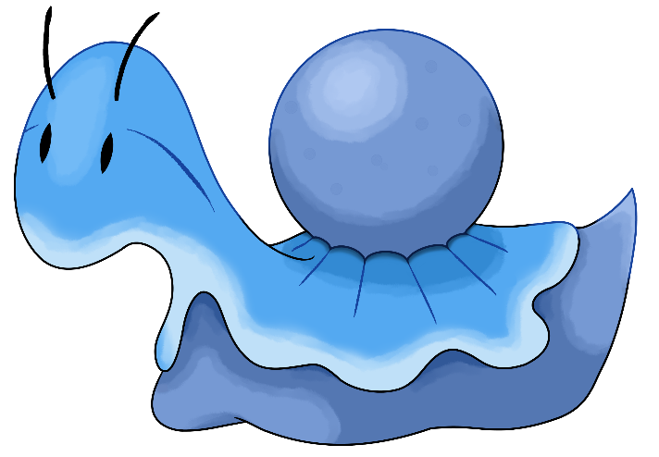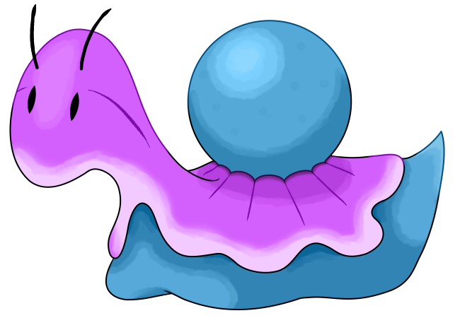

Name: Slugaqua
Classification: Sea Slug Pokémon
Evolves into Flabaqua from level 16

Description: It feeds on organic remains lining the ocean floor. The ball on its back stores its energy reserves.
Height: 0.3 m (1’00")
Mass: 2.3 kg (5.1 lbs)
Catch rate: 140
Experience yield: 62
Held item in the wild: None
Raw material recovered by hunting: Stardust (×0.4)
Appearance: Serpentine
Color: Blue
Rarity: Rare
Tier: Poorly Used – LC
----------

Type: Water
Secondary types: Normal, Poison, Psychic
Resistances: Fire, Water, Ice, Steel
Weaknesses: Electric, Grass
----------

Bases stats:
HP: 65
Atk: 20
Def: 48
Sp. Atk: 70
Sp. Def: 66
Spd: 40
----------
Total: 309

EV: +1 Sp. Atk

Abilities:
• Torrent: Powers up Water-type moves a little when the Pokémon is injured, and significantly if badly.
• Hydration: Heals status conditions if it’s raining or if it’s in aquatic battlefield.
• Swift Swim (hidden): Doubles the Pokémon’s Speed if it’s raining or if it’s in aquatic battlefield.

Sexual dimorphism:
None, the Pokémon is hermaphrodite.

Flabaqua

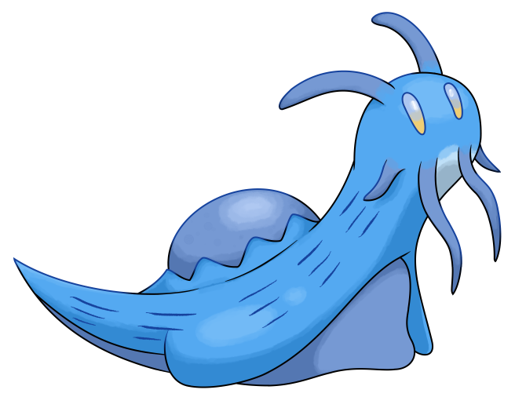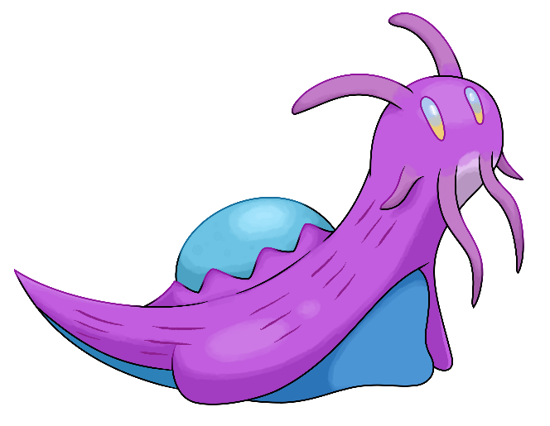

Name: Flabaqua
Classification: Flabellina Pokémon
Evolves from Slugaqua at level 16
Evolves into Glautilus at level 32

Description: Flabaqua absorbs and stores toxins from its prey to release them in the event of a threat. Its excrescence on its back glows when it uses its psychic powers.
Height: 0.6 m (2’00")
Mass: 12.5 kg (27.6 lbs)
Catch rate: 70
Experience yield: 138
Held item in the wild: Luminous Moss (18,75%)
Raw material recovered by hunting: Stardust (×1)
Appearance: Serpentine
Color: Blue
Rarity: Rare
Tier: Poorly Used – NFE
----------

Type: Water / Psychic
Secondary types: Normal, Poison, Fairy
Immunities: Fairy
Resistances: Fire, Water, Ice, Fighting, Poison, Psychic, Light
Weaknesses: Electric, Grass, Bug, Ghost, Dark, Shadow
----------

Bases stats:
HP: 81 (+16)
Atk: 25 (+5)
Def: 62 (+14)
Sp. Atk: 103 (+33)
Sp. Def: 88 (+22)
Spd: 50 (+10)
----------
Total: 409 (+100)

EV: +2 Sp. Atk

Abilities:
• Torrent: Powers up Water-type moves a little when the Pokémon is injured, and significantly if badly.
• Hydration: Heals status conditions if it’s raining or if it’s in aquatic battlefield.
• Swift Swim (hidden): Doubles the Pokémon’s Speed if it’s raining or if it’s in aquatic battlefield.

Sexual dimorphism:
None, the Pokémon is hermaphrodite.

Glautilus

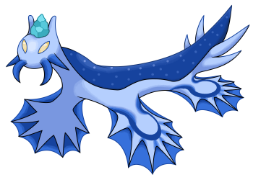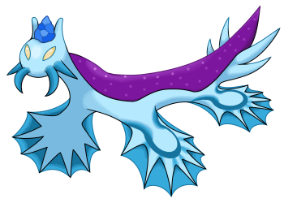

Name: Glautilus
Classification: Glaucus Pokémon
Evolves from Flabaqua at level 32
Mega Stone: none

Description: Intelligent and endowed with powerful psychic powers, sailors nickname it “the sage of the seas”. It is said that this Pokémon is Lugia’s emissary.
Height: 1.0 m (3’03")
Mass: 17.5 kg (38.6 lbs)
Catch rate: 35
Experience yield: 238
Held item in the wild: Psychic Gem (18,75%), Luminous Moss (50%)
Raw material recovered by hunting: Stardust (×2)
Appearance: Serpentine
Color: Blue
Rarity: Very rare
Tier: Under Used
----------

Type: Water / Psychic
Secondary types: Normal, Poison, Fairy
Immunities: Fairy
Resistances: Fire, Water, Ice, Fighting, Poison, Psychic, Light
Weaknesses: Electric, Grass, Bug, Ghost, Dark, Shadow
----------

Bases stats:
HP: 104 (+23)
Atk: 30 (+5)
Def: 71 (+9)
Sp. Atk: 141 (+38)
Sp. Def: 111 (+23)
Spd: 68 (+18)
----------
Total: 525 (+116)

EV: +3 Sp. Atk

Abilities:
• Torrent: Powers up Water-type moves a little when the Pokémon is injured, and significantly if badly.
• Hydration: Heals status conditions if it’s raining or if it’s in aquatic battlefield.
• Swift Swim (hidden): Doubles the Pokémon’s Speed if it’s raining or if it’s in aquatic battlefield.

Sexual dimorphism:
None, the Pokémon is hermaphrodite.

Innate movepool (by leveling up or Move Reminder)

❌: Attack impossible to learn for this evolutionary stage or this form
💿: Attack not yet innate to this stage of evolution, but can be learned through external teaching.
Bold: Move benefiting from STAB at the time it is learned.
Italics: Move learned at a time when future evolution is required to unlock a STAB or secondary affinity.
Red: Anti-STAB because no secondary affinity on all stages of evolution. This move will consume more energy and have less power.
A learning level of 0 means that the Pokémon learns it when it evolves. Attacks that appear at level 1 after an evolution can be unlocked without a TM thanks to the Move Reminder.

Move | Type | Cat. | Power | Acc. | Learning level
 |  |  |  |  | Slugaqua | Flabaqua | Glautilus
Acid |  |  | 40 | 100 | 💿 | 1 | 1
Bubble Beam |  |  | 65 | 100 | 💿 | 1 | 1
Psybeam |  |  | 65 | 100 | 💿 | 1 | 1
Whirlpool |  |  | 35 | 85 | ❌ | 💿 | 1
Spit Up |  |  | 120-480 | 100 | 💿 | 💿 | 1
Aqua Ring |  |  | - | ∞ | 💿 | 💿 | 1
Gastro Acid |  |  | - | 150 | 💿 | 💿 | 1
Psycho Shift |  |  | - | 120 | 💿 | 💿 | 1
Healing Wish |  |  | - | ∞ | ❌ | ❌ | 1
Disable |  |  | - | 150 | ❌ | ❌ | 1
Hypnosis |  |  | - | 60 | ❌ | ❌ | 1
Poison Sting |  |  | 20 | 100 | 1 | 1 | 1
Acid Armor |  |  | - | 100 | 3 | 3 | 3
Bubble |  |  | 25 | 100 | 6 | 6 | 6
Water Gun |  |  | 40 | 100 | 10 | 10 | 10
Confusion |  |  | 50 | 100 | 13 | 13 | 13
Teleport |  |  | - | ∞ | 16 | 16 | 16
Water Pulse |  |  | 60 | 100 | 19 | 20 | 20
Swallow |  |  | - | ∞ | 22 | 24 | 24
Stockpile |  |  | - | ∞ | 22 | 24 | 24
Extrasensory |  |  | 80 | 100 | 25 | 28 | 28
Calm Mind |  |  | - | ∞ | 28 | 32 | 32
Surf |  |  | 90 | 100 | ❌ | ❌ | 37
Rain Dance |  |  | - | ∞ | 31 | 37 | 42
Stored Power |  |  | 20-300 | 100 | 34 | 42 | 47
Recover |  |  | - | ∞ | 37 | 47 | 52
Dazzling Gleam |  |  | 80 | 100 | ❌ | 💿 | 58
Hydro Pump |  |  | 120 | 85 | 40 | 52 | 64
Future Sight |  |  | 120 | 100 | ❌ | 57 | 70

Shadow and Light movepool

Moves in blue are not part of the innate movepool and can only be obtained by Move Tutor once the Pokémon has obtained the type in question at least once and reached the minimum level.

Move | Type | Cat. | Power | Acc. | Learned instead of | Learning level
 |  |  |  |  |  | Slugaqua | Flabaqua | Glautilus
Shadow Blitz |  |  | 40 | 100 | Bubble | 6 | 6 | 6
Sacred Blitz |  |  | 40 | 100 | Bubble | 6 | 6 | 6
Shadow Wave |  |  | 50 | 100 | Confusion | 13 | 13 | 13
Sacred Wave |  |  | 50 | 100 | Confusion | 13 | 13 | 13
Shadow Chill |  |  | 75 | 100 | Extrasensory | 25 | 28 | 28
Celestial Chill |  |  | 75 | 100 | Extrasensory | 25 | 28 | 28
Shadow Sky |  |  | - | ∞ | Rain Dance | 31 | 37 | 42
Sigil of Light |  |  | - | ∞ | Rain Dance | 31 | 37 | 42
Shadow Sap |  |  | 55 | 100 | Recover | 37 | 47 | 52
Life Dew |  |  | - | ∞ | Recover | 37 | 47 | 52
Shadow Storm |  |  | 90 | 100 | Dazzling Gleam | ❌ | ❌ | 58
Shadow Half |  |  | - | 100 | Future Sight | ❌ | 57 | 70
Light of Ruin |  |  | 140 | 90 | Future Sight | ❌ | 57 | 70
Shadow Panic |  |  | 65 | 100 | (Nothing) | 10 | 10 | 10

Acquired movepool (Technical Parchment, Move Tutor …)

• The attacks listed below or in the innate movepool are all legitimate for this Pokémon because the Mirror Herb – a kind of universal TM – allows you to transfer any move from a Pokémon that already knows it to another.
• Moves that benefit from STAB for at least one of the forms or evolutionary stages are noted in bold.
• If an evolution is required to unlock a STAB or secondary affinity and the attack could already be learned before the evolution in question, they are indicated in italics.
• Those that obtain no secondary affinity for all evolutionary stages (anti-STAB) are marked in red.

Move | Type | Category | Aptitude
Move | Type | Category | Slugaqua | Flabaqua | Glautilus
Facade |  |  | ✔️ | ✔️ | ✔️
Frustration |  |  | ✔️ | ✔️ | ✔️
Return |  |  | ✔️ | ✔️ | ✔️
Secret Power |  |  | ✔️ | ✔️ | ✔️
Hidden Power |  |  | ✔️ | ✔️ | ✔️
Spit Up |  |  | ✔️ | ✔️ | Inné
Protect |  |  | ✔️ | ✔️ | ✔️
Sleep Talk |  |  | ✔️ | ✔️ | ✔️
Substitute |  |  | ✔️ | ✔️ | ✔️
Refresh |  |  | ✔️ | ✔️ | ✔️
Bubble Beam |  |  | ✔️ | Inné | Inné
Brine |  |  | ✔️ | ✔️ | ✔️
Water Pledge |  |  | ✔️ | ✔️ | ✔️
Aqua Ring |  |  | ✔️ | ✔️ | Inné
Giga Drain |  |  | ✔️ | ✔️ | ✔️
Mist |  |  | ✔️ | ✔️ | ✔️
Endure |  |  | ✔️ | ✔️ | ✔️
Psybeam |  |  | ✔️ | Inné | Inné
Psywave |  |  | ✔️ | ✔️ | ✔️
Rest |  |  | ✔️ | ✔️ | ✔️
Amnesia |  |  | ✔️ | ✔️ | ✔️
Psych Up |  |  | ✔️ | ✔️ | ✔️
Psycho Shift |  |  | ✔️ | ✔️ | Inné
Acid |  |  | ✔️ | Inné | Inné
Sludge Wave |  |  | ✔️ | ✔️ | ✔️
Sludge Bomb |  |  | ✔️ | ✔️ | ✔️
Toxic |  |  | ✔️ | ✔️ | ✔️
Gastro Acid |  |  | ✔️ | ✔️ | Inné
Attract |  |  | ✔️ | ✔️ | ✔️
Body Slam |  |  | ❌ | ✔️ | ✔️
Whirlpool |  |  | ❌ | ✔️ | Inné
Scald |  |  | ❌ | ✔️ | ✔️
Zen Headbutt |  |  | ❌ | ✔️ | ✔️
Psychic |  |  | ❌ | ✔️ | ✔️
Mirror Coat |  |  | ❌ | ✔️ | ✔️
Synchronoise |  |  | ❌ | ✔️ | ✔️
Expanding Force |  |  | ❌ | ✔️ | ✔️
Psychic Noise |  |  | ❌ | ✔️ | ✔️
Light Screen |  |  | ❌ | ✔️ | ✔️
Reflect |  |  | ❌ | ✔️ | ✔️
Skill Swap |  |  | ❌ | ✔️ | ✔️
Heal Block |  |  | ❌ | ✔️ | ✔️
Telekinesis |  |  | ❌ | ✔️ | ✔️
Psychic Terrain |  |  | ❌ | ✔️ | ✔️
Dazzling Gleam |  |  | ❌ | ✔️ | Inné
Giga Impact |  |  | ❌ | ❌ | ✔️
Hyper Beam |  |  | ❌ | ❌ | ✔️
Flash |  |  | ❌ | ❌ | ✔️
Waterfall |  |  | ❌ | ❌ | ✔️
Dive |  |  | ❌ | ❌ | ✔️
Muddy Water |  |  | ❌ | ❌ | ✔️
Hydro Cannon |  |  | ❌ | ❌ | ✔️
Thunderbolt |  |  | ❌ | ❌ | ✔️
Thunder |  |  | ❌ | ❌ | ✔️
Shock Wave |  |  | ❌ | ❌ | ✔️
Thunder Wave |  |  | ❌ | ❌ | ✔️
Thunderstorm |  |  | ❌ | ❌ | ✔️
Ice Beam |  |  | ❌ | ❌ | ✔️
Blizzard |  |  | ❌ | ❌ | ✔️
Haze |  |  | ❌ | ❌ | ✔️
Snowscape |  |  | ❌ | ❌ | ✔️
Air Slash |  |  | ❌ | ❌ | ✔️
Hurricane |  |  | ❌ | ❌ | ✔️
Dream Eater |  |  | ❌ | ❌ | ✔️
Cosmic Power |  |  | ❌ | ❌ | ✔️
Gravity |  |  | ❌ | ❌ | ✔️
Trick Room |  |  | ❌ | ❌ | ✔️
Wonder Room |  |  | ❌ | ❌ | ✔️
Magic Room |  |  | ❌ | ❌ | ✔️
Ancient Power |  |  | ❌ | ❌ | ✔️
Power Gem |  |  | ❌ | ❌ | ✔️
Twister |  |  | ❌ | ❌ | ✔️
Mystical Mist |  |  | ❌ | ❌ | ✔️

