Larfae / Chrysantle / Druichy / Duchefly

Lineage’s Lore

Inspiration:

This Fakemon was born out of my desire to have a Bug / Fairy-type like the Nimflora line of Pokémon Uranium. I wanted to have something in the same spirit, with three stages of evolution, but original and unique to Keltios.
It was finally SplittingJaws who came up with a sketch of an insect reminiscent of a duchess, with a sort of shimmering cape, while the primitive form is wrapped in a cocoon of silk and leaves. I was enchanted by the idea and put it into my own artwork.
SplittingJaws also wanted to make a distinct form between the male and female of the final evolution. This was achieved two years after its creation: Druichy was born and was even considered a separate species due to a slightly different movepool from Duchefly. Thus, a total of 4 Fakemons came to life.

Etymology:

The etymology of Larfae comes from “larva” and “fae” (ancient term for fairy).
The etymology of Chrysantle comes from “chrysalis” and “gentle”.
The etymology of “Druichy” comes from “druid” and “duchy”.
The etymology of Duchefly comes from “duchess” and “butterfly”.

Habitat:

This Pokémon is a creature that lives in the enchanted forests of western Keltios, namely those of Elda and Bréliande. These insects get along very well with the Treewise and Florges lineages, and are feared by the ancient Conkeldurr lineage. (The trolls of Keltios carefully avoid them.) They do, however, fear birds, which are their natural predators.
Less common than Caterpies, Sewaddles or Venipedes, which can be found in all wooded areas, this is not a very rare species either.
The baby form is found only in the Elda Forest, while the full-grown form is found in the Breliande Forest.

Type:

Larfae is a Bug-type Pokémon with a movepool similar to that of chrysalis Pokémon. As it evolves, it acquires the Fairy-type and its array of interesting resistances (9 resistances or immunities against 5 weaknesses).
In terms of secondary affinities, we find the Psychic-type (often common to fairy lines) and the Grass-type (allowing the use of powder attacks without penalty). The Fairy-type is of course a secondary affinity of Larfae pending its evolution.
Evolution to the final stage unlocks Flying for Druichy and Dark for Duchefly as secondary types, adding further coverage.

Stats:

Evolving relatively quickly and endowed with interesting abilities, a Larfae will prove to be an invaluable ally in the adventure. From level 27, she evolves into a Duchefly if female, which makes her one of the most quickly accessible Under Used in the adventure.
The baby is slow but bulky.
The intermediate stage has its stats rather balanced, although quite slow.
Its final female evolution has average bulk, but a good Special Attack stat and interesting Speed. As for the male, he’s a tad faster than Duchefly, but with balanced offensive stats. So, he has less Special Attack but more Attack than the female.
In terms of strategic niche, Duchefly is distinguished from Ribombee by more balanced stats and the ability to handicap its opponents, even though both lines are in the same tier. Druichy, on the other hand, is more mixed and therefore a little less specialized, placing it a tier below (despite 10 more BST points).

Movepool:

Its arsenal is broadly similar to that of Ribombee, but with access to healing moves.
The larva stage has a limited movepool, with virtually no Fairy-type moves and no coverage. That said, it can already stall and weaken opponents with Harden, Silk Trap, Struggle Bug, plus the ability to look at HP with Leech Bite (or Leech Life, its more powerful version, if taught).

Evolving into a chrysalis unlocks the Fairy-type tree (excluding Moonblast) and access to two powerful Grass-type moves via teaching: Energy Ball and Giga Drain. Its Cleric potential is revealed with Aromatherapy, Moonlight, Draining Kiss or Pollen Puff and will combine very well with an Eviolite in a defensive strategy. You can also find Sticky Web by looking in the buried moves of the innate movepool to further handicap your opponents and play stall.

The final evolution reveals the Fakemon’s offensive potential. Combined with Moonblast or Bug Buzz, Quiver Dance can transform Duchefly or Druichy into a special Sweeper, guaranteeing it will often strike first after a single use thanks to its good speed. This can be complemented by an acquired Psychic movepool which is unlocked at the same time. Calm Mind can be taught while waiting to unlock Quiver Dance, Psychic (or Expanding Force) adds powerful special coverage, Trick can incapacitate an opponent, and screens increase staying power (to be combined with the stall movepool learned at low level). This combines very well with U-turn, which is unlocked at final evolution thanks to the Move Reminder.

Let’s finish with the differences between the male and the female, elements that will differentiate them strategically.
Druichy unlocks Magic Bounce as a hidden ability. This gives him potential to support his team defensively. It also unlocks a few Flying-type moves + Horn Leech as he evolves.
Duchefly, on the other hand, is stall-oriented, with her Prankster ability and her ability to hinder opponents. She can also turn her enemies’ strength against them with her Foul Play attack, or block them with Taunt. Once her opponents have been incapacitated and momentum has been built up, she can go on the attack and sweep after placing a Quiver Dance.

Despite their potential and a good double-type, don’t forget that the line doesn’t have exceptional bulk and remains vulnerable to Wallbreakers and status alterations. Faster opponents (thanks in particular to a Choice Scarf) can also surprise them.

Lineage characteristics:

Experience curve: Average (1,000,000 XP at level 100)
Breeding group: Insectoid
Sex ratio: 50% male, 50% female for Larfae and Chrysantle; 100% male for Druichy, 100% female for Duchefly
Pain of evolution: Minimal (bearable)
Species fertility: From level 15 and evolution into Chrysantle
Hatching time: Quite fast (15 cycles, or 3,780 steps)
Possible reincarnation after death: Shedinja

Larfae

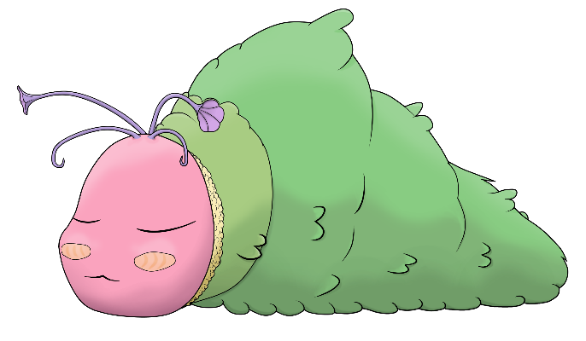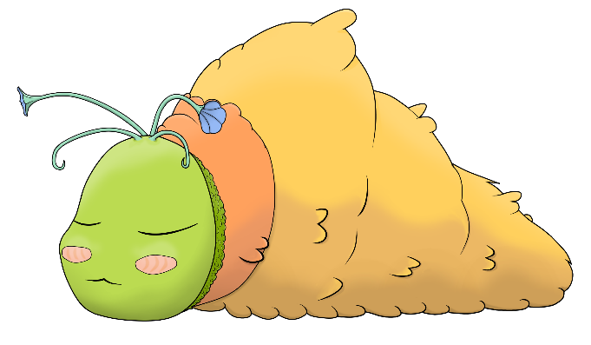

Name: Larfae
Classification: Larva Pokémon
Evolves into Chrysantle from level 14

Description: Born in the humus of lush forests, the Larfaes protect themselves by camouflaging in a cocoon of leaves.
Height: 0.4 m (1’04")
Mass: 5.1 kg (11.2 lbs)
Catch rate: 220
Experience yield: 58
Held item in the wild: Oran Berry (6.25 %)
Raw material recovered by hunting: Raw silk (×0.5)
Appearance: Insectoid
Color: Green
Rarity: Uncommon
Tier: Poorly Used – LC

----------

Type: Bug
Secondary types: Normal, Grass, Psychic, Fairy
Resistances: Grass, Fighting, Ground, Psychic
Weaknesses: Fire, Flying, Rock
----------

Base stats:
HP: 55
Atk: 38
Def: 67
Sp. Atk: 43
Sp. Def: 64
Spd: 37
----------
Total: 304

EV: +1 Sp. Def

Abilities:
• Shield Dust: This Pokémon’s dust blocks the additional effects of attacks taken.
• Natural Cure: All status conditions heal when the Pokémon switches out.
• Shed Skin (hidden): The Pokémon may heal its own status conditions by shedding its skin.

Sexual dimorphism:
None at this stage of development

Chrysantle

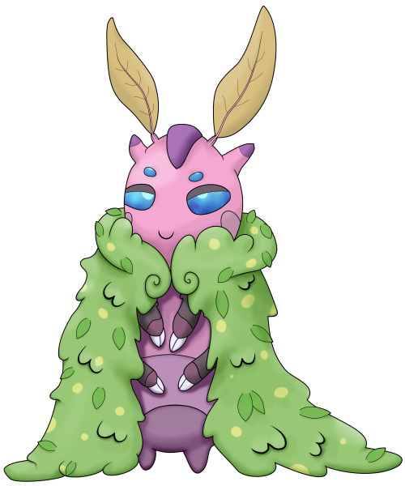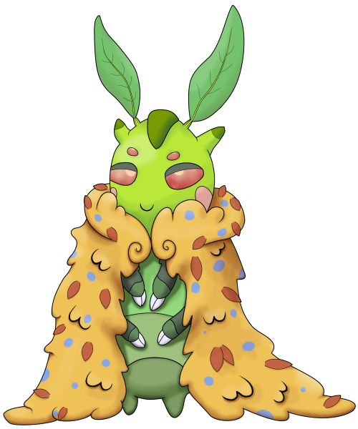

Name: Chrysantle
Classification: Caterpillar Pokémon
Evolves from Larfae at level 14
Evolves in Druichy at level 27 if male
Evolves in Duchefly at level 27 if female

Description: Chrysantles like to dress in the most beautiful plants. Their antennas are sensitive to emotions.
Height: 0.6 m (2’00")
Mass: 8.6 kg (19.0 lbs)
Catch rate: 110
Experience yield: 118
Held item in the wild: Lum Berry (6.25 %), Mental Herb (18.75 %)
Raw material recovered by hunting: Raw silk (×1)
Appearance: Insectoid
Color: Green
Rarity: Uncommon
Tier: Poorly Used – NFE (Never Used with Eviolite)
----------

Type: Bug / Fairy
Secondary types: Normal, Grass, Psychic
Immunities: Dragon
Critical resistances: Fighting
Resistances: Grass, Ground, Bug, Dark, Fairy, Shadow, Light
Weaknesses: Fire, Poison, Flying, Rock, Steel
----------

Base stats:
HP: 69 (+14)
Atk: 63 (+25)
Def: 68 (+1)
Sp. Atk: 70 (+27)
Sp. Def: 80 (+16)
Spd: 55 (+18)
----------
Total: 405 (+101)

EV: +1 Sp. Atk, +1 Sp. Def

Abilities:
• Shield Dust: This Pokémon’s dust blocks the additional effects of attacks taken.
• Natural Cure: All status conditions heal when the Pokémon switches out.
• Prankster (hidden): Status moves gain one level of priority, but lose their effectiveness against the Dark-type.

Sexual dimorphism:
None at this stage of development

Druichy
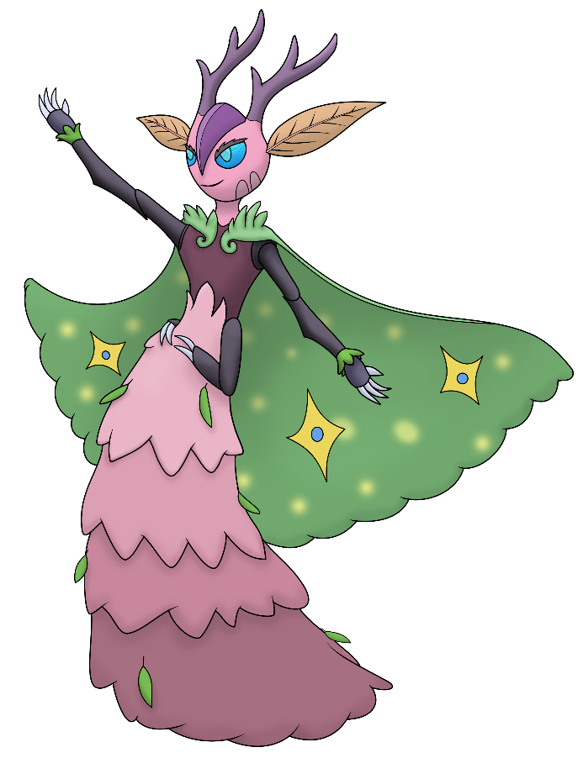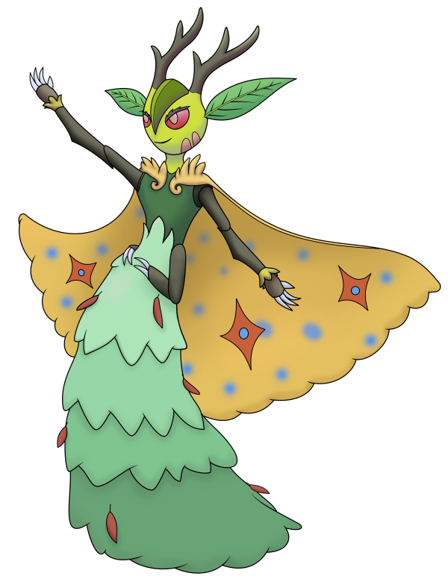

Name: Druichy
Classification: Horned Pokémon
Evolves from male Chrysantle at level 27

Description: When the warm weather returns, they gather to celebrate the awakening of nature. Their druidic powers protect them from harmful effects.
Height: 1.0 m (3’03")
Mass: 12.1 kg (26.7 lbs)
Catch rate: 50
Experience yield: 204
Held item in the wild: Fairy Feather (6.25 %), Mental Herb (18.75 %), Lum Berry (50 %)
Raw material recovered by hunting: Raw silk (×2)
Appearance: Insectoid
Color: Pink
Rarity: Rare
Tier: Rarely Used
----------

Type: Bug / Fairy
Secondary types: Normal, Grass, Psychic, Flying
Immunities: Dragon
Critical resistances: Fighting
Resistances: Grass, Ground, Bug, Dark, Fairy, Shadow, Light
Weaknesses: Fire, Poison, Flying, Rock, Steel
----------

Base stats:
HP: 73 (+4)
Atk: 84 (+21)
Def: 71 (+3)
Sp. Atk: 91 (+21)
Sp. Def: 101 (+21)
Spd: 96 (+41)
----------
Total: 516 (+111)

EV: +2 Sp. Def, +1 Vit

Abilities:
• Shield Dust: This Pokémon’s dust blocks the additional effects of attacks taken.
• Natural Cure: All status conditions heal when the Pokémon switches out.
• Magic Bounce (hidden): Reflects debuff moves instead of getting hit by them.

Sexual dimorphism:
The female is a distinct species (slightly different stats, movepool and abilities) less slender, hornless but with larger antennae and a different cape.

Duchefly
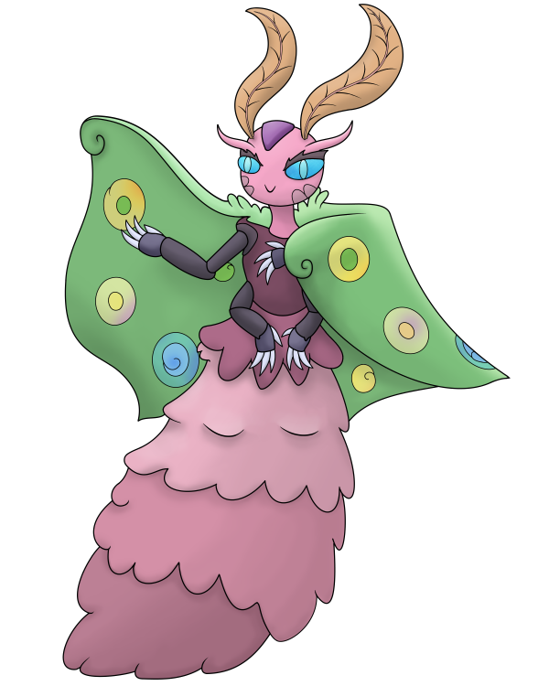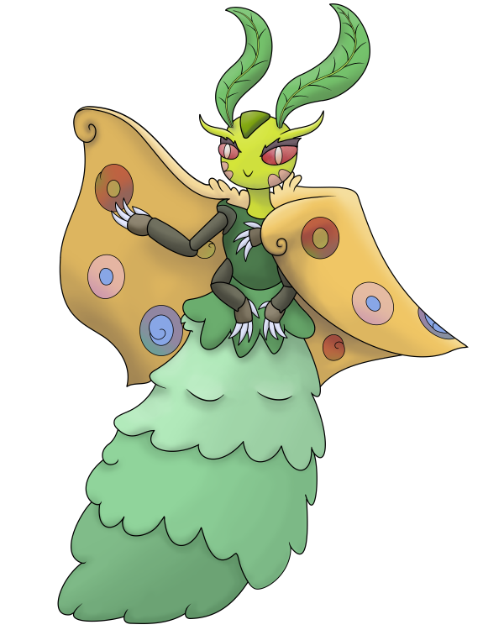

Name: Duchefly
Classification: Pillywiggin Pokémon
Evolves from female Chrysantle at level 27

Description: Impish and agile, Ducheflies use the power of nature to fight. Flowers thrive where they reside.
Height: 1.0 m (3’03")
Mass: 13.3 kg (29.3 lbs)
Catch rate: 50
Experience yield: 214
Held item in the wild: Fairy Feather (6.25 %), Mental Herb (18.75 %), Lum Berry (50 %)
Raw material recovered by hunting: Raw silk (×2)
Appearance: Insectoid
Color: Pink
Rarity: Rare
Tier: Under Used
----------

Type: Bug / Fairy
Secondary types: Normal, Grass, Psychic, Dark
Immunities: Dragon
Critical resistances: Fighting
Resistances: Grass, Ground, Bug, Dark, Fairy, Shadow, Light
Weaknesses: Fire, Poison, Flying, Rock, Steel
----------

Base stats:
HP: 76 (+7)
Atk: 72 (+9)
Def: 69 (+1)
Sp. Atk: 101 (+31)
Sp. Def: 95 (+15)
Spd: 93 (+38)
----------
Total: 506 (+101)

EV: +1 Sp. Def, +2 Sp. Atk

Abilities:
• Shield Dust: This Pokémon’s dust blocks the additional effects of attacks taken.
• Natural Cure: All status conditions heal when the Pokémon switches out.
• Prankster (hidden): Status moves gain one level of priority, but lose their effectiveness against the Dark-type.

Sexual dimorphism:
The male is a distinct species (slightly different stats, movepool and abilities) more slender, with horns and a different cape.

Innate movepool (by leveling up or Move Reminder)

❌: Attack impossible to learn for this evolutionary stage or this form
💿: Attack not yet innate to this stage of evolution, but can be learned through external teaching.
Bold: Move benefiting from STAB at the time it is learned.
Italics: Move learned at a time when future evolution is required to unlock a STAB or secondary affinity.
Red: Anti-STAB because no secondary affinity on all stages of evolution. This move will consume more energy and have less power.
A learning level of 0 means that the Pokémon learns it when it evolves. Attacks that appear at level 1 after an evolution can be unlocked without a TM thanks to the Move Reminder.

Move | Type | Cat. | Power | Acc. | Learning level
 |  |  |  |  | Larfae | Chrysantle | Druichy | Duchefly
Disarming Voice |  |  | 40 | ∞ | ❌ | 0 | 1 | 1
Hug Tackle |  |  | 50 | 100 | ❌ | 1 | 1 | 1
Sticky Web |  |  | - | ∞ | 💿 | 1 | 1 | 1
Horn Leech |  |  | 75 | 100 | ❌ | ❌ | 0 | ❌
Foul Play |  |  | 95 | 100 | ❌ | ❌ | ❌ | 0
U-turn |  |  | 55 | 100 | ❌ | ❌ | 1 | 1
Spirit Break |  |  | 75 | 100 | ❌ | ❌ | 1 | 1
Tackle |  |  | 40 | 100 | 1 | 1 | 1 | 1
Leech Bite |  |  | 25 | 100 | 1 | 1 | 1 | 1
String Shot |  |  | - | 95 | 3 | 3 | 3 | 3
Harden |  |  | - | ∞ | 5 | 5 | 5 | 5
Silk Trap |  |  | - | ∞ | 9 | 9 | 9 | 9
Struggle Bug |  |  | 50 | 100 | 12 | 12 | 12 | 12
Stun Spore |  |  | - | 75 | 16 | 18 | 18 | 18
Sleep Powder |  |  | - | 75 | 16 | 18 | 18 | 18
Bug Bite |  |  | 60 | 100 | 19 | 21 | 21 | 21
Aromatherapy |  |  | - | ∞ | 22 | 24 | 24 | 24
Silver Wind |  |  | 60 | 100 | 26 | 29 | 30 | 30
Draining Kiss |  |  | 50 | 100 | ❌ | 32 | 34 | 34
Moonlight |  |  | - | ∞ | ❌ | 35 | 38 | 38
Pollen Puff |  |  | 90 | 100 | 32 | 38 | 42 | 42
Quiver Dance |  |  | - | ∞ | ❌ | ❌ | 46 | 46
Bug Buzz |  |  | 90 | 100 | 38 | 44 | 50 | 50
Moonblast |  |  | 95 | 100 | ❌ | ❌ | 55 | 55

Shadow and Light movepool

Moves in blue are not part of the innate movepool and can only be obtained by Move Tutor once the Pokémon has obtained the type in question at least once and reached the minimum level.

Move | Type | Cat. | Power | Acc. | Learned instead of | Learning level
 |  |  |  |  |  | Larfae | Chrysantle | Druichy and Duchefly
Shadow Wave |  |  | 55 | 100 | Struggle Bug | 12 | 12 | 12
Sacred Wave |  |  | 60 | 100 | Struggle Bug | 12 | 12 | 12
Shadow Panic |  |  | 0 | 100 | Aromatherapy | 22 | 24 | 24
Sacred Veil |  |  | - | ∞ | Aromatherapy | 22 | 24 | 24
Shadow Sap |  |  | 50 | 10 | Draining Kiss | ❌ | 32 | 34
Light of Ruin |  |  | 140 | 90 | Moonblast | ❌ | ❌ | 55
Shadow Rush |  |  | 55 | 100 | (None) | 10 | 10 | 10
Sacred Rush |  |  | 60 | 100 | (None) | 10 | 10 | 10
Shadow Sky |  |  | - | ∞ | (None) | ❌ | ❌ | 35
Sigil of Light |  |  | - | ∞ | (None) | ❌ | ❌ | 40

Acquired movepool (Technical Parchment, Move Tutor …)

• The attacks listed below or in the innate movepool are all legitimate for this Pokémon because the Mirror Herb – a kind of universal TM – allows you to transfer any move from a Pokémon that already knows it to another.
• Moves that benefit from STAB for at least one of the forms or evolutionary stages are noted in bold.
• If an evolution is required to unlock a STAB or secondary affinity and the attack could already be learned before the evolution in question, they are indicated in italics.
• Those that obtain no secondary affinity for all evolutionary stages (anti-STAB) are marked in red.

Move | Type | Category | Aptitude
Move | Type | Category | Larfae | Chrysantle | Druichy | Duchefly
Frustration |  |  | ✔️ | ✔️ | ✔️ | ✔️
Return |  |  | ✔️ | ✔️ | ✔️ | ✔️
Hidden Power |  |  | ✔️ | ✔️ | ✔️ | ✔️
Protect |  |  | ✔️ | ✔️ | ✔️ | ✔️
Sleep Talk |  |  | ✔️ | ✔️ | ✔️ | ✔️
Substitute |  |  | ✔️ | ✔️ | ✔️ | ✔️
Rest |  |  | ✔️ | ✔️ | ✔️ | ✔️
Skitter Smack |  |  | ✔️ | ✔️ | ✔️ | ✔️
Leech Life |  |  | ✔️ | ✔️ | ✔️ | ✔️
Sticky Web |  |  | ✔️ | Innate | Innate | Innate
Attract |  |  | ✔️ | ✔️ | ✔️ | ✔️
Charm |  |  | ✔️ | ✔️ | ✔️ | ✔️
Facade |  |  | ❌ | ✔️ | ✔️ | ✔️
Secret Power |  |  | ❌ | ✔️ | ✔️ | ✔️
Nature Power |  |  | ❌ | ✔️ | ✔️ | ✔️
Safeguard |  |  | ❌ | ✔️ | ✔️ | ✔️
Giga Drain |  |  | ❌ | ✔️ | ✔️ | ✔️
Energy Ball |  |  | ❌ | ✔️ | ✔️ | ✔️
Endure |  |  | ❌ | ✔️ | ✔️ | ✔️
Magic Coat |  |  | ❌ | ✔️ | ✔️ | ✔️
Play Rough |  |  | ❌ | ✔️ | ✔️ | ✔️
Dazzling Gleam |  |  | ❌ | ✔️ | ✔️ | ✔️
Aromatic Mist |  |  | ❌ | ✔️ | ✔️ | ✔️
Mystical Mist |  |  | ❌ | ✔️ | ✔️ | ✔️
Psychic |  |  | ❌ | ❌ | ✔️ | ✔️
Dream Eater |  |  | ❌ | ❌ | ✔️ | ✔️
Expanding Force |  |  | ❌ | ❌ | ✔️ | ✔️
Reflect |  |  | ❌ | ❌ | ✔️ | ✔️
Light Screen |  |  | ❌ | ❌ | ✔️ | ✔️
Calm Mind |  |  | ❌ | ❌ | ✔️ | ✔️
Trick |  |  | ❌ | ❌ | ✔️ | ✔️
Wonder Room |  |  | ❌ | ❌ | ✔️ | ✔️
Magic Room |  |  | ❌ | ❌ | ✔️ | ✔️
Lunge |  |  | ❌ | ❌ | ✔️ | ✔️
Aerial Ace |  |  | ❌ | ❌ | ✔️ | ❌
Bounce |  |  | ❌ | ❌ | ✔️ | ❌
Acrobatics |  |  | ❌ | ❌ | ✔️ | ❌
Thief |  |  | ❌ | ❌ | ❌ | ✔️
Taunt |  |  | ❌ | ❌ | ❌ | ✔️
Fake Tears |  |  | ❌ | ❌ | ❌ | ✔️

