Furfang / Boarhorn

Lineage’s Lore

Inspiration:

This lineage is inspired by the wild boar, a very important animal in Celtic culture. So, I had to transpose it into my Pokémon universe. That of Keltios has a horn, small tusks and a tail with an acorn-like tip. Its fur is very dense on its spine.
It will be the equivalent of the Route 1’s rodent, so not very powerful but common and accessible from the start of the game with two stages of evolution. Its type is Ground / Fighting, a unique combination until the arrival of Great Tusk in Gen 9.

Etymology:

The etymology of Furfang comes from “fur” and “fang”.
The etymology of Boarhorn comes from “boar” and “horn”.

Habitat:

This very common Fakemon lives in hilly and temperate places all over Keltios. This corresponds to almost the entirety of the Eleanor Shire (except the coasts), Breliande and the contours of the Avalon Sea (except the southern part and the Aerouant Shire).
At the bottom of the food chain, it is hunted and prized for its meat. For those who prefer to make it an ally, the pre-evolutionary is docile and will make a good pet. Some even have a knack for unearthing berries, mushrooms and other objects of interest in the wild!
As for the evolved form, don’t underestimate it because Boarhorn has the means to defend itself if it feels in danger. This is why defeating one and bringing back its carcass for a good banquet is often seen as a warrior feat. Its evolution is also rapid and will allow you to have a Pokémon with good potential quite early in the game.

Type:

Both evolutionary stages have the Ground / Fighting combination, a unique double-type. Advantages include excellent offensive coverage (almost half the bestiary is vulnerable to it), almost insensitivity to the Rock-type (therefore to Stealth Rock) and Electric immunity. Resistance to Poison, Dark and Shadow-types is also a plus in certain hostile environments.
On the other hand, this combination suffers from six weaknesses, four of which are types commonly used to attack. This degrades the Pokémon’s defensive potential and explains its unfavorable position in the Ardrasil University’s rankings.
The Thick Fat ability allows you to cancel a vulnerability and gain additional resistance, thus rebalancing the defensive balance of affinities.

In terms of secondary affinities, and therefore possible coverages, we find the Rock and Psychic-types. Evolution adds the Dark-type (with a strategically interesting move).

Stats:

Furfang’s stats are fragile, though fairly balanced. Its Special Attack remains very weak, however, making its first two Ground-type moves, which strike as special, not very effective.
Its evolution almost doubles its stats and consigns its Special Attack to oblivion. The most impressive increase is in HP (which will give it a decent bulk despite its medium-low defenses), and Attack (which will enable it to hit hard and well).
Its speed is rather low, but still higher than that of most purely defensive magical creatures. This is its second weak point, along with its rather low staying power. This can compensate with a Choice Scarf, but it will block it on one attack.
For an even gruffer, wallbreaker-oriented strategy, you can make it hold a Choice Band or a Life Orb. If it’s played with its hidden ability Guts, the Flame Orb becomes ideal: once burned, its physical damage becomes devastating, while protecting it from another status that would be more detrimental.

Movepool:

Its innate movepool is half Normal-type moves, one-quarter Ground-type moves, and one-quarter Fighting-type moves. They are often brutal and based on charging the opponent or attacking it recklessly. One of the most powerful, Thrash, is learned quite quickly.
As it evolves, it can pseudo-haze enemies with Circle Throw or slow them down with Bulldoze.
At high level, it unlocks Double-Edge, Headlong Rush and Close Combat: enough to inflict powerful raw damage at the cost of its defensive potential. It ends up with Horn Drill but especially No Retreat. Symbol of its recklessness, this move allows it to increase all its stats just once, but at the cost of prohibiting itself from leaving the fight. If the placement works, it can become a physical sweeper.

Regarding the moves taught, there are a few interesting trump cards. Because its Special Attack is much lower than its Attack stat, it’s a good idea to teach it Bulk Up as soon as possible, instead of Work Up, an innately obtained attack.
Facade becomes a must-have if played with Guts and the Flame Orb.
Earthquake is a move not to be overlooked (at least to stay on Headlong Rush as suicide lead).
Zen Headbutt and Rock Slide are Psychic and Rock-type coverages that can be used from pre-evolution.
Evolution unlocks several Fighting-type physical moves (including Rock Smash and Strength, two secret field techniques), Stone Edge, Stealth Rock (useful in suicide lead or if played defensively) and Knock Off, a powerful asset for handicapping opponents in addition to the coverage it provides.

Shadow and Light-type trees should not be overlooked. At the price of STAB on its Fighting moves, acquiring one of these two types can enable it to extend its coverage and have an additional physical attack that reaches or exceeds 100 of base power.

In conclusion, Boarhorn can hardly be played defensively, as its staying power is below average. Its full potential is to be found in aggressive strategies, thanks to its excellent offensive coverage and powerful physical attacks, which can be even more devastating with the Guts ability and/or the right held item. That said, its relative slowness leaves it vulnerable to revenge killers and relegates it to the lower tiers. Playing it as a suicide lead with Stealth Rock + hard-hitting attacks at the expense of its defensive skills could be a way of turning this flaw into an asset.

Lineage characteristics:

Experience curve: Fast (800,000 XP at level 100)
Breeding group: Mammal
Sex ratio: 50% male, 50% female
Pain of evolution: High (painful)
Hatching time: Quite fast (15 cycles, or 3,780 steps)
Possible reincarnation after death: Misdreavus

Furfang

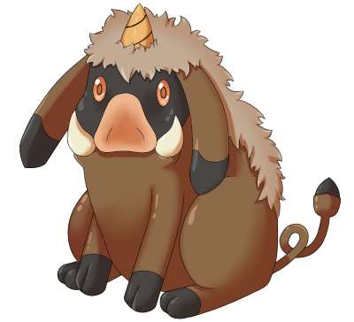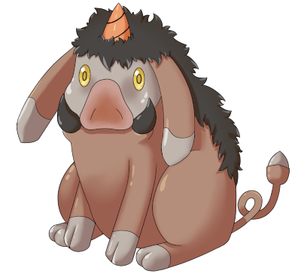

Name: Furfang
Classification: Young Boar Pokémon
Evolves into Boarhorn from level 23

Description: This Pokémon sniffs the ground for roots, berries and mushrooms. Curious by nature, it is easily tamed and can help humans find food in the wild.
Height: 0.5 m (1’08")
Mass: 22.3 kg (49.2 lbs)
Catch rate: 245
Experience yield: 51
Held item in the wild: Oran Berry (25 %)
Raw material recovered by hunting: Leather (×1)
Appearance: Quadruped
Color: Brown
Rarity: Very common
Tier: Poorly Used – LC
----------

Type: Ground / Fighting
Secondary types: Normal, Psychic, Rock
Immunities: Electric
Critical resistances: Rock
Resistances: Fire (if Thick Fat ability), Poison, Dark, Shadow
Weaknesses: Water, Grass, Ice (unless Thick Fat ability), Flying, Psychic, Fairy
----------

Base stats:
HP: 56
Atk: 52
Def: 40
Sp. Atk: 35
Sp. Def: 45
Spd: 47
----------
Total: 275

EV: +1 HP

Abilities:
• Thick Fat: The Pokémon is protected by a layer of thick fat, which halves the affinity from Fire- and Ice-type moves.
• Gluttony: Makes the Pokémon eat a held Berry when its HP drops to half or less, which is sooner than usual.
• Pickup (hidden): The Pokémon may pick up the item an opposing Pokémon used during a battle. It may pick up items outside of battle, too.

Sexual dimorphism:
None

Boarhorn

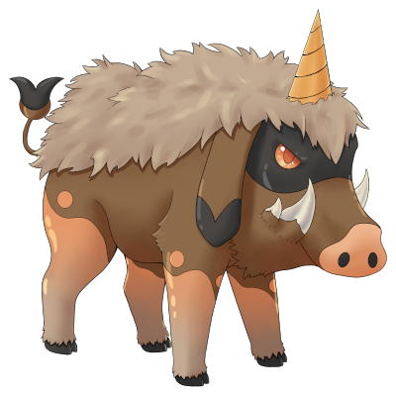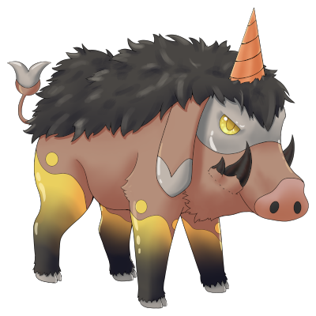

Name: Boarhorn
Classification: Boar Pokémon
Evolves from Furfang at level 23

Description: Its evolution has made it fierce and combative. It is a symbol of strength and courage among the Kelts, and its meat is particularly prized by those who manage to hunt it.
Height: 1.1 m (3’07")
Mass: 123.0 kg (271.2 lbs)
Catch rate: 100
Experience yield: 171
Held item in the wild: Sitrus Berry (18,75 %), Mental Herb (50 %)
Raw material recovered by hunting: Leather (×2)
Appearance: Quadruped
Color: Brown
Rarity: Common
Tier: Never Used
----------

Type: Ground / Fighting
Secondary types: Normal, Psychic, Rock, Dark
Immunities: Electric
Critical resistances: Rock
Resistances: Fire (if Thick Fat ability), Poison, Dark, Shadow
Weaknesses: Water, Grass, Ice (unless Thick Fat ability), Flying, Psychic, Fairy
----------

Base stats:
HP: 108 (+52)
Atk: 101 (+49)
Def: 75 (+35)
Sp. Atk: 47 (+12)
Sp. Def: 80 (+35)
Spd: 74 (+27)
----------
Total: 485 (+210)

EV: +2 HP

Abilities:
• Thick Fat: The Pokémon is protected by a layer of thick fat, which halves the affinity from Fire- and Ice-type moves.
• Gluttony: Makes the Pokémon eat a held Berry when its HP drops to half or less, which is sooner than usual.
• Guts (hidden): It’s so gutsy that having a status condition boosts the Pokémon’s Attack stat.

Sexual dimorphism:
None

Innate movepool (by leveling up or Move Reminder)

❌: Attack impossible to learn for this evolutionary stage or this form
💿: Attack not yet innate to this stage of evolution, but can be learned through external teaching.
Bold: Move benefiting from STAB at the time it is learned.
Italics: Move learned at a time when future evolution is required to unlock a STAB or secondary affinity.
Red: Anti-STAB because no secondary affinity on all stages of evolution. This move will consume more energy and have less power.
A learning level of 0 means that the Pokémon learns it when it evolves. Attacks that appear at level 1 after an evolution can be unlocked without a TM thanks to the Move Reminder.

Move | Type | Cat. | Power | Acc. | Learning level
 |  |  |  |  | Furfang | Boarhorn
Bulldoze |  |  | 60 | 100 | 💿 | 0
Circle Throw |  |  | 60 | 100 | ❌ | 0
Rage |  |  | 20 | 100 | ❌ | 1
Take Down |  |  | 90 | 85 | 💿 | 1
Headbutt |  |  | 70 | 100 | 💿 | 1
Tackle |  |  | 40 | 100 | 1 | 1
Tail Whip |  |  | - | 100 | 1 | 1
Odor Sleuth |  |  | - | ∞ | 3 | 3
Mud-Slap |  |  | 20 | 100 | 5 | 5
Low Kick |  |  | 20-120 | 100 | 9 | 9
Covet |  |  | 60 | 100 | 13 | 13
Mud Shot |  |  | 45 | 100 | 16 | 16
Reversal |  |  | 20-200 | 100 | 20 | 20
Work Up |  |  | - | ∞ | 24 | 26
Thrash |  |  | 120 | 100 | 28 | 30
Drill Run |  |  | 80 | 95 | ❌ | 34
Double-Edge |  |  | - | ∞ | 32 | 39
Headlong Rush |  |  | 120 | 100 | 36 | 44
Close Combat |  |  | 120 | 100 | ❌ | 49
No Retreat |  |  | - | ∞ | ❌ | 54
Horn Drill |  |  | ∞ | 30 | ❌ | 60

Shadow and Light movepool

Moves in blue are not part of the innate movepool and can only be obtained by a Move Tutor once the Pokémon has obtained the type in question at least once and reaches the minimum level.

Move | Type | Cat. | Power | Acc. | Learned instead of | Learning level
 |  |  |  |  |  | Furfang | Boarhorn
Shadow Blitz |  |  | 40 | 100 | Low Kick | 9 | 9
Sacred Blitz |  |  | 40 | 100 | Low Kick | 9 | 9
Shadow Rush |  |  | 55 | 90 | Reversal | 20 | 20
Sacred Rush |  |  | 60 | 100 | Reversal | 20 | 20
Shadow Shed |  |  | - | ∞ | Work Up | 24 | 26
Sacred Break |  |  | 80 | 100 | Thrash | 28 | 30
Shadow End |  |  | 120 | 90 | Double-Edge | 32 | 39
Ram of Light |  |  | 100 | 95 | Double-Edge | 32 | 39

Acquired movepool (Technical Parchment, Move Tutor …)

• The attacks listed below or in the innate movepool are all legitimate for this Pokémon because the Mirror Herb – a kind of universal TM – allows you to transfer any move from a Pokémon that already knows it to another.
• Moves that benefit from STAB for at least one of the forms or evolutionary stages are noted in bold.
• If an evolution is required to unlock a STAB or secondary affinity and the attack could already be learned before the evolution in question, they are indicated in italics.
• Those that obtain no secondary affinity for all evolutionary stages (anti-STAB) are marked in red.

Move | Type | Category | Aptitude
Move | Type | Category | Furfang | Boarhorn
Facade |  |  | ✔️ | ✔️
Frustration |  |  | ✔️ | ✔️
Return |  |  | ✔️ | ✔️
Body Slam |  |  | ✔️ | ✔️
Secret Power |  |  | ✔️ | ✔️
Giga Impact |  |  | ✔️ | ✔️
Endeavor |  |  | ✔️ | ✔️
Take Down |  |  | ✔️ | Innate
Headbutt |  |  | ✔️ | Innate
Hidden Power |  |  | ✔️ | ✔️
Snore |  |  | ✔️ | ✔️
Echoed Voice |  |  | ✔️ | ✔️
Protect |  |  | ✔️ | ✔️
Sleep Talk |  |  | ✔️ | ✔️
Substitute |  |  | ✔️ | ✔️
Arm Thrust |  |  | ✔️ | ✔️
Endure |  |  | ✔️ | ✔️
Bulk Up |  |  | ✔️ | ✔️
Belch |  |  | ✔️ | ✔️
Bulldoze |  |  | ✔️ | Innate
High Horsepower |  |  | ✔️ | ✔️
Earthquake |  |  | ✔️ | ✔️
Dig |  |  | ✔️ | ✔️
Stomping Tantrum |  |  | ✔️ | ✔️
Earth Power |  |  | ✔️ | ✔️
Zen Headbutt |  |  | ✔️ | ✔️
Rest |  |  | ✔️ | ✔️
Amnesia |  |  | ✔️ | ✔️
Rock Tomb |  |  | ✔️ | ✔️
Rock Slide |  |  | ✔️ | ✔️
Thief |  |  | ✔️ | ✔️
Iron Head |  |  | ✔️ | ✔️
Attract |  |  | ✔️ | ✔️
Counter |  |  | ❌ | ✔️
Strength |  |  | ❌ | ✔️
Rock Smash |  |  | ❌ | ✔️
Brick Break |  |  | ❌ | ✔️
Revenge |  |  | ❌ | ✔️
Body Press |  |  | ❌ | ✔️
Stone Edge |  |  | ❌ | ✔️
Stealth Rock |  |  | ❌ | ✔️
Sandstorm |  |  | ❌ | ✔️
Knock Off |  |  | ❌ | ✔️
Torment |  |  | ❌ | ✔️

