Skiddo / Gogoat
Basic form + ancient form

Lineage’s Lore

Inspiration:

Like its original form, this regional variant is inspired by the Alpine ibex. At the same time, the idea of having an ice Gogoat came to me from Skyrim’s mountain goat: just as there is a brown variant and a white variant that lives higher up in the mountains, we find this same duality in Keltios. Thus, the Grass-type Gogoat lives in hilly pastures, while the mountain version will be found on steep relief and will possess ice horns.

Gogoat’s weight has been revised upwards: a draught animal 1.7 meters tall weighs around 200 kg. The mountain version is slightly stockier and heavier than the hill version.

Etymology:

The etymology of Skiddo comes from “skid” and “kiddo” (young goat).
The etymology of Gogoat comes from “go” and “goat”.

Habitat:

Very common, the highland Gogoat lives naturally on the northern and southwestern slopes of the Argon Mountains and in the Vale of Lugh just north of Fearnos. A few also live in the highlands between Ardrasil and Hulis and around Collia.
The rarer ice line will be found in the mountainous heights near the southeastern border of Kalos. This corresponds to the snow-covered reliefs of the Vale of Lugh and the Lake of Time, as well as the road leading to the Iagos Peak to the west of Phoenix Hill.
It’s worth noting that the Pokémon is at the bottom of the food chain, with its basic form ranked in the lowest tier according to Ardrasil University. Each form has its own weak point (Defense for the Grass-type, Speed for the Ground/Ice-type) which makes it vulnerable to predators. That said, the mountain form fares better thanks to a double-type and a movepool more advantageous than a pure Grass-type, and manages to rise to the rank of Rarely Used.
To compensate for its fragility in the wild, it grows very quickly, which makes it much easier to breed and an ideal draught animal. As a result, many farmers and shepherds own them.

Type:

Keltios’ regional form becomes Ground / Ice like the Mamoswine line. In official play, this is one of the worst combinations defensively. Not in Keltios, thanks to the rebalancing of the type chart. With 2 immunities and 1 resistance against 3 vulnerabilities, we get a rather neutral combination with weaknesses that are often compensated for by the second type.
Offensively, this double-type is one of the best, with more than half of all existing Pokémons vulnerable to it. Add to this a secondary affinity with the Rock-type (in addition to Normal and Fighting), and the icy Gogoat can have perfect coverage.

As for the form of the valleys, its pure Grass-type suffers from its 5 weaknesses and doesn’t give it much versatility. It has a secondary affinity with the Normal, Fighting, Ground and Rock-types for a little coverage, but this won’t be enough to protect it from the Flying and Poison types, which remain its natural counters.

In both cases, don’t overlook the Sap Sipper ability, which provides an additional immunity, especially for the ice form (transforming a simple weakness into absorption), although the hidden ability will be preferred for more advanced strategies.

Stats:

Skiddo has fairly balanced and decent stats for a primitive form with a total of 350. Its offensive stats are mixed. Only Defense and Speed are really low.
By evolving into a Gogoat, its HP increase enormously and its two offensive stats strengthen significantly and equally, while its two weakest stats... remain those that rise the least! In short, its strengths and weaknesses are accentuated.
On balance, we get a rather bulky Pokémon in special but average on the physical level. Its main handicap remains its speed, which is really slow, but not slow enough to be exploited under Trick Room. This makes it vulnerable to Revenge killers. At the same time, its mixed side makes it “quite good” on both offensive aspects, but prevents it from excelling in either. Further analysis even shows that the basic Gogoat’s Special Attack stat is of little use, due to its limited movepool in this category.

The mountain form is slightly more physically resistant but a little slower, which reverses the two weakest stats compared with the valley form. This should be seen in the context of the hidden ability of the two forms: Grass Pelt and Slush Rush, which respectively reinforce their weakest stat... even if the Ice-type Gogoat remains slower than the fastest Pokémon or those with a Choice Scarf! That said, this little detail gives it greater strategic potential than its basic form, as there’s a way it won’t get outspeeded if it’s offered icy terrain or weather.

Movepool (basic form):

The basic form has a fairly basic movepool with practically only Normal or Grass-type attacks, and only physical with regard to offensive attacks. (You have to draw from the acquired movepool to find special attacks, especially of the Grass type.) Bulldoze is the only innate coverage, to which Earthquake can be added by requesting a Move Reminder after its evolution + Trailblaze, which it learns as it evolves.
Fortunately, it can rely on a few healing attacks learned at higher levels. Horn Leech allows it to steal its opponents’ HP, Milk Drink (or Synthesis) to heal itself and Bulk Up to increase its stamina. Combined with Substitute, this can create a bulky setup sweeper strategy, to be complemented with Fighting, Ground and Rock coverage … even if it will take several turns for it to give its full potential and pray that he does not suffer a status or the Encore debuff!

Speaking of coverage, it’s mostly obtained through the acquired movepool. Rock Climb or Rock Slide are the two best Rock moves; Brick Break, Superpower or Strength are its best Fighting moves. Forget, however, coverages of other types, which will be penalized by an anti-STAB.
The Shadow or Light-type can extend its coverage while giving it a second type. This is an option that should not be overlooked.

Finally, setting up a grassy battlefield with Grassy Terrain (or Grass Pledge) can provide an interesting advantage if combined with Grass Pelt. Indeed, this ability grants +50% Defense in a forest or a meadow (to which is added a +25% if it is sunny) and allows you to double the regeneration provided at the end of the turn by the meadow or the forest cave (i.e., 1/8th of max HP instead of 1/16th).

Movepool (ancient form):

At birth, Skiddo begins with basic Ground and Ice attacks. Unlike the basic form, which has an exclusively physical innate movepool for offensive attacks, the first moves learned by the Ice Skiddo are predominantly special. The innate offensive movepool will switch entirely to physical once the evolution level has been reached, but more powerful special attacks (Ice Beam, Earth Power …) will remain accessible by teaching. This shows that, unlike the grassy Gogoat, the mountain Gogoat has real mixed potential.
Nevertheless, the physical aspect will remain privileged. Firstly, because it learns Bulk Up naturally, but also because its innate movepool has many powerful moves at high level. This is complemented by a Rock and Fighting arsenal that can be taught (Brick Break, Rock Climb …), the same as for the basic Gogoat.

On the other hand, this regional form loses its entire Grass movepool, including Horn Leech. This limits its coverages to Fighting and Rock-types, but it remains one of the best offensive combinations with its two STABs. In fact, each of these 4 types strikes effectively on 4 or 5 defensive types, making it possible to hit three quarters of the existing bestiary super effectively. Special mention must be made of Freeze-Dry, which can give it the upper hand over aquatic Pokémons. Ice Spinner can also be interesting for getting rid of an unfavorable battlefield, but be careful not to break an ice-type terrain!
This brings us to one final point: the weather. This regional form can summon snow (or blizzard) thanks to Snowscape. Combined with its hidden ability Slush Rush, this has several positive effects: Defense is increased, its Ice attacks are more powerful and its Speed is doubled. Enough to have a more powerful effect than Bulk Up in one turn! So, this Pokémon will fit perfectly into a Snow team.

In conclusion, the Gogoat of the mountains has a better offensive potential than that of the hills. It has a way to do a lot of damage thanks to its coverages and its fairly high attack stat and can easily strike first if it has the Slush Rush ability combined with frozen terrain or weather.

Lineage characteristics:

Experience curve: Very fast (600,000 XP at level 100)
Breeding group: Mammal
Sex ratio: 50% male, 50% female
Pain of evolution: Low (quite bearable)
Species fertility: From level 15
Hatching time: Average (20 cycles, or 5,120 steps)
Possible reincarnation after death: Calafoal

Skiddo (basic form)

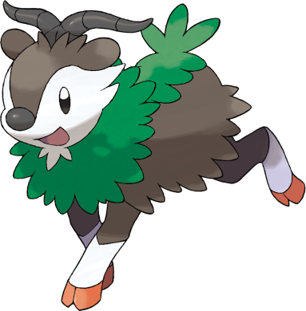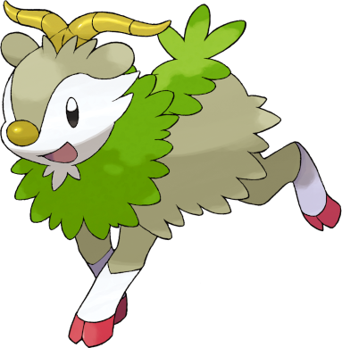

Name: Skiddo
Classification: Mount Pokémon
Evolves into Gogoat (basic form) from level 32

Description: If it has sunshine and water, it doesn’t need to eat, because it can generate energy from the leaves on its back.
Height: 0.9 m (2’11")
Mass: 31.50 kg (68.3 lbs)
Catch rate: 180
Experience yield: 70
Held item in the wild: White Herb (6,25%), Oran Berry (18,75 %)
Raw material recovered by hunting: Seed (×1)
Appearance: Quadruped
Color: Brown
Rarity: Very common
Tier: Poorly Used – LC
----------

Type: Grass
Secondary types: Normal, Fighting, Ground, Rock
Resistances: Water, Electric, Grass (absorption if Sap Sipper ability), Light
Weaknesses: Fire, Ice, Poison, Flying, Bug
----------

Base stats:
HP: 66
Atk: 65
Def: 48
Sp. Atk: 62
Sp. Def: 57
Spd: 52
----------
Total: 350

EV: +1 HP

Abilities:
• Sap Sipper: Boosts the Attack stat if hit by a Grass-type move instead of taking damage.
• Grass Pelt (hidden): Boosts the Pokémon’s Defense stat on a grassy battlefield, and doubles the HP regeneration from a meadow. Sunlight also slightly increases Defense.

Sexual dimorphism:
None

Gogoat (basic form)

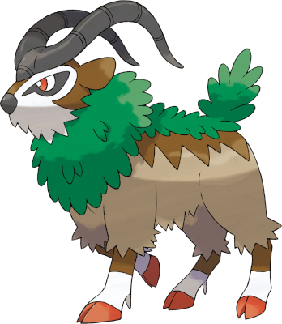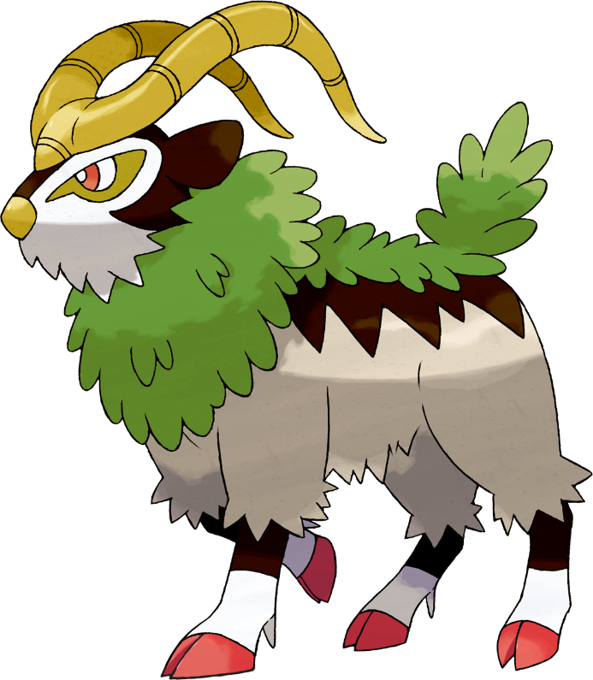

Name: Gogoat
Classification: Mount Pokémon
Evolution of Skiddo (basic form) from level 32

Description: They inhabit hilly regions. The leader of the herd is decided by a battle of clashing horns.
Height: 1.7 m (5’07")
Mass: 184.0 kg (405.7 lbs)
Catch rate: 65
Experience yield: 166
Held item in the wild: White Herb (18,75 %), Sitrus Berry (50 %)
Raw material recovered by hunting: Seed (×2)
Appearance: Quadruped
Color: Brown
Rarity: Common
Tier: Poorly Used
----------

Type: Grass
Secondary types: Normal, Fighting, Ground, Rock
Resistances: Water, Electric, Grass (absorption if Sap Sipper ability), Light
Weaknesses: Fire, Ice, Poison, Flying, Bug
----------

Base stats:
HP: 123 (+57)
Atk: 100 (+35)
Def: 62 (+14)
Sp. Atk: 97 (+35)
Sp. Def: 81 (+24)
Spd: 68 (+16)
----------
Total: 531 (+181)

EV: +2 HP

Abilities:
• Sap Sipper: Boosts the Attack stat if hit by a Grass-type move instead of taking damage.
• Grass Pelt (hidden): Boosts the Pokémon’s Defense stat on a grassy battlefield, and doubles the HP regeneration from a meadow. Sunlight also slightly increases Defense.

Sexual dimorphism:
None

Innate movepool (by leveling up or Move Reminder)

❌: Attack impossible to learn for this evolutionary stage or this form
💿: Attack not yet innate to this stage of evolution, but can be learned through external teaching.
Bold: Move benefiting from STAB at the time it is learned.
Italics: Move learned at a time when future evolution is required to unlock a STAB or secondary affinity.
Red: Anti-STAB because no secondary affinity on all stages of evolution. This move will consume more energy and have less power.
A learning level of 0 means that the Pokémon learns it when it evolves. Attacks that appear at level 1 after an evolution can be unlocked without a TM thanks to the Move Reminder.

Move | Type | Cat. | Power | Acc. | Learning level
 |  |  |  |  | Skiddo | Gogoat
Trailblaze |  |  | 50 | 100 | 💿 | 0
Earthquake |  |  | 100 | 150 | ❌ | 1
Tackle |  |  | 40 | 100 | 1 | 1
Growth |  |  | - | ∞ | 1 | 1
Vine Whip |  |  | 45 | 100 | 6 | 6
Tail Whip |  |  | - | 85 | 9 | 9
Leech Seed |  |  | - | 90 | 12 | 12
Razor Leaf |  |  | 55 | 95 | 13 | 13
Worry Seed |  |  | 70 | 150 | 16 | 16
Synthesis |  |  | - | ∞ | 20 | 20
Take Down |  |  | 90 | 85 | 22 | 22
Bulldoze |  |  | 60 | 100 | 26 | 26
Seed Bomb |  |  | 80 | 100 | 30 | 30
Bulk Up |  |  | - | ∞ | 34 | 35
Double-Edge |  |  | 120 | 100 | 38 | 40
Horn Leech |  |  | 75 | 100 | 42 | 47
Leaf Blade |  |  | 90 | 100 | 45 | 54
Milk Drink |  |  | - | ∞ | 50 | 58

Shadow and Light movepool

Moves in blue are not part of the innate movepool and can only be obtained by a Move Tutor once the Pokémon has obtained the type in question at least once.

Move | Type | Cat. | Power | Acc. | Learned instead of | Learning level
 |  |  |  |  |  | Skiddo | Gogoat
Shadow Blitz |  |  | 40 | 100 | Vine Whip | 6 | 6
Sacred Blitz |  |  | 40 | 100 | Vine Whip | 6 | 6
Shadow Break |  |  | 75 | 100 | Bulldoze | 26 | 26
Sacred Break |  |  | 80 | 100 | Bulldoze | 26 | 26
Shadow End |  |  | 120 | 90 | Double-Edge | 38 | 40
Ram of Light |  |  | 100 | 95 | Double-Edge | 38 | 40
Shadow Sap |  |  | 55 | 100 | Horn Leech | 42 | 47
Life Dew |  |  | - | ∞ | Milk Drink | 50 | 58

Acquired movepool (Technical Parchment, Move Tutor …)

• The attacks listed below or in the innate movepool are all legitimate for this Pokémon because the Mirror Herb – a kind of universal TM – allows you to transfer any move from a Pokémon that already knows it to another.
• Exception: for Light and Shadow attacks that are not part of the innate movepool, it is imperative that the Pokémon has acquired the type in question at least once to have the right to learn them.
• Moves that benefit from STAB for at least one of the forms or evolutionary stages are noted in bold.
• If an evolution is required to unlock a STAB or secondary affinity and the attack could already be learned before the evolution in question, they are indicated in italics.
• Those that obtain no secondary affinity for all evolutionary stages (anti-STAB) are marked in red.

Move | Type | Category | Aptitude
Move | Type | Category | Skiddo | Gogoat
Facade |  |  | ✔️ | ✔️
Frustration |  |  | ✔️ | ✔️
Return |  |  | ✔️ | ✔️
Body Slam |  |  | ✔️ | ✔️
Secret Power |  |  | ✔️ | ✔️
Hidden Power |  |  | ✔️ | ✔️
Snore |  |  | ✔️ | ✔️
Echoed Voice |  |  | ✔️ | ✔️
Protect |  |  | ✔️ | ✔️
Sleep Talk |  |  | ✔️ | ✔️
Substitute |  |  | ✔️ | ✔️
Defense Curl |  |  | ✔️ | ✔️
Helping Hand |  |  | ✔️ | ✔️
Work Up |  |  | ✔️ | ✔️
Roar |  |  | ✔️ | ✔️
Sunny Day |  |  | ✔️ | ✔️
Wild Charge |  |  | ✔️ | ✔️
Bullet Seed |  |  | ✔️ | ✔️
Trailblaze |  |  | ✔️ | Innate
Solar Beam |  |  | ✔️ | ✔️
Giga Drain |  |  | ✔️ | ✔️
Magical Leaf |  |  | ✔️ | ✔️
Grass Knot |  |  | ✔️ | ✔️
Energy Ball |  |  | ✔️ | ✔️
Leaf Storm |  |  | ✔️ | ✔️
Grass Pledge |  |  | ✔️ | ✔️
Grassy Terrain |  |  | ✔️ | ✔️
Brick Break |  |  | ✔️ | ✔️
Endure |  |  | ✔️ | ✔️
Bulldoze |  |  | ✔️ | ✔️
Dig |  |  | ✔️ | ✔️
Mud-Slap |  |  | ✔️ | ✔️
Mud Shot |  |  | ✔️ | ✔️
Zen Headbutt |  |  | ✔️ | ✔️
Rest |  |  | ✔️ | ✔️
Rollout |  |  | ✔️ | ✔️
Rock Slide |  |  | ✔️ | ✔️
Payback |  |  | ✔️ | ✔️
Play Rough |  |  | ✔️ | ✔️
Attract |  |  | ✔️ | ✔️
Giga Impact |  |  | ❌ | ✔️
Strength |  |  | ❌ | ✔️
Rock Smash |  |  | ❌ | ✔️
Superpower |  |  | ❌ | ✔️
Aerial Ace |  |  | ❌ | ✔️
Bounce |  |  | ❌ | ✔️
Rock Climb |  |  | ❌ | ✔️
Iron Tail |  |  | ❌ | ✔️

Ancient Skiddo

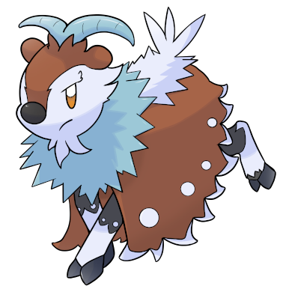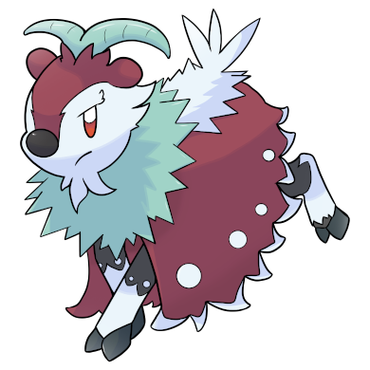

Stats and abilities:

Name: Ancient Skiddo
Classification: Ibex Pokémon
Evolves into ancient Gogoat from level 32

Description: Its hooves enable it to climb steep slopes and reach food nestled between rocks. Its mane can project ice crystals if feels threatened.
Height: 0.9 m (2’11")
Mass: 36.5 kg (80.5 lbs)
Catch rate: 160
Experience yield: 84
Held item in the wild: White Herb (6,25%), Oran Berry (18,75 %)
Raw material recovered by hunting: Ice Shard (×1)
Appearance: Quadruped
Color: Brown
Rarity: Uncommon
Tier: Poorly Used – LC
----------

Type: Ground / Ice
Secondary types: Normal, Fighting, Rock
Absorbed: Grass (if Sap Sipper ability)
Immunities: Electric, Ice
Resistances: Bug
Weaknesses: Fire, Fighting, Steel
----------

Base stats:
HP: 66
Atk: 65
Def: 53
Sp. Atk: 62
Sp. Def: 57
Spd: 47
----------
Total: 350

EV: +1 HP

Abilities:
• Sap Sipper: Boosts the Attack stat if hit by a Grass-type move instead of taking damage.
• Slush Rush (hidden): Doubles the Pokémon’s Speed stat under a freezing weather or on an icy battlefield.

Sexual dimorphism:
None

Ancient Gogoat

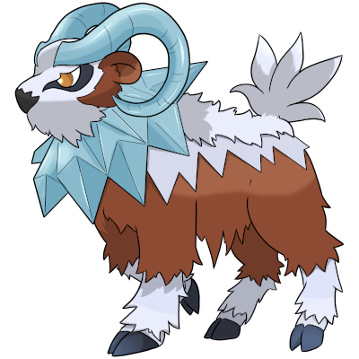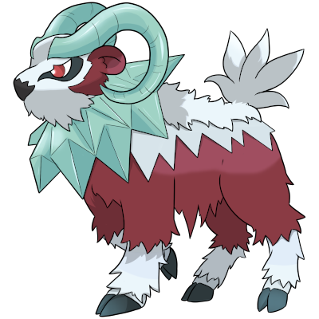

Stats and abilities:

Name: Ancient Gogoat
Classification: Ibex Pokémon
Evolution of Ancient Skiddo from level 32

Description: An agile draught animal in the mountains, it can shake the ground with its hooves. Its horns have the power to cool the air or sense people’s emotions.
Height: 1.7 m (5’07")
Mass: 223.0 kg (491.6 lbs)
Catch rate: 50
Experience yield: 196
Held item in the wild: White Herb (18,75 %), Sitrus Berry (50 %)
Raw material recovered by hunting: Ice Shard (×2)
Appearance: Quadruped
Color: Brown
Rarity: Rare
Tier: Rarely Used
----------

Type: Ground / Ice
Secondary types: Normal, Fighting, Rock
Absorbed: Grass (if Sap Sipper ability)
Immunities: Electric, Ice
Resistances: Bug
Weaknesses: Fire, Fighting, Steel
----------

Base stats:
HP: 123 (+57)
Atk: 100 (+35)
Def: 69 (+16)
Sp. Atk: 97 (+35)
Sp. Def: 81 (+24)
Spd: 61 (+14)
----------
Total: 531 (+181)

EV: +2 HP

Abilities:
• Sap Sipper: Boosts the Attack stat if hit by a Grass-type move instead of taking damage.
• Slush Rush (hidden): Doubles the Pokémon’s Speed stat under a freezing weather or on an icy battlefield.

Sexual dimorphism:
None

Innate movepool (by leveling up or Move Reminder)

❌: Attack impossible to learn for this evolutionary stage or this form
💿: Attack not yet innate to this stage of evolution, but can be learned through external teaching.
Bold: Move benefiting from STAB at the time it is learned.
Italics: Move learned at a time when future evolution is required to unlock a STAB or secondary affinity.
Red: Anti-STAB because no secondary affinity on all stages of evolution. This move will consume more energy and have less power.
A learning level of 0 means that the Pokémon learns it when it evolves. Attacks that appear at level 1 after an evolution can be unlocked without a TM thanks to the Move Reminder.

Move | Type | Cat. | Power | Acc. | Learning level
 |  |  |  |  | Ancient Skiddo | Ancient Gogoat
Ice Spinner |  |  | 80 | 100 | ❌ | 0
Icicle Spear |  |  | 25 | 100 | 💿 | 1
Magnitude |  |  | 22-140 | 150 | 💿 | 1
Tackle |  |  | 40 | 100 | 1 | 1
Sand Attack |  |  | - | 100 | 1 | 1
Mud-Slap |  |  | 20 | 100 | 6 | 6
Tail Whip |  |  | - | 85 | 9 | 9
Powder Snow |  |  | 40 | 100 | 12 | 12
Mud Shot |  |  | 55 | 95 | 13 | 13
Mist |  |  | - | ∞ | 16 | 16
Icy Wind |  |  | 55 | 95 | 20 | 20
Take Down |  |  | 90 | 85 | 22 | 22
Bulldoze |  |  | 60 | 100 | 26 | 26
Ice Shard |  |  | 40 | 100 | 30 | 30
Bulk Up |  |  | - | ∞ | 34 | 35
Headlong Rush |  |  | 120 | 100 | 38 | 40
Earthquake |  |  | 100 | 150 | 42 | 47
Icicle Crash |  |  | 85 | 90 | 45 | 54
Milk Drink |  |  | - | ∞ | 50 | 58

Shadow and Light movepool

Moves in blue are not part of the innate movepool and can only be obtained by a Move Tutor once the Pokémon has obtained the type in question at least once and reaches the minimum level.

Move | Type | Cat. | Power | Acc. | Learned instead of | Learning level
 |  |  |  |  |  | Ancient Skiddo | Ancient Gogoat
Shadow Blitz |  |  | 40 | 100 | Powder Snow | 12 | 12
Sacred Blitz |  |  | 40 | 100 | Powder Snow | 12 | 12
Shadow Break |  |  | 75 | 100 | Take Down | 22 | 22
Sacred Break |  |  | 80 | 100 | Take Down | 22 | 22
Shadow Chill |  |  | 75 | 100 | Ice Shard | 30 | 30
Celestial Chill |  |  | 75 | 100 | Ice Shard | 30 | 30
Shadow End |  |  | 120 | 90 | Headlong Rush | 38 | 40
Ram of Light |  |  | 100 | 95 | Headlong Rush | 38 | 40
Life Dew |  |  | - | ∞ | Milk Drink | 50 | 58

Acquired movepool (Technical Parchment, Move Tutor …)

• The attacks listed below or in the innate movepool are all legitimate for this Pokémon because the Mirror Herb – a kind of universal TM – allows you to transfer any move from a Pokémon that already knows it to another.
• Exception: for Light and Shadow attacks that are not part of the innate movepool, it is imperative that the Pokémon has acquired the type in question at least once to have the right to learn them.
• Moves that benefit from STAB for at least one of the forms or evolutionary stages are noted in bold.
• If an evolution is required to unlock a STAB or secondary affinity and the attack could already be learned before the evolution in question, they are indicated in italics.
• Those that obtain no secondary affinity for all evolutionary stages (anti-STAB) are marked in red.

Move | Type | Category | Aptitude
Move | Type | Category | Ancient Skiddo | Ancient Gogoat
Facade |  |  | ✔️ | ✔️
Frustration |  |  | ✔️ | ✔️
Return |  |  | ✔️ | ✔️
Body Slam |  |  | ✔️ | ✔️
Secret Power |  |  | ✔️ | ✔️
Double-Edge |  |  | ✔️ | ✔️
Hidden Power |  |  | ✔️ | ✔️
Snore |  |  | ✔️ | ✔️
Echoed Voice |  |  | ✔️ | ✔️
Protect |  |  | ✔️ | ✔️
Sleep Talk |  |  | ✔️ | ✔️
Substitute |  |  | ✔️ | ✔️
Defense Curl |  |  | ✔️ | ✔️
Helping Hand |  |  | ✔️ | ✔️
Work Up |  |  | ✔️ | ✔️
Roar |  |  | ✔️ | ✔️
Brick Break |  |  | ✔️ | ✔️
Endure |  |  | ✔️ | ✔️
Ice Ball |  |  | ✔️ | ✔️
Icicle Spear |  |  | ✔️ | Innate
Avalanche |  |  | ✔️ | ✔️
Freeze-Dry |  |  | ✔️ | ✔️
Ice Beam |  |  | ✔️ | ✔️
Blizzard |  |  | ✔️ | ✔️
Haze |  |  | ✔️ | ✔️
Snowscape |  |  | ✔️ | ✔️
Dig |  |  | ✔️ | ✔️
Fissure |  |  | ✔️ | ✔️
Stomping Tantrum |  |  | ✔️ | ✔️
High Horsepower |  |  | ✔️ | ✔️
Magnitude |  |  | ✔️ | Innate
Earth Power |  |  | ✔️ | ✔️
Zen Headbutt |  |  | ✔️ | ✔️
Rest |  |  | ✔️ | ✔️
Rock Slide |  |  | ✔️ | ✔️
Payback |  |  | ✔️ | ✔️
Play Rough |  |  | ✔️ | ✔️
Attract |  |  | ✔️ | ✔️
Giga Impact |  |  | ❌ | ✔️
Strength |  |  | ❌ | ✔️
Rock Smash |  |  | ❌ | ✔️
Superpower |  |  | ❌ | ✔️
Aerial Ace |  |  | ❌ | ✔️
Bounce |  |  | ❌ | ✔️
Rock Climb |  |  | ❌ | ✔️
Iron Tail |  |  | ❌ | ✔️

